

|  |  |  |  |  |
| --- | --- | --- | --- | --- |
| 72 Central Campus Dr Salt Lake City, UT 84112 |  |  |  | yong.wan@utah.edu  www.fluorender.com |

FluoRender Tutorials

Version 2.33/July 2025

|  |  |
| --- | --- |
|  | **Many of the tutorials have corresponding demonstration videos published on YouTube.com. Tutorials with videos are identified with the YouTube logo: .**  **You may follow the links to watch these videos. Or you can search for the title of the video on YouTube.** |
|  | **Please make sure that you have the latest graphics driver installed on your computer before start using FluoRender. Your graphics card needs to support:**  **OpenGL 4.0**  **OpenCL 1.2**  **Look up your graphics card’s capability on Wikipedia.org**  **For AMD graphics processing units:**  [**https://en.wikipedia.org/wiki/List_of_AMD_graphics_processing_units**](https://en.wikipedia.org/wiki/List_of_AMD_graphics_processing_units)  **For Intel graphics processing units:**  [**https://en.wikipedia.org/wiki/List_of_Intel_graphics_processing_units**](https://en.wikipedia.org/wiki/List_of_Intel_graphics_processing_units)  **For Nvidia graphics processing units:**  [**https://en.wikipedia.org/wiki/List_of_Nvidia_graphics_processing_units**](https://en.wikipedia.org/wiki/List_of_Nvidia_graphics_processing_units) |

Table of Contents

List of Figures 4

Tutorial 1 Loading Volumes 6

Supported Formats

Loading a stack of images

Loading a Time-Dependent Sequence

Tutorial 2 Visualizing Multichannel Data 9

Channel Colors

Channel Intermixing Modes

Depth Attenuation

Channel Selection

Tutorial 3 Volume Properties 14

Automatic Settings

Intensity Distribution

Parameters

Volume Colors

Color Maps

High Transparency

Interpolation and Filtering

Tutorial 4 Visualizing a Time Sequence 18

Playback Controls

4D Color Maps

Tutorial 5 Rendering Holograms 20

Install Bridge

Enable Holography

Focusing

Holography Settings

Tutorial 6 Visualizing Mesh Objects 23

Tutorial 7 Screen Capture and Movie Export 25

Tutorial 8 Measuring Position, Length, and Volume 29

Tutorial 9 Measuring Branching Structures 34

Tutorial 10 Channel Segmentation with Paint Brush 37

Tutorial 11 Selecting Using the Grow Tool 41

Tutorial 12 Image Processing with OpenCL Kernels 44

Tutorial 13 Semi-automatic Tracking of Cells 47

Tutorial 14 Fully Automated Data Analysis 50

Tutorial 15 Image Registration 53

Tutorial 16 Video Analysis 56

Index 59

# List of Figures

Figure 1‑1. Open Volume dialog. 7

Figure 1‑2. Open Volume dialog, options for time sequences. 8

Figure 2‑1. File-format settings. 9

Figure 2‑2. Workspace panel. 10

Figure 2‑1. Layered channel intermixing mode. 11

Figure 2‑2. Depth channel intermixing mode. 11

Figure 2‑3. Composite channel intermixing mode. 12

Figure 2‑6. Increase depth attenuation value to darken deep structures. 12

Figure 2‑7. Volume properties. 13

Figure 3‑1. Volume properties. 14

Figure 3‑1. Intensity distribution shown on a slider. 14

Figure 3‑1. Before and after boundary enhancement. 15

Figure 3‑1. Color map results. From first to last: Default settings, Intensity values mapped to rainbow, Z coordinates mapped to rainbow, Gradient magnitude values mapped to rainbow, Low-key color map with white background, Normals mapped to rainbow, and High transparency color map. 17

Figure 3‑1. Volume properties. 17

Figure 4‑1. Movie playback controls. 18

Figure 4‑1. 4D color map results. From left to right: Intensity values mapped to rainbow, Time value mapped to rainbow, Intensity delta mapped to rainbow, and Speed mapped to rainbow. 19

Figure 4‑1. Enable holography. 20

Figure 23‑5. Holography settings. 21

Figure 5‑1. An example of a mesh-based atlas built with FluoRender and other tools. 23

Figure 5‑2. Mesh properties. 23

Figure 5‑3. Mesh transparency quality settings. 24

Figure 6‑1. Capture a single image of the rendering viewport. 25

Figure 6‑2. Enable cropping. 26

Figure 6‑3. Rotation movie settings. 26

Figure 6‑4. The advanced panel is for recording keyframe animations. 27

Figure 6‑5. Settings for an added keyframe. 27

Figure 6‑6. Common controls for movie playback and export. 28

Figure 6‑7. Save movie dialog and its settings. 28

Figure 7‑1. Real-time coordinate information of mouse cursor. 29

Figure 7‑2. Measurement window. 30

Figure 7‑3. Different ruler tools. 32

Figure 7‑4. Track a cell using the ruler tool. 32

Figure 8‑1. Analyzing branching structure. 34

Figure 8‑2. Draw with the pencil ruler. 35

Figure 8‑3. Draw branches. 35

Figure 8‑4. Use the grow tool to automatically generate a branching ruler. 36

Figure 9‑1. The “Analyze” window. 37

Figure 9‑2. Segmentation with paintbrush. 38

Figure 9‑3. Edge detection strength 39

Figure 9‑4. Select structures section by section. 40

Figure 10‑1. Select a branching structure. 41

Figure 10‑2. Click and hold with the grow tool. 42

Figure 10‑3. Auto size evaluation. 42

Figure 10‑4. Drag the mouse to one side to control the directional growth. 43

Figure 11‑1. OpenCL kernel editor. 44

Figure 11‑2. A branching structure for skeletonization. 45

Figure 11‑3. Run the thinning kernels multiple times to generate the skeleton. 46

Figure 12‑1. An example 4D data set. 47

Figure 12‑2. Enable and select the 4D script for semiautomatic tracking. 47

Figure 12‑3. Select two cells that need tracking. 48

Figure 12‑4. Switch to another script for viewing tracking results. 48

Figure 12‑5. View tracking result. 49

Figure 13‑1. Load data. 50

Figure 13‑2. Enable a script. 51

Figure 13‑3. Select frame range. 51

Figure 13‑4. Run the script and see the results. 52

Figure 13‑5. Analysis results in a spreadsheet. 52

Figure 14‑1. Load time data for image registration. 53

Figure 14‑2. Select the script. 53

Figure 14‑3. Run the script and resave the time sequence. 54

Figure 14‑4. Reload the result. 54

Figure 14‑5. Turn off script running. 55

Figure 15‑1. Load a video file in FluoRender. 56

Figure 15‑2. Adjust the settings for the video. 56

Figure 15‑3. Draw a ruler using the Pencil tool. 57

Figure 15‑4. Export ruler point coordinates to a spreadsheet. 57

# Loading Volumes

|  |  |
| --- | --- |
|  | **On YouTube:**  [**https://youtu.be/YjPaqZVvV-w**](https://youtu.be/YjPaqZVvV-w)  **Or search:**  **FluoRender Tutorials Handling Different Data Formats** |

A volume is a 3D image data set consisting of a series of 2D image sections, or Z sections. A volume data set can have multiple channels, each representing a collection of biological structures by grayscale values. A volume data set can also be a time-dependent sequence, storing a 3D stack at each timepoint. FluoRender supports the visualization and analysis of volume data in a fully interactive 3D environment. Loading a volume data set into FluoRender is an easy task.

## Supported Formats

FluoRender supports native microscopy formats from the major microscope manufacturers, such as Bruker, Leica, Nikon, Olympus, and Zeiss. You can load files of these formats directly without conversion. The native formats are generally preferred over converted formats because they preserve information such as resolution and laser wavelengths, which can be used to show the size and color of a microscopy scan correctly in FluoRender.

FluoRender supports image formats that are commonly used as exchange formats, including TIFF, JPEG, and PNG. If you convert a native format to an exchange format, TIFF is generally preferred because it provides versatile channel and bit-depth support. Specifically, FluoRender supports the TIFF files generated using ImageJ, which supplemented the standard TIFF by including information to correctly identify the organization of a 5D data set, i.e., spatial dimensions, channels, and timepoints. An ImageJ converted TIFF can also preserve information including resolution and laser wavelengths.

FluoRender supports reading a sequence of time-dependent images stored in a compressed video format, including MPEG, MOV, AVI, etc. These files are always treated as a time sequence when opened in FluoRender.

There are multiple methods to load volume data sets:

* Use the Open Volume button  on the main toolbar.
* Use the Open Volume option from the main menu.
* Drag and drop a file into FluoRender’s main window. You can select multiple files and drop them together.
* Specify a file name to load as a command line parameter. Multiple files are also supported.

As most of the native microscopy formats are monolithic, self-contained in a single file for one scan, loading these formats is straightforward. One exception is the format from Bruker/Prairie View, which saves a scan in a series of TIFF images and uses an XML to store the indices and scan information. If you load a Bruker file, locate and choose the XML file to load it.

However, if the data you obtained are only a sequence of 2D images without extra metadata to identify their organization, you can still use FluoRender to read them as either a stack or a time sequence.

## Loading a stack of images

Click “Open Volume”  on the main toolbar of FluoRender. A dialog window is shown, allowing you to choose file to load. It includes a set of additional options to configure how a file sequence is interpreted by their names.

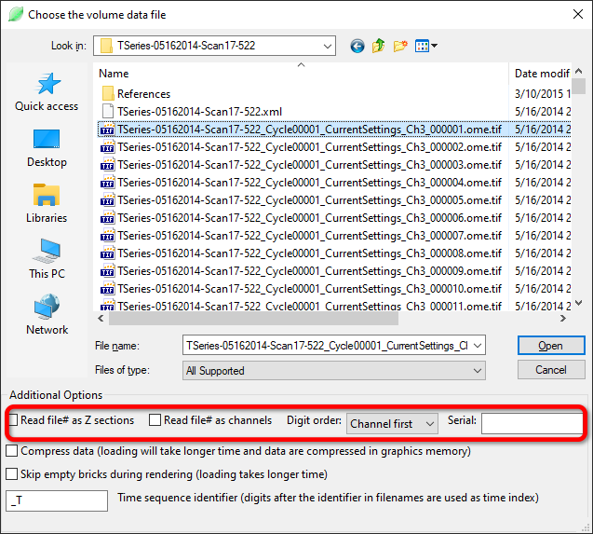

Figure 1‑1. Open Volume dialog.

The basic assumption for FluoRender to interpret the file names in a sequence is that the names have mostly common parts with only varying digits as indices to identify their locations in a multichannel stack. To open a stack, only select one file in the sequence and set the settings for file name analysis. FluoRender will separate name of the selected file into sections of characters and digits. Here are the rules for determining the organization of an image sequence.

* Check Read file# as Z sections if the sequence contains sections for a stack.
* Check Read file# as channels if the sequence contains multiple channels stored in individual images.
* When both Z section and channel reading are enabled, FluoRender needs to know which index goes first in the file name. Choose Channel first if the indices for channels are placed before those for Z sections, and vice versa.

In the example in Figure 1‑1, channel indices (digits after Ch) are placed before the Z section indices (000001, etc.). Therefore, Channel first needs to be selected to read the stack correctly.

## Loading a Time-Dependent Sequence

The interpretation of indices for a time sequence is handled similarly to channels and Z sections. It needs an precedent identifier for time indices, and the setting can be found in the additional options as well (Figure 1‑2).



Figure 1‑2. Open Volume dialog, options for time sequences.

Make sure the identifier is unique in the file name. By default, FluoRender uses “_T” as the time sequence identifier.

# Visualizing Multichannel Data

|  |  |
| --- | --- |
|  | **On YouTube:**  [**https://youtu.be/pUDPZiFGk9E**](https://youtu.be/pUDPZiFGk9E)  **Or search:**  **FluoRender Tutorials Visualizing Multichannel Data** |

Most fluorescence microscopy scans contain three or more channels from various fluorescence labels and laser wavelengths. When you choose multiple files at loading without setting up additional options for channel, section, or timepoint arrangement, the files are treated as separate channels. Additionally, you can append channels to those already loaded in FluoRender by opening more files or using the data processing and analysis tools to generate new channels.

## Channel Colors

When you load a native microscopy format containing laser wavelength information, the colors of multiple channels are determined by their wavelengths. You can configure how laser wavelengths are mapped to channel colors in FluoRender’s Configuration window (Figure 2‑1).

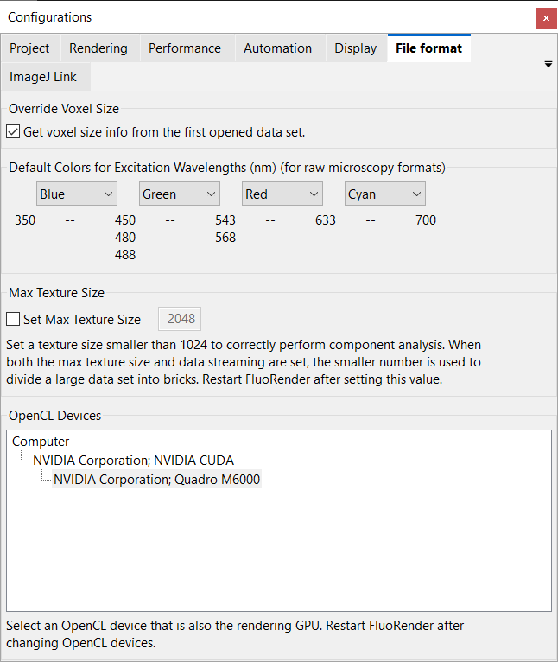

Figure ‑. File-format settings.

If no wavelength information is available, the first four channels loaded into FluoRender have fixed colors: red, green, blue, and white. If more channels are loaded, a randomly selected color is applied. You can randomize the colors of one or multiple channels in the Workspace panel (Figure 2‑2). Right click on a group or a channel and choose Randomize colors from the menu. Alternatively, you can hold the Ctrl key and double click on a group or a channel to randomize colors.

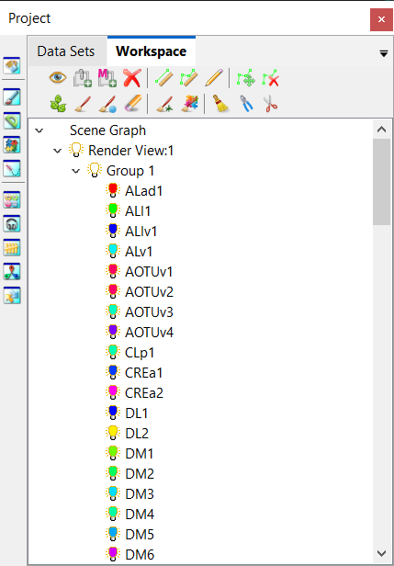

Figure ‑. Workspace panel.

## Channel Intermixing Modes

FluoRender provides three channel intermixing modes to best visualize features from different channels in an interactive setting. To switch among the channel intermixing modes, use buttons in the top toolbar of the render view.

**Layered** . Channels are rendered individually and then layered one on top of another. Top channels in the workspace are also rendered on top. Changing the order of channels in the workspace will affect the visualization result. Layered mode is good for un-occluded visualization of features from top channels.



Figure 2‑3. Layered channel intermixing mode.

**Depth** . Channels are intermixed with correct spatial occlusion. Depth mode is good for inspecting spatial relationships between channels.



Figure 2‑4. Depth channel intermixing mode.

**Composite** . Channels are rendered individually and then their colors are summed up. Composite mode is good for visualizing otherwise occluded features of colocalized structures.



Figure 2‑5. Composite channel intermixing mode.

## Depth Attenuation

Use “Depth Attenuation” to darken structures that are farther from the viewer in 3D space, so that spatial relationship may become more obvious. Turn on depth attenuation by clicking its icon . Adjust the slider below to change its intensity.



Figure 2‑6. Increase depth attenuation value to darken deep structures.

## Channel Selection

Most operations in FluoRender are applied to a currently selected channel. There are multiple methods to select a channel:

* Click the channel from the Workspace panel.
* Click the channel from the Data set panel.
* Click the channel in the Render View.
* A newly generated channel from analysis tools is automatically selected.

When a channel is selected, its properties are shown (Figure 2‑7). Make sure the selected channel is desired before making further changes to its properties or applying analysis functions.

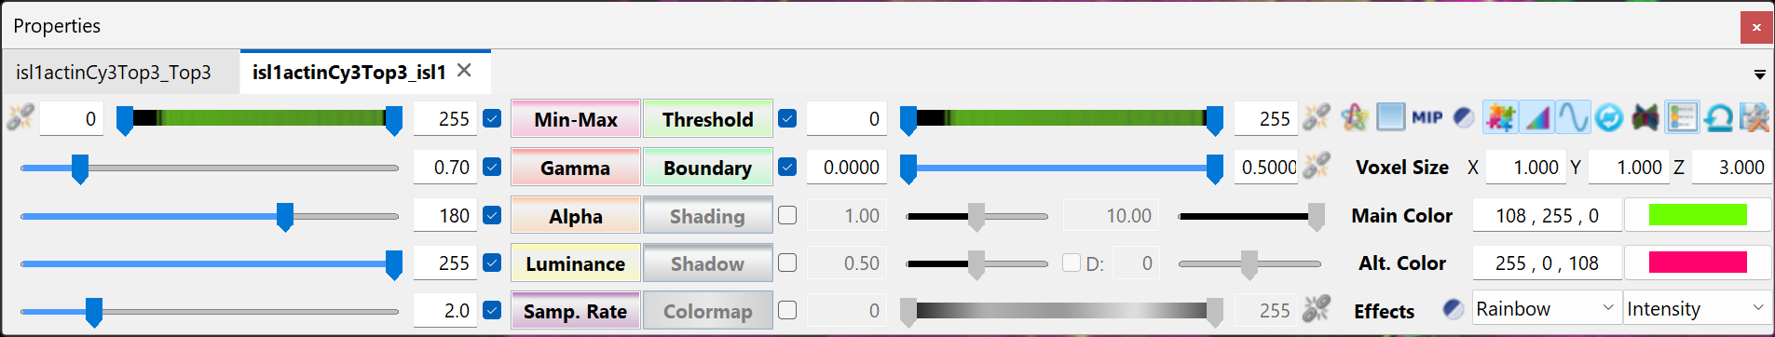

Figure 2‑7. Volume properties.

# Volume Properties

FluoRender provides a plethora of settings to adjust the visualization of multichannel volumes for either enhancing clarity or achieving artistic effects. Settings that determine how the raw intensity values are mapped to colors and transparency for volume rendering and intermixing are in the Volume Property panel (Figure 3‑1).

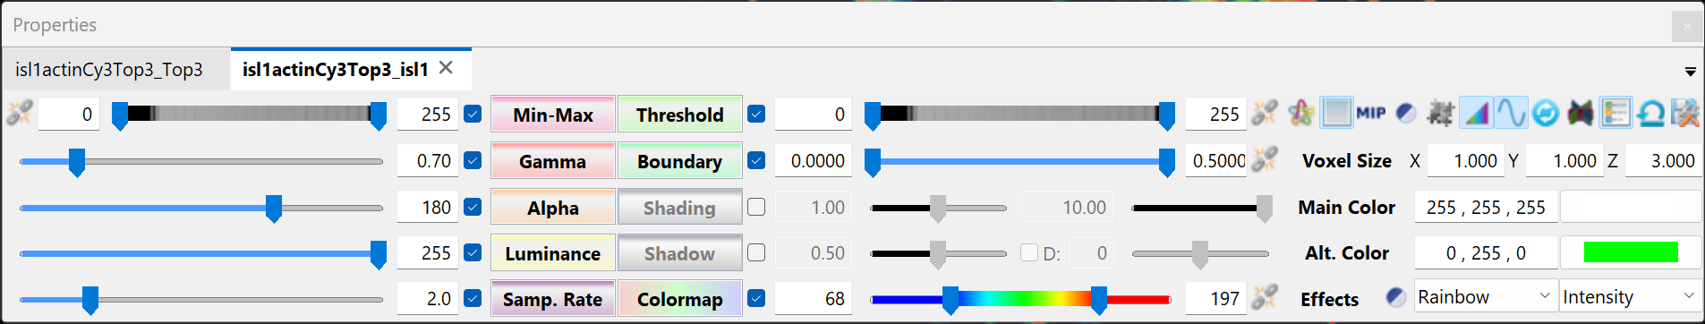

Figure 3‑1. Volume properties.

The properties of multiple volumes are organized in tabs on the Property panel. You can quickly switch to the properties of a different channel using the tabs. However, notice that the selected channel is not switched automatically when you switch tabs.

## Automatic Settings

FluoRender can generate settings based on the intensity distribution of a volume. Click Machine Learning  to generate the settings automatically. Users are encouraged to try this function first before adjusting the settings by themselves.

## Intensity Distribution

The sliders for two top-most settings, Min-Max and Threshold, also display the intensity distribution of the volume. Use the distribution as a guide of how the low and high values from the original scan are located. Consider the display of the intensity distribution as a contrast-enhanced histogram, emphasizing local intensity variations like in a spectrum.

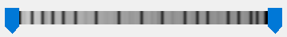

Figure 3‑2. Intensity distribution shown on a slider.

## Parameters

The numeric parameters with slider adjustments generally modify how the original intensity values are scaled. Each parameter can be enabled or disabled using the check box. When a parameter is disabled, it does not affect how the original intensity maps for volume rendering. The buttons for the names of the settings are multi-functional. By default, their function is value adjustment by scrolling the mouse wheel. You can click the name button of a parameter, move the mouse cursor into the render view, and then scroll the mouse wheel to adjust the setting. You can have focused attention to the visualization results by using this method.

**Min-Max.** It sets a range of intensity values mapped to the minimum and maximum output intensities. All intensity values out of the range are clipped. This value is automatically adjusted to match the intensity range of the data when the bit depth is greater than 8. The slider of the Min-Max adjustment shows the intensity distribution of the volume, which is a contrast-enhanced version of the histogram of the data. The computation of the histogram and subsequent intensity distribution display may be disabled for large data.

**Gamma.** It adjusts a nonlinear intensity and transparency mapping of the channel values, using a “Gamma curve”: $V_{out}=V_{in}^{γ}$. Increasing the Gamma value maps original intensity values to brighter colors; decreasing the Gamma darkens them. Notice that transparency mapping is also influenced by the Gamma value. Therefore, setting a high Gamma value also makes rendering noisier. Or it accentuates the low-intensity values from the original volume, which usually makes the rendering (an integration calculation) darker. Considering such characteristics of Gamma, the direction of the slider is reversed by design.

**Alpha.** A multiplier to transparency mapping. Decreasing this value makes rendering more transparent. Alpha setting can be disabled. When disabled, volume transparency mapping is disabled. All voxels become opaque. It is useful when a thin layer of volume is visualized. For example, the image sections in **Error! Reference source not found.** have Alpha disabled.

**Luminance.** It changes the luminance of the primary color assigned to the volume. This setting is linked to the primary color setting. An HSV color model is used for luminance calculation.

**Threshold.** It sets two thresholding values (low and high). Voxels of intensity values within the range of setting are rendered. Use this setting to exclude noisy signals. When the low and high values are linked by clicking the link button, the distance between the two values will be maintained when dragging the thumbs on the slider. An intensity distribution similar to the Min-Max settings is displayed on the slider. The distribution can be used as a guide for excluding certain intensity values. Use a narrow range for the linked low and high values to explore how the intensity distribution corresponds to different regions of a volume.

**Boundary.** The low boundary value sets a threshold to exclude regions with low gradient magnitude, which are homogeneous structures that are less likely to belong to the boundaries. The high boundary values is a factor to enhance regions with high gradient magnitude, which are boundary structures.

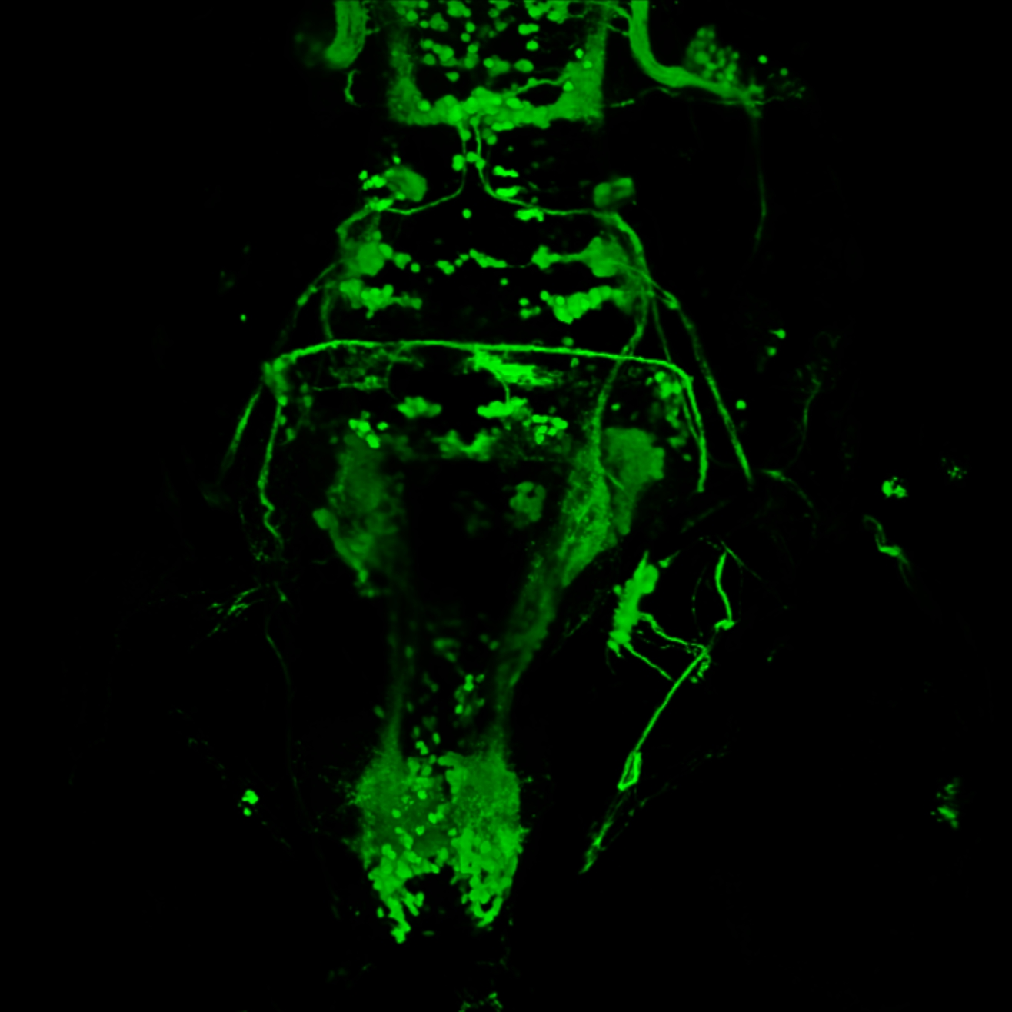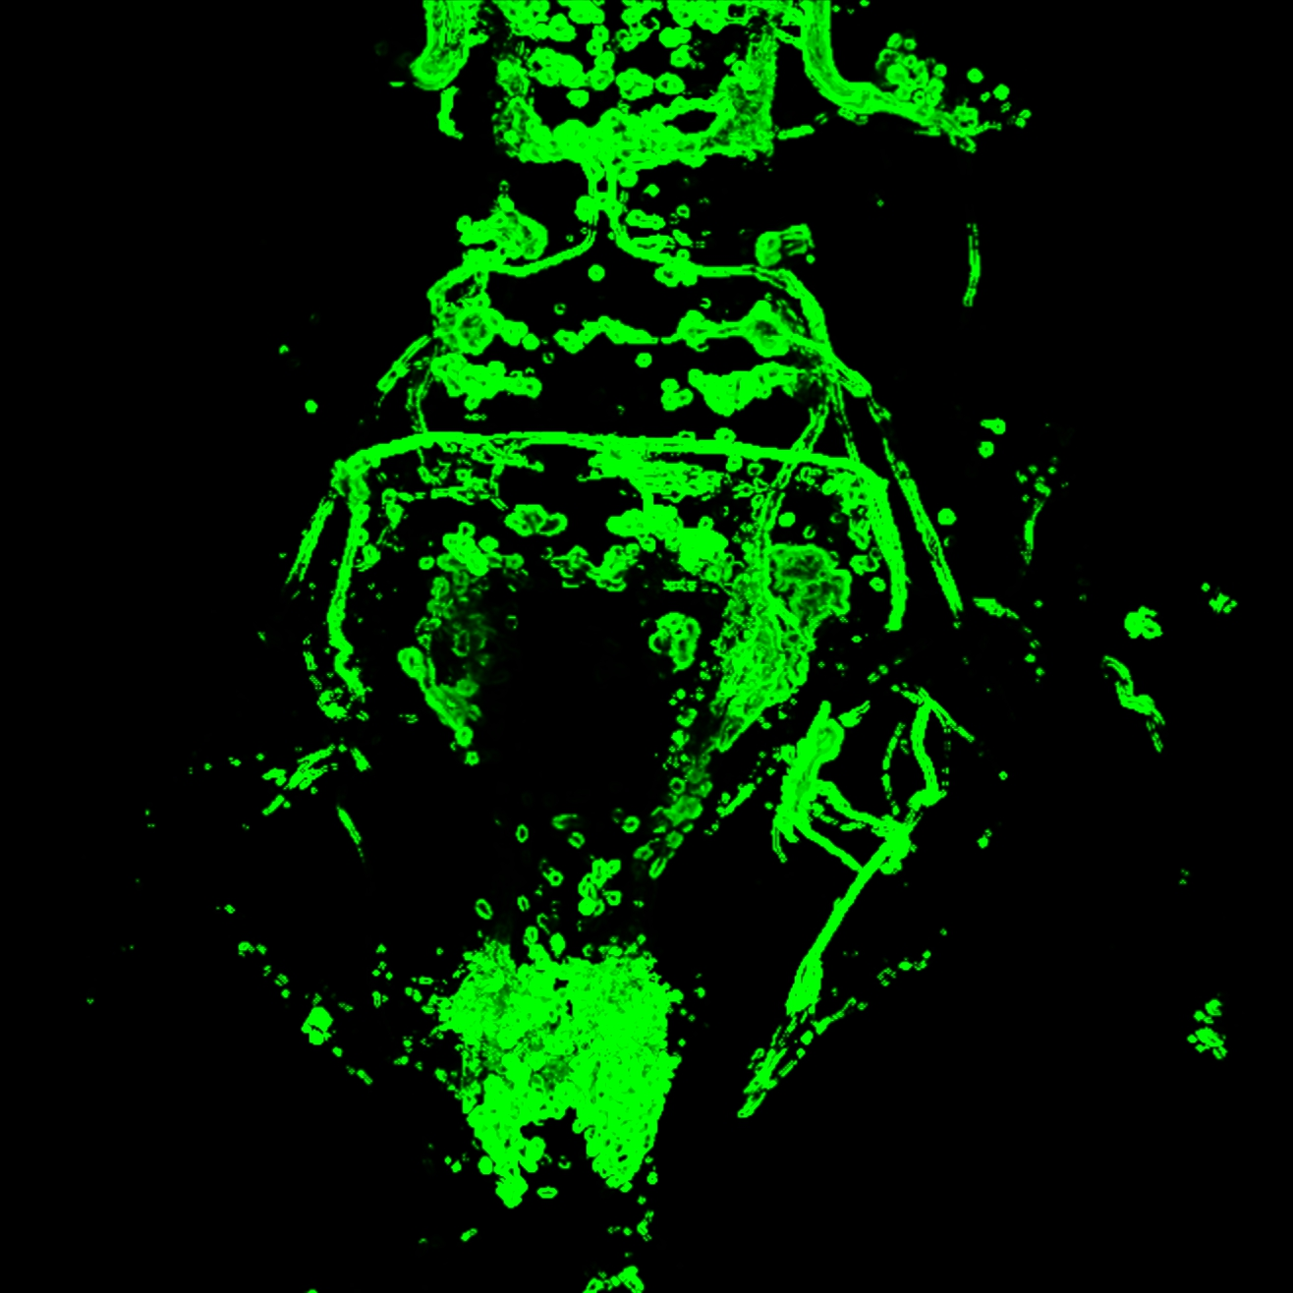

Figure 3‑3. Before and after boundary enhancement.

## Volume Colors

Use the color pickers to set the color of a volume.

**Main color**. It is the base color of a selected volume channel. Use different colors to distinguish multiple channels.

**Alt. color.** It is the color to highlight selected structures within a volume. By default, the highlight color is calculated as the inverse of the primary color and changes with it. Once you choose a secondary color, it is fixed to your choice.

To change the colors quickly, double click on the numeric values of a color and type a letter from the alphabet. For example, the letter R is for red, G for green, and B for blue.

## Color Maps

FluoRender provides a series of color maps to map the original intensity values of a volume to colors. Note that there are two aspects when a color map is applied to a volume.

**Spectrum.** This is the first setting for a color map. It determines the spectrum of the output of color mapping. Examples of the color map mode include Rainbow, Hot, Cool, and Diverging. Each color map can be reverted by the invert button . When a color map is selected, the color map function is automatically enabled. The spectrum for the selected color map is shown on the slider to adjust its range.

**Projection.** This is the second setting for a color map. It determines what values from the original volume are mapped to colors. By default, the intensities values of a volume are mapped to colors. But you can choose other values, such as XYZ coordinates, gradient magnitudes, or normals. For a time sequence, you can also map timepoint, intensity delta, or speed to colors. The ability to change the projection of color maps allows fast semi-quantitative analysis.

## High Transparency

FluoRender provides a high-transparency mode for large scans containing obscure structures embedded deep inside. The high-transparency mode can work in tandem with color maps to enhance the visualizations of deep structures. You can enable the high-transparency mode using methods as follows.

* Click the **High Transparency**  button to enable the effect directly. It changes the transparency nonlinearly to make low intensity values more transparent.
* Select a High Transparency color map.
  + **High-key.** It is designed to be used with a low luminance main color and a bright background to enhance the contrast and detail examination.
  + **Low-key.** It presents an effect like negatives when used together with a dark background and a high luminance main color.
  + **Hi-transparency.** It is designed for viewing deep structures in large scans.

Below are results from different color map settings.

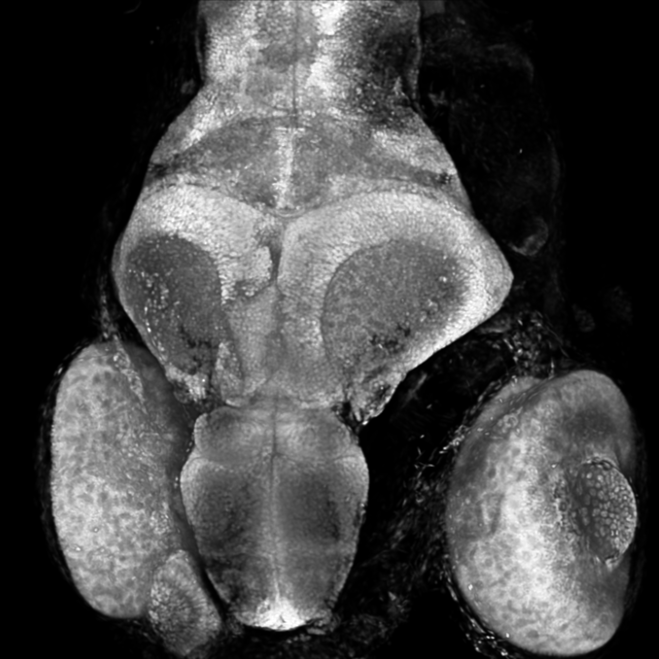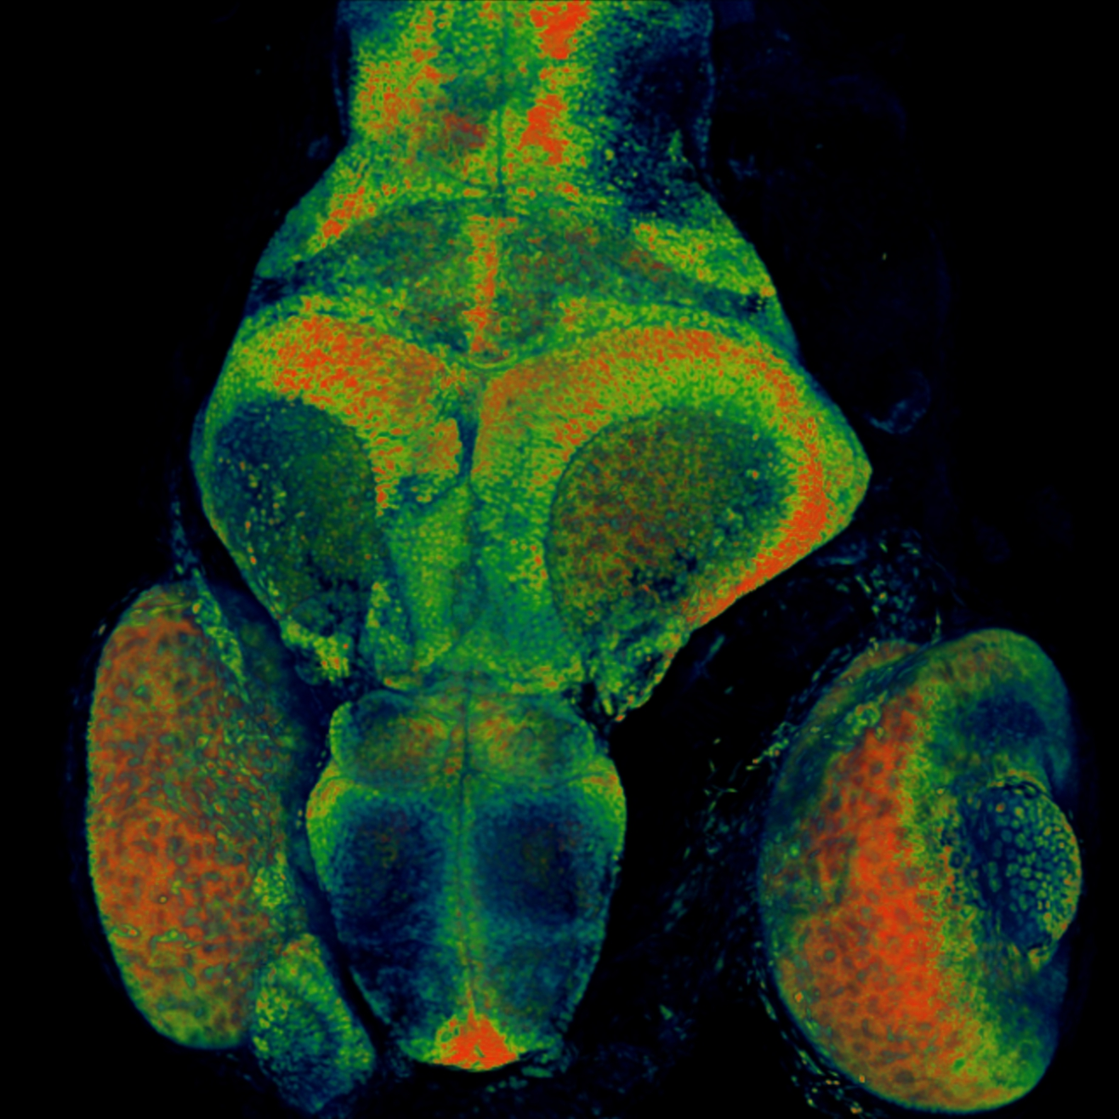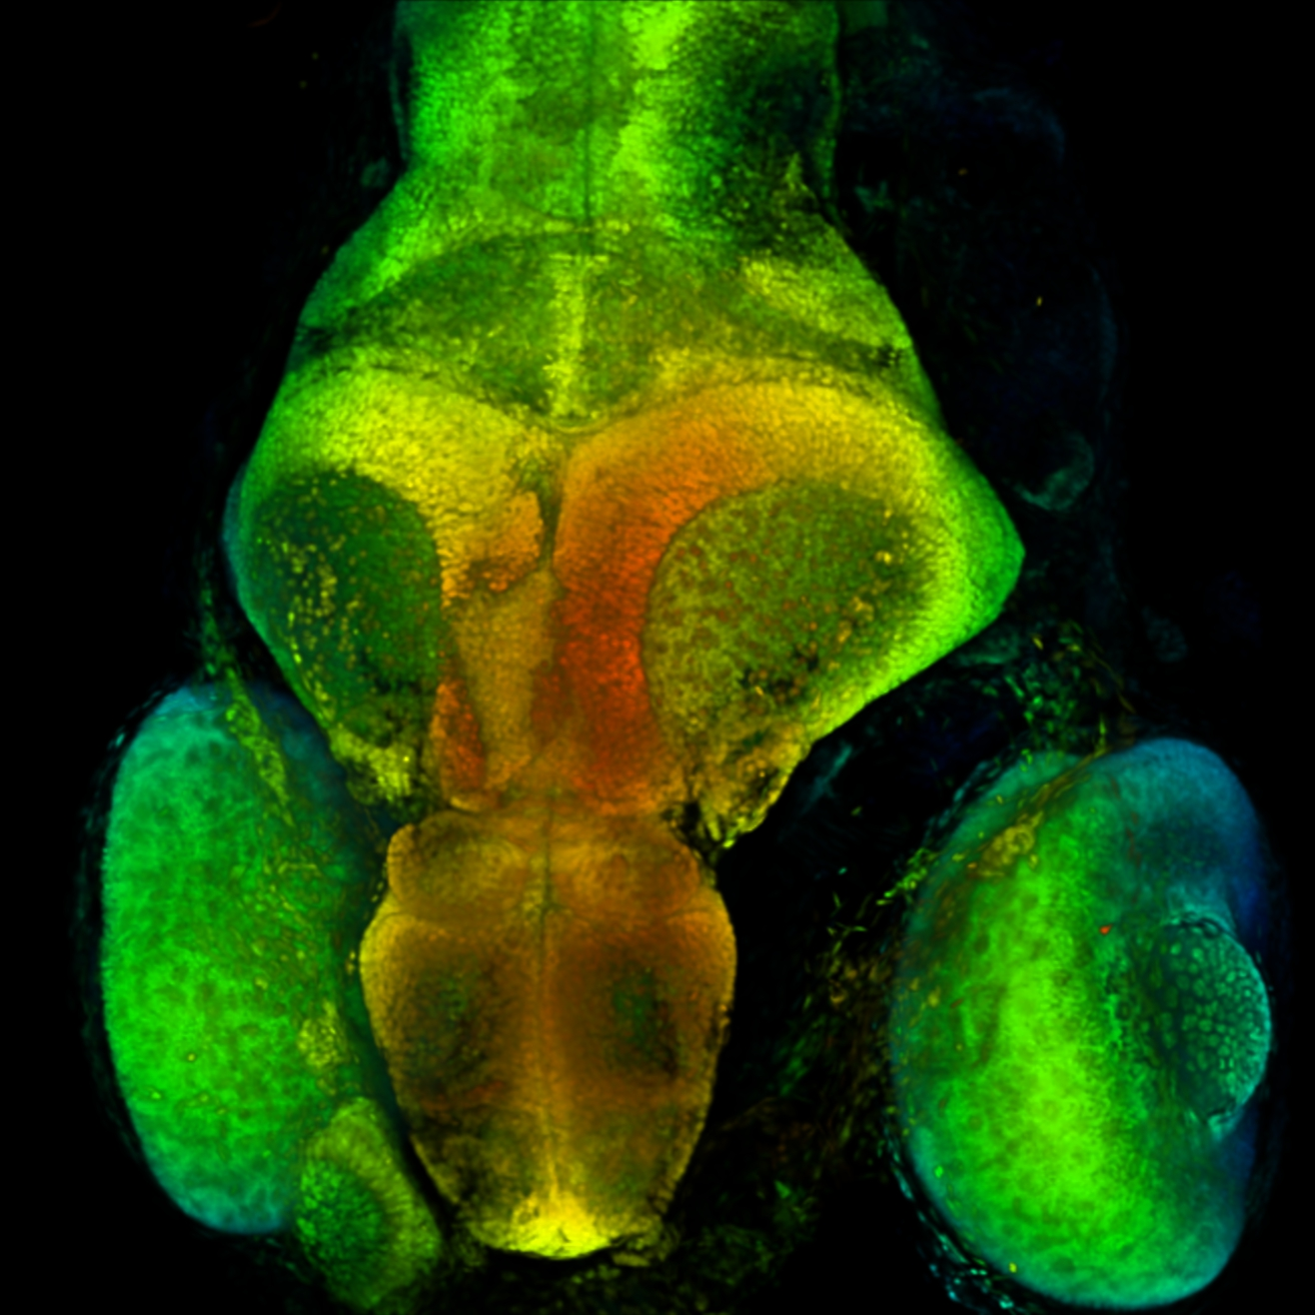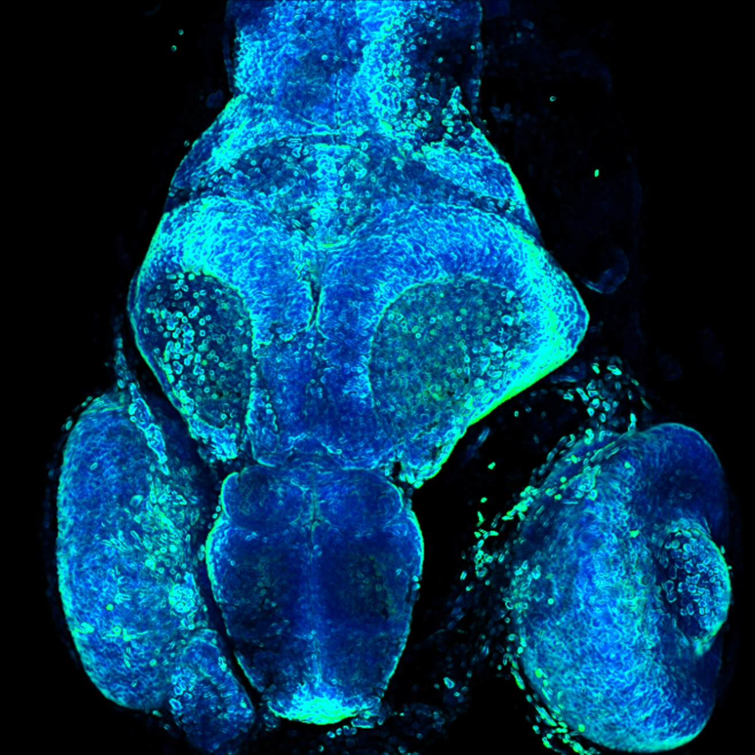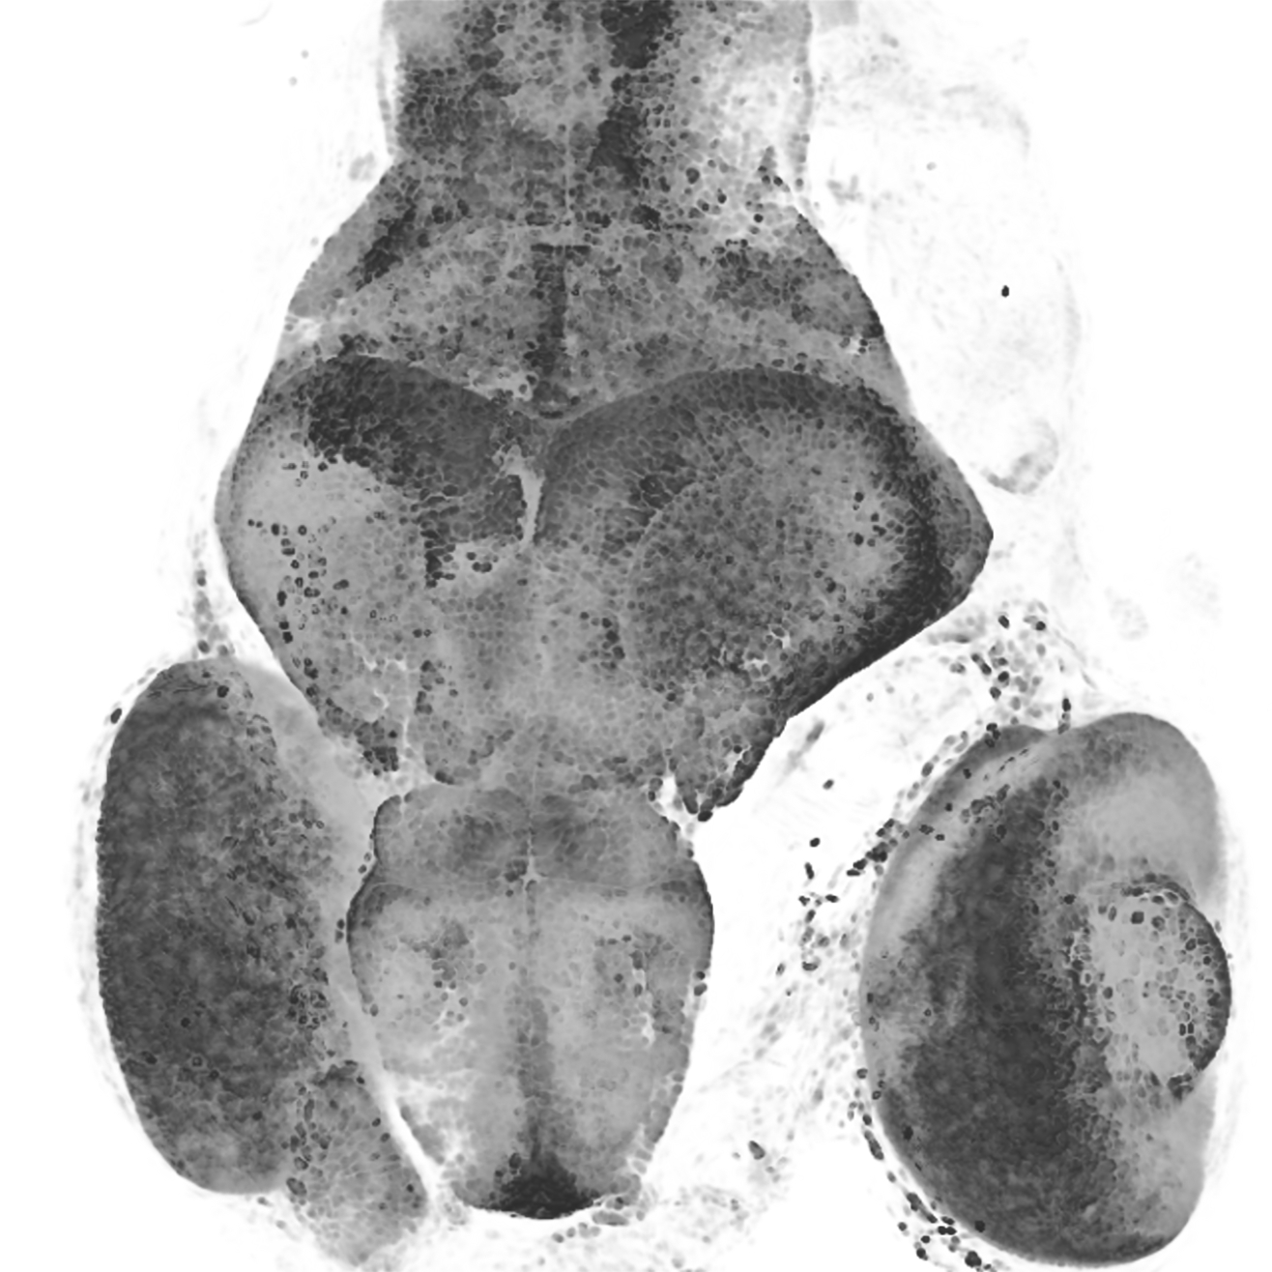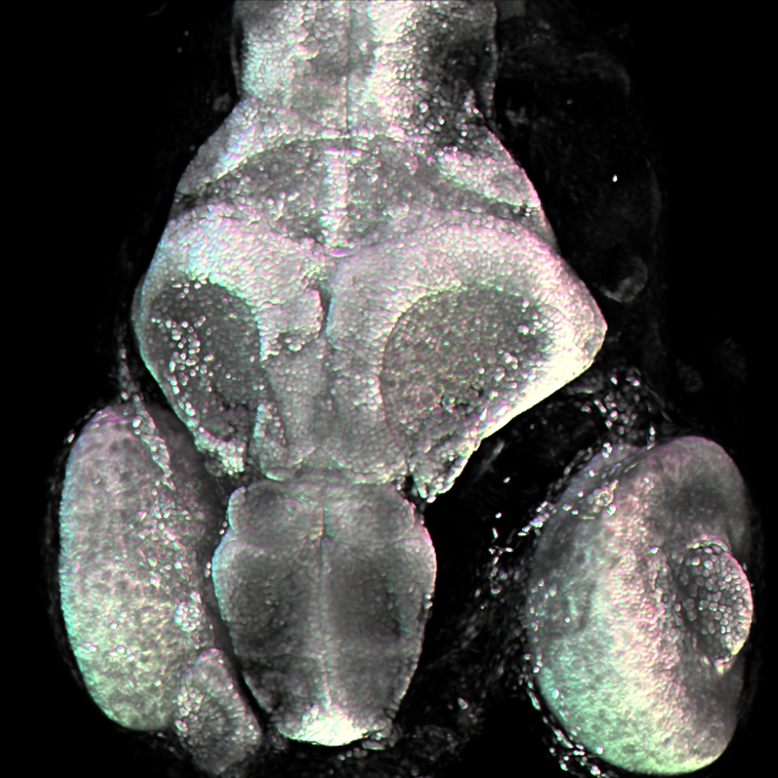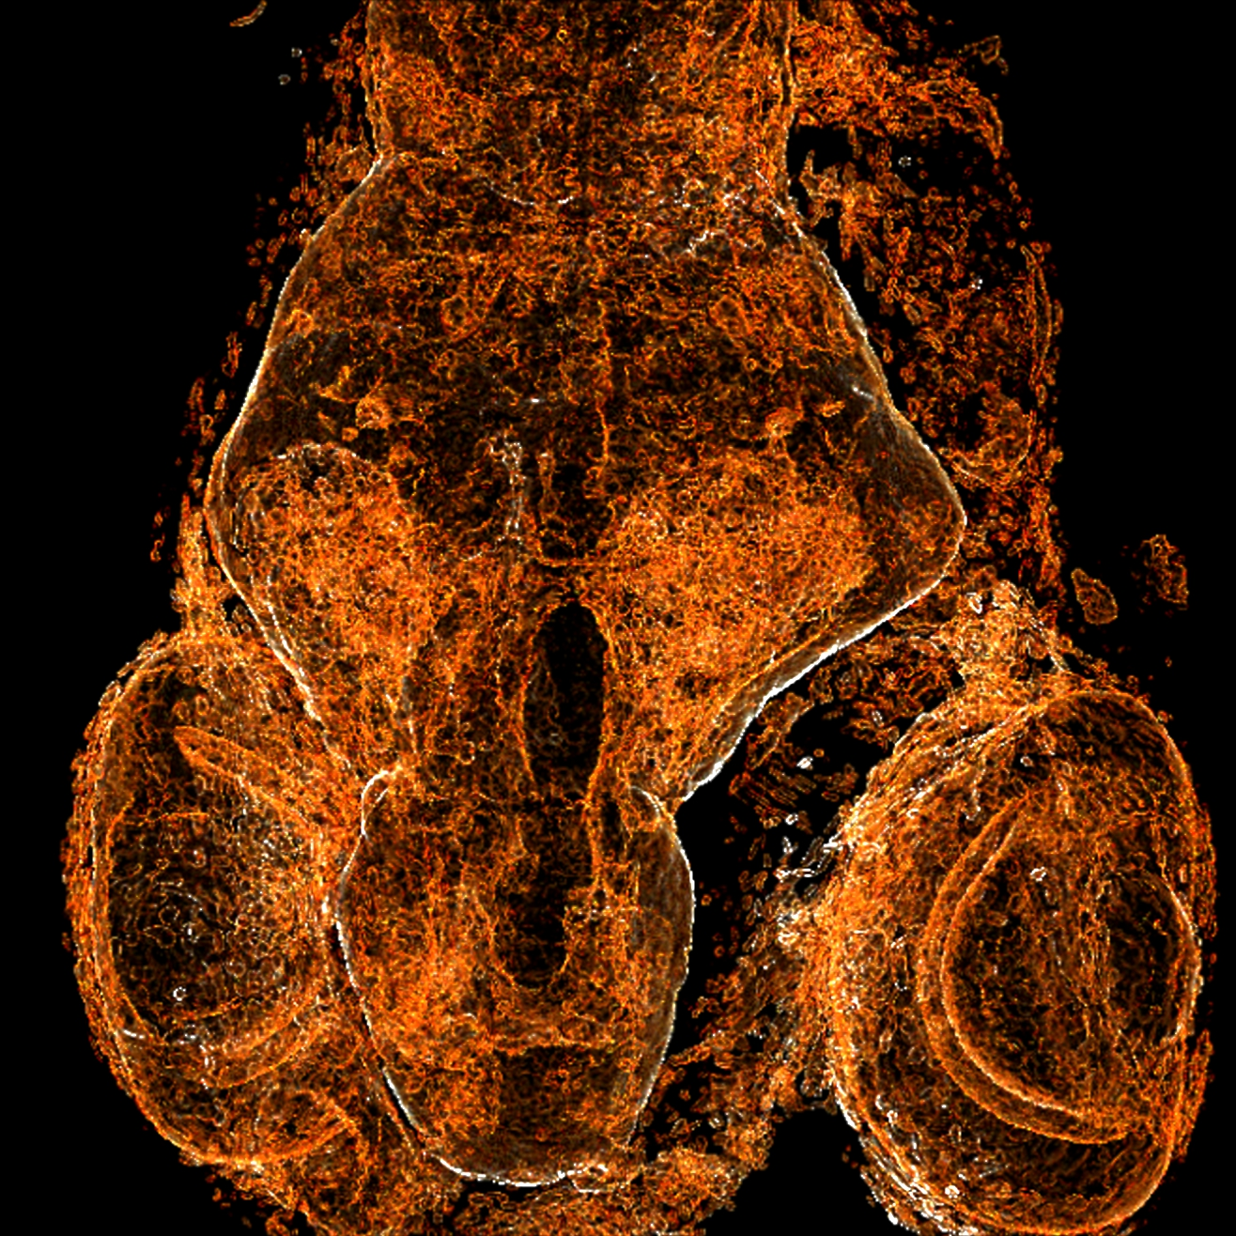

Figure 3‑4. Color map results. From first to last: Default settings, Intensity values mapped to rainbow, Z coordinates mapped to rainbow, Gradient magnitude values mapped to rainbow, Low-key color map with white background, Normals mapped to rainbow, and High transparency color map.

## Interpolation and Filtering

FluoRender provides interpolation and filtering functions to preserve details and suppress artifacts at various magnification levels.

 **Interpolation.** When enabled, it uses trilinear interpolation for smooth rendering results. Otherwise, the nearest neighbor interpolation is used. Disable linear interpolation for a pixel-perfect result to examine the intensity values of the raw data.

/ **Filter.** When enabled, a Lanczos-Bicubic filter is applied to rendered images to suppress high-frequency noise. Systems equipped with older or legacy GPUs may experience significantly reduce performance when filtering is enabled. The filter window size changes with the zoom level. At high zoom ratios, the bicubic filter is dominant to remove high-frequency artifacts. This can be useful when settings such as boundary and MIP are applied. At low zoom ratios, the Lanczos filter is dominant to remove the moire effect. See the examples below.

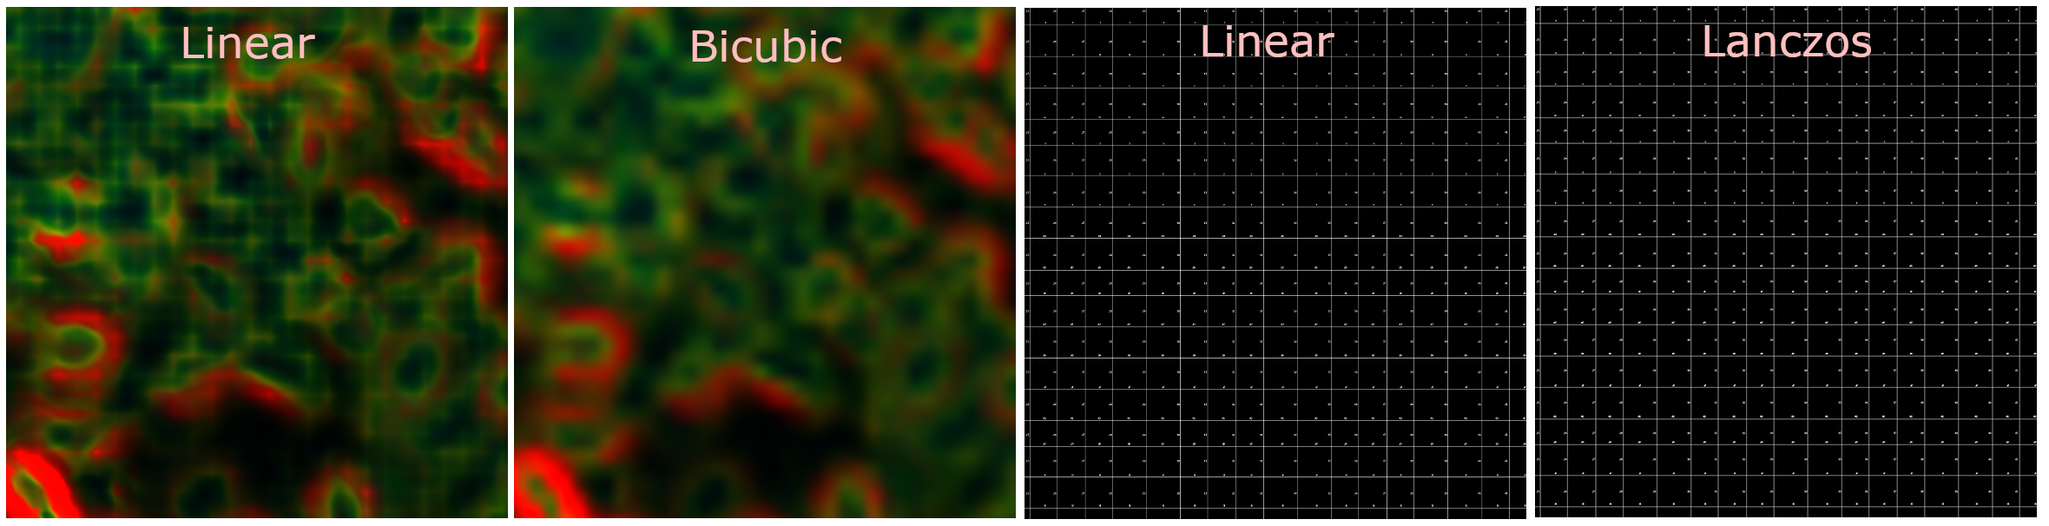

Figure 3‑5. Volume properties.

# Visualizing a Time Sequence

|  |  |
| --- | --- |
|  | **On YouTube:**  [**https://youtu.be/YjPaqZVvV-w?t=36s**](https://youtu.be/YjPaqZVvV-w?t=36s)  **Start at 0:36, Part II Time Sequence**  **Or search:**  **FluoRender Tutorials Handling Different Data Formats** |

FluoRender supports the visualization of a time sequence. A time sequence is a series of scans over time, a volume at each time point. Most native microscopy formats support time sequence storage. Additionally, FluoRender can read a sequence of images or a video file.

## Playback Controls

The controls for playing back a time sequence can be found in the Movie Making panel.

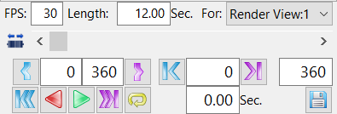

Figure 4‑1. Movie playback controls.

Most controls are indicated by commonly used symbols for media playback.

 **Play Backward and Forward.** Click the play backward button to play a movie clip continuously in reverse order. Click the play forward button to play a movie clip continuously.

 **Pause.** The playback buttons are shown as the pause button during movie playback. Click the pause button to pause the playback.

 **Rewind and Move to End.** Click the rewind button to set the current frame to the start of a movie clip. Click the move to end button to set the current frame to the end of a movie clip.

 **Step Playback.** Click the step playback button once to step forward or backward one frame of the movie clip. When the start or end of the clip is reached, it will wrap around to the other end of the clip.

Additionally, a clip can be set to play only a portion of the time sequence. For example, when a video capturing the movement of a mouse is loaded, the mouse is only visible in one part of the video. Use the clip function to set a range for playback.

 **Set Clip Range.** The buttons set the start and end frames of a movie clip. Use the time slider or step buttons to change the current frame. The start frame of a movie clip is set to the current frame when the clip start button is clicked. The same method is used for the end frame.

The playback of a time sequence can also be controlled by moving the slider. There are two modes for the slider: jog and normal. You can turn on the jog mode to play through the time frames quickly, like using the fast forward and backward functions on a physical media player.

## 4D Color Maps

FluoRender provides a series of 4D color maps to visualize crucial information from a time sequence.

**T.** It maps the timepoint value of a time sequence to color. Current time, or degree of development in an experiment, can be observed directly by colors.

**Intensity delta.** It calculates the difference of intensity values between two timepoints at each voxel and then maps the difference to colors. Regions or structures where intensity changes can be observed easily.

**Speed.** It calculates the speed of each voxel using the optical flow formula and then maps the speed value to colors. Regions or structures that move at different speeds can be observed easily.

You can change the range of the color map using the sliders. The range of color maps can also be recorded as keyframes in an animation movie.

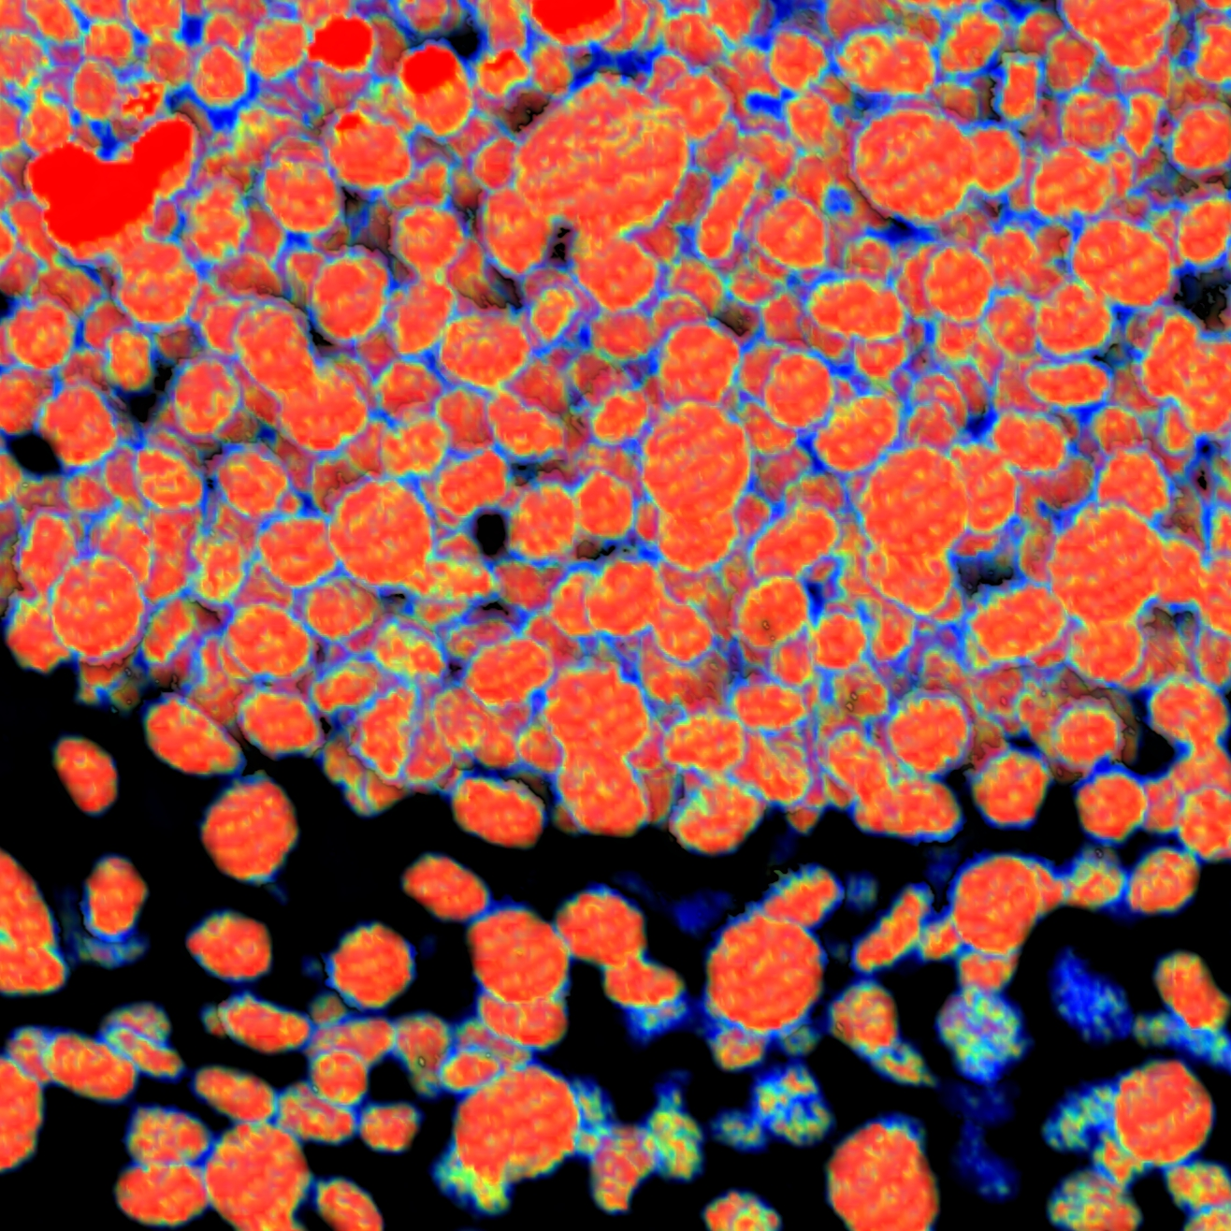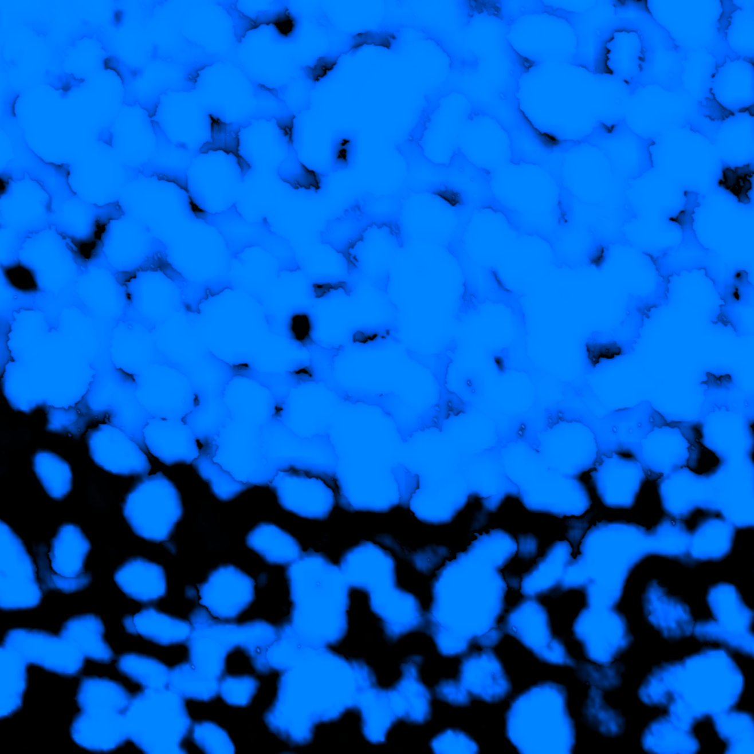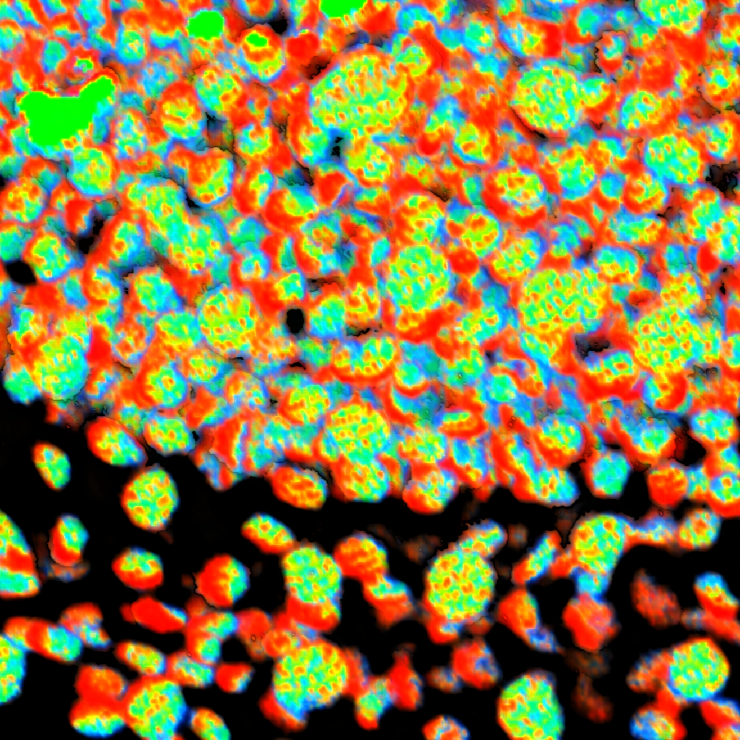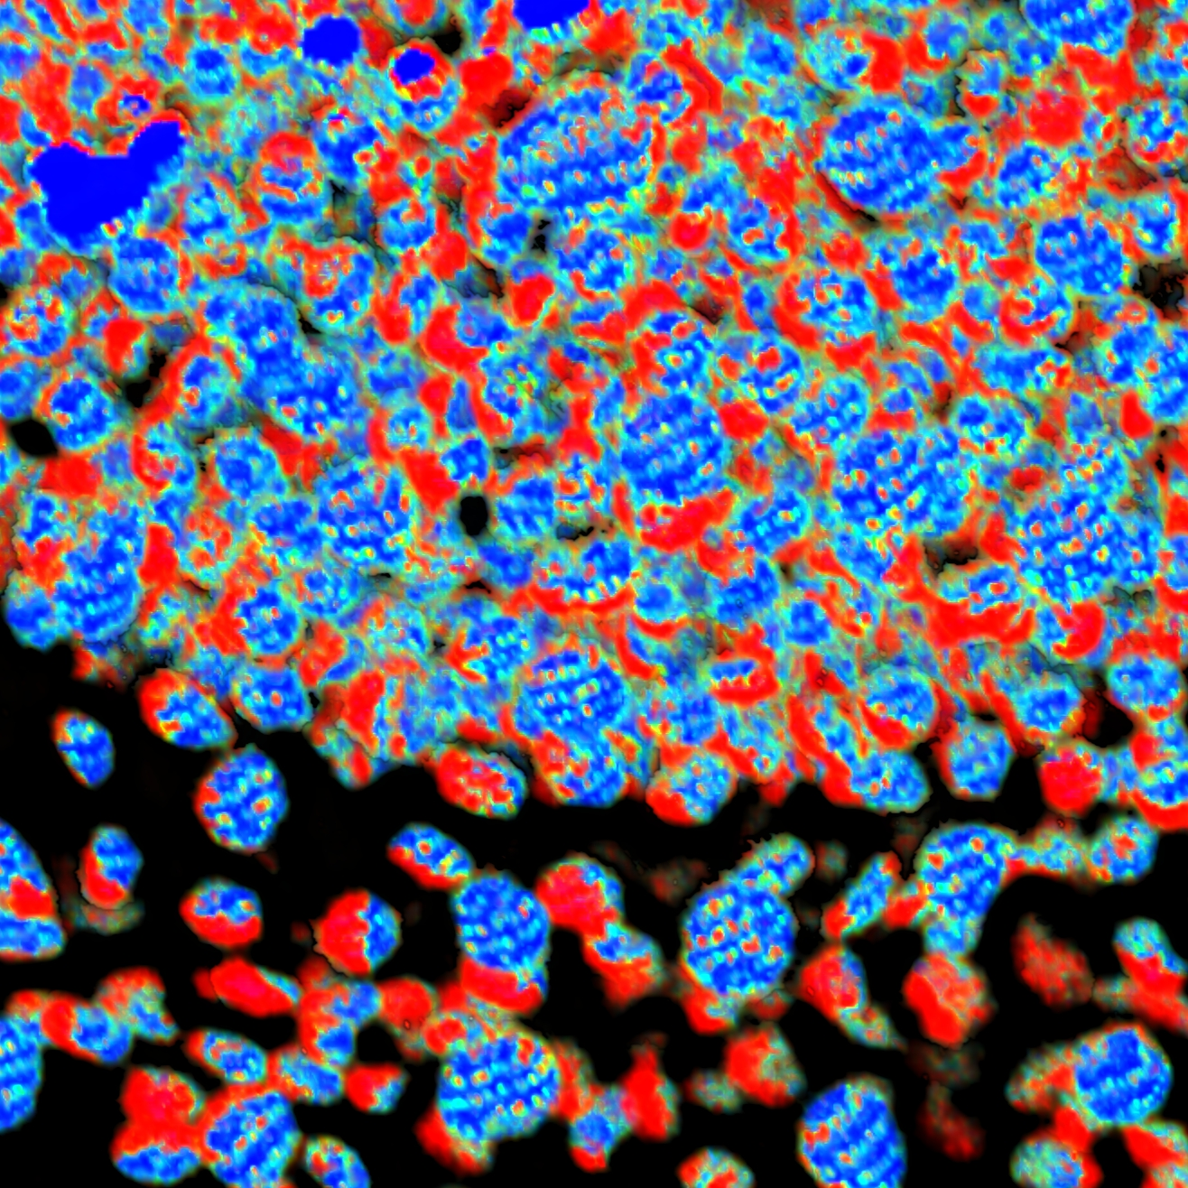

Figure 4‑2. 4D color map results. From left to right: Intensity values mapped to rainbow, Time value mapped to rainbow, Intensity delta mapped to rainbow, and Speed mapped to rainbow.

# Rendering Holograms

FluoRender supports holographic displays from the Looking Glass Factory. A series of display models can be purchased from the Looking Glass Factory’s website. A holographic display is capable of showing depth information as well as spatial relationships between biological structures without the aid of shutter glasses or VR headsets. Visualizing 3D microscopy scans on a holographic display significantly boosts research workflow efficiency when a large amount of 3D need examination. Following these steps to enable holographic volume rendering in FluoRender.

## Install Bridge

Go to the Looking Glass Factory’s website and download the Bridge software for the operating system (OS): <https://lookingglassfactory.com/software/looking-glass-bridge>. The Bridge software can be installed by double-clicking the downloaded installer.

Connect a Looking Glass display to the computer. A Looking Glass display may use different display interfaces and power methods. For example, the portable display, Looking Glass Go, only uses a USB-C cable for both video signal and power. You will need a computer supporting video signal output through USB-C to connect it. After connecting to a Looking Glass Display, make sure it is detected by the Bridge software. Right click the Bridge icon in the system tray and check if the display is listed. Sometimes the display may not work properly because it is mirroring the primary display, or it has a magnification greater than 100%. You need to make sure the Looking Glass display is in the “extension” mode and the magnification is 100%.

## Enable Holography

Click the button Enable Holography  to render a 3D scene as a hologram and display it on the connected Looking Glass display. The function can be found on the top toolbar of the Render View.

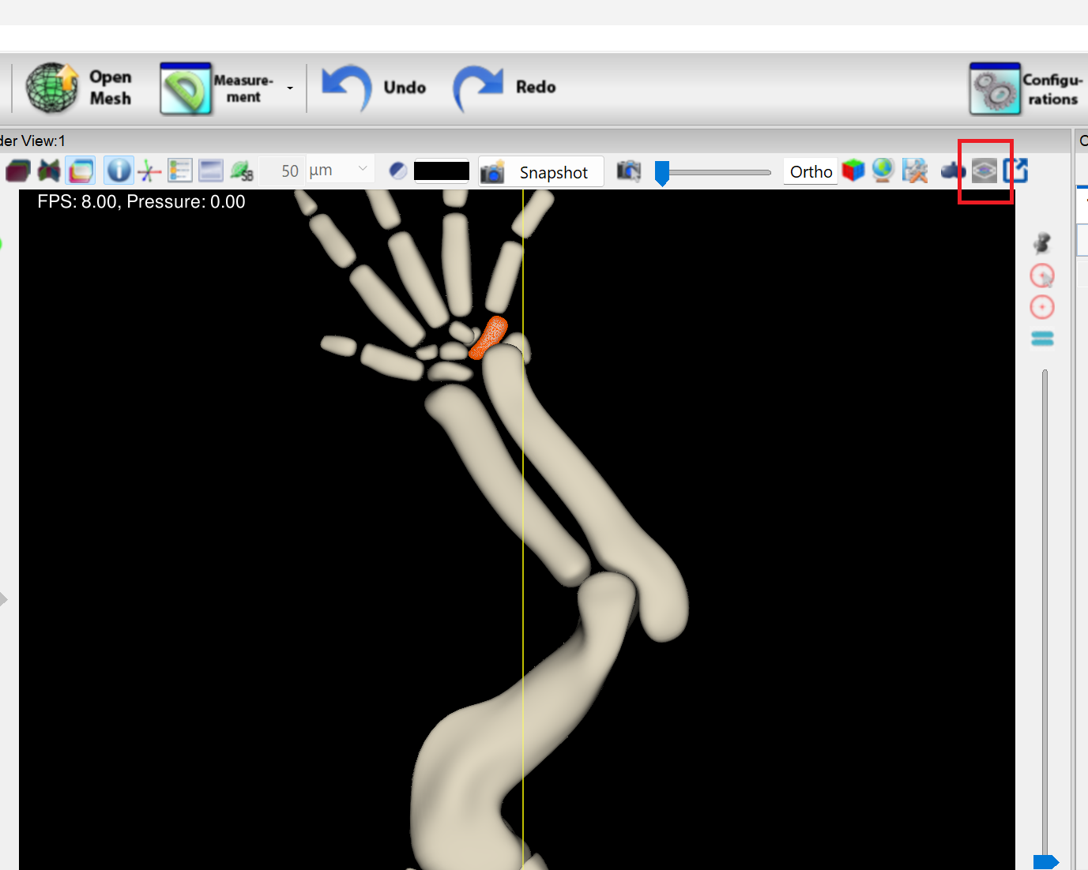

Figure 5‑1. Enable holography.

Most FluoRender visualization functions can be used with the Looking Glass display, including render view camera operations and volume property adjustments.

## Focusing

Structures at different depths can present a depth-of-field effect when visualized on a Looking Glass display. You can focus on a specific point in 3D so that structures at the focus plane are sharp and clear. Use the Choose Center  button to focus on a point clicked by mouse in the Render view.

## Holography Settings

Settings for the Looking Glass display can be found in the Display tab of the Configuration window. In addition to turning holography functions on and off, these settings also make detailed adjustments to the visualization results on the Looking Glass display.

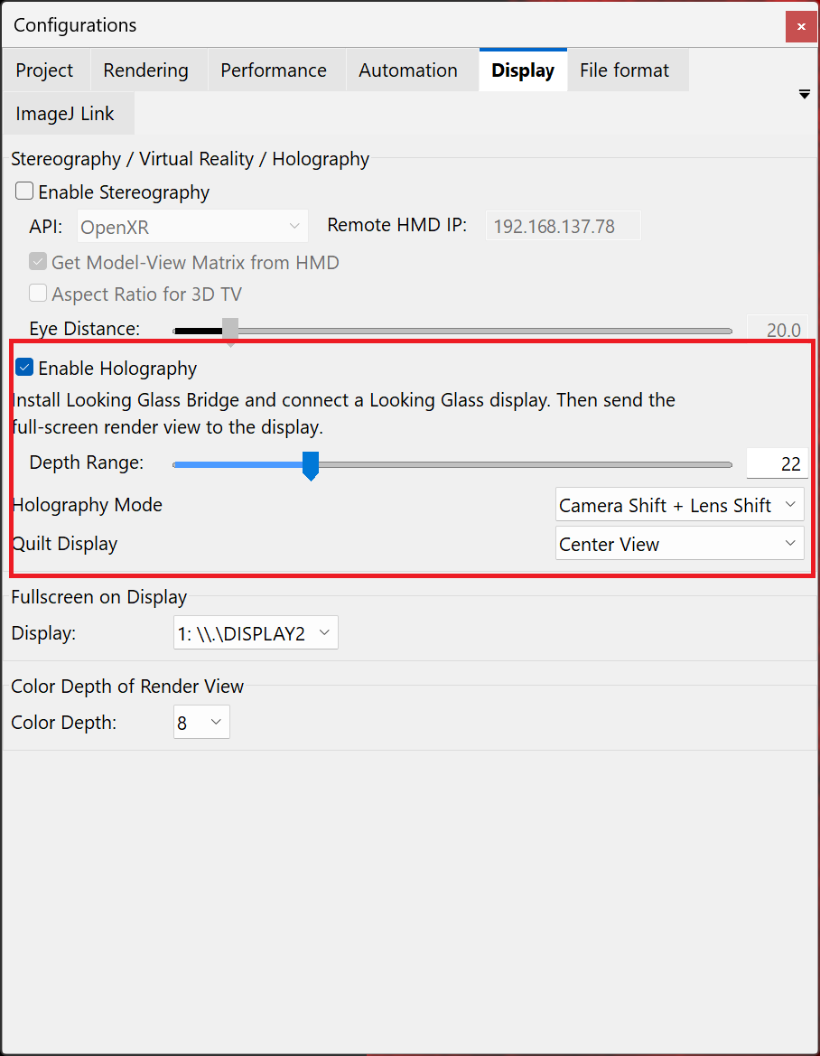

Figure 5‑2. Holography settings.

**Enable Holography.** It provides the same function to enable or disable holography as the button on the Render View toolbar.

**Depth Range.** A holographic display shows the renderings of a 3D object from multiple perspectives by moving camera or lens. This value determines the maximum movement of the camera or lens. When it is set to 0, the 3D effect of the hologram diminishes to be similar to a 2D rendering.

**Holography Mode.** A hologram for the Looking Glass display is generated by rendering a scene from different viewing perspectives. The holography mode sets how the camera and lens are moved to generate the perspectives.

* **Camera Shift + Lens Shift.** The camera moves in a straight line. The lens shifts to center the view on the data.
* **Camera Shift + Swing.** The camera moves in a straight line. The camera and lens rotate together around its own center to center the view on the data.
* **Object Rotation.** The camera is static while the object rotates around its own center.

**Quilt Display.** A Looking Glass display can show 3D renderings as a hologram, but the main display is 2D only. The FluoRender view can display the hologram as just one perspective or as a tiled pattern of multiple perspectives.

* **Center View.** Render view shows the perspective that the camera is looking at the data without shift.
* **First View.** Render view shows the perspective that the camera is looking at the data with maximum shift to one side.
* **Last View.** Render view shows the perspective that the camera is looking at the data with maximum shift to the other side.
* **All Views.** Render view shows a tiled pattern of all views comprising the hologram.

# Visualizing Mesh Objects

Mesh objects can be visualized along with volume channels. It is possible to make detailed anatomical atlases comprising both volumes and mesh objects.

1. Prepare data. Only the Wavefront OBJ format is currently supported. The OBJ format is a text file containing geometry information. In addition to the basic feature set of the OBJ format, FluoRender can support materials and textures. Textures have to be saved in TGA format. An alpha channel can be saved with the TGA format to modulate transparency. FluoRender can be used to generate mesh objects from the selected structures of a volume channel. However, we recommend using mesh editing software packages for well-defined results. Here is an online tutorial on using Maya to build muscles from volume data: <http://www.cs.utah.edu/~wanyong/maya/>.



Figure 6‑1. An example of a mesh-based atlas built with FluoRender and other tools.

2. To load mesh objects, click “Open Mesh”  in the main toolbar. In the file browser dialog, choose one or multiple mesh files and load them. The loaded mesh files should be visualized in the render view.

3. The same render view interactions for volume channels apply similarly to visualizing mesh objects. You can rotate, zoom, and pan the view. Additionally, you can click and select a mesh object directly from the render view.

4. The selected mesh object’s name is highlighted in the “Workspace” panel. Its look can be further customized through the settings in the “Property” panel.

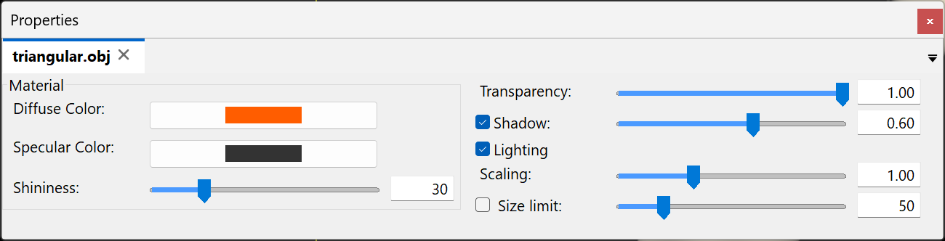

Figure 6‑2. Mesh properties.

**Diffuse color**. The base color of the mesh object.

**Specular color**. The color of the mesh object’s highlight.

**Shininess**. The size of the mesh object’s highlight.

**Transparency**. The overall transparency of the mesh object. Lower is more transparent.

**Shadow**. It applies a shadow effect on the mesh object. Its strength can be adjusted with the slider.

5. If any number of mesh objects are semi-transparent either by setting or texture, depth peeling is used to remove artifacts from random ordering. To adjust the quality of semi-transparent mesh objects, adjust the depth-peeling layers in the “Settings” dialog. To open the “Settings” dialog, click “Settings”  in the main toolbar. The depth peeling settings are under the second tab “Rendering”. Increase the number of peeling layers for better transparency quality.

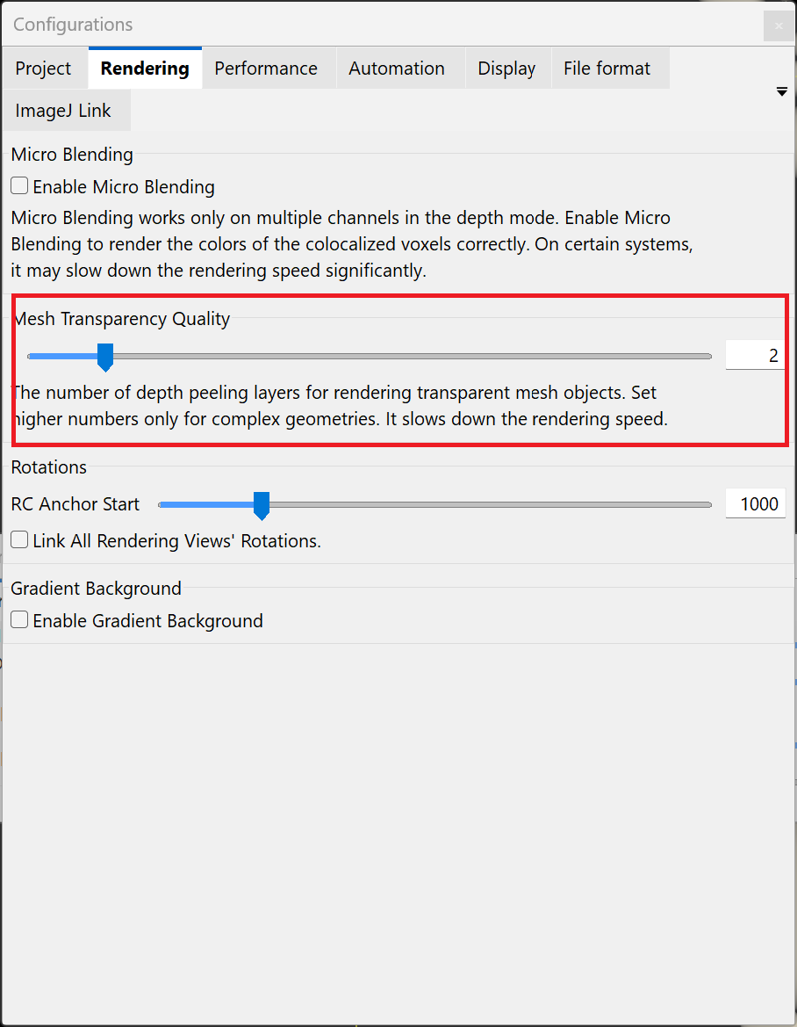

Figure 6‑3. Mesh transparency quality settings.

# Screen Capture and Movie Export

|  |  |
| --- | --- |
|  | **On YouTube:**  [**https://youtu.be/R43WkfValF0**](https://youtu.be/R43WkfValF0)  **Or search:**  **FluoRender Tutorials Capturing Render View and Movie Export** |

You can capture the rendering result in a render view port and save it as an image file. You can also export a movie for a series of renderings, including rotation, zooming, clipping plane movements, and time sequence.

1. To capture the rendering result in a render view port, click the button Capture. It prompts you to save the result as a TIF file.



Figure 7‑1. Capture a single image of the rendering viewport.

2. You can enable automatic cropping of the viewport. Go to the “Record/Export” panel, and then click the “Cropping” tab. Check “Cropping” to enable it. When enabled, the default cropping region is calculated to just include the currently selected volume channel. The cropped region is shown as a yellow-bordered box.



Figure 7‑2. Enable cropping.

3. You can also adjust the size and position of the cropping region with the numeric inputs in the cropping tab.

4. When the view is changed, you can reset the cropping region by clicking the reset button . It recalculates the cropping region to just include the currently selected volume channel.

5. To make simple rotation movies, click the “basic” tab of the “Record/Export” panel. Make sure only the “Rotation” option is checked. Then, choose an axis for the rotation. Notice that the Y axis is pointed up by default. So, rotation around the Y axis looks like a common “turntable” animation. Type in the number of degrees of the rotation. Notice that you can type in a negative number to make a rotation movie in the opposite direction.



Figure 7‑3. Rotation movie settings.

6. More complex movies can be recorded in the “Advanced” panel of the “Record/Export” panel. It is a recorder of keyframes. For each keyframe, you can change the viewing angle, channel visibility, and clipping planes. Then, you specify the number of frames between two consecutive keyframes. These frames, called in-betweens, are generated by interpolating changing parameters.



Figure 7‑4. The advanced panel is for recording keyframe animations.

7 To record a keyframe animation, first find the initial settings for the viewport. Click “Add” to add a keyframe to the keyframe list above. Notice that you can set the in-between number and the interpolation method beforehand, using the inputs to the left of the “Add” button. A recorded key frame is listed in the key frame list. You can still modify the number of in-betweens and interpolation methods after adding a keyframe. Notice that the in-between number denotes those before the currently selected keyframe. So the number for the first key frame will always be 0. Additionally, you can type descriptive text in the description box, to help you organize the keyframes.



Figure 7‑5. Settings for an added keyframe.

8. You can change the viewport by rotating, panning, and zooming, or change the clipping plane settings. Then, record another keyframe by clicking the “Add” button again. You can repeat this process until a complex animation is completely recorded. You can view the result of each keyframe by double-clicking it in the keyframe list.

|  |  |
| --- | --- |
|  | A rotation of more than 180 degrees may confuse the interpolation since it calculates the shortest distance between two keyframes. To make sure rotations are recorded correctly, use rotation angles less than 180. |

9. To play back the animation, you need the common controls in the “Record/Export” panel. First, make sure the intended render view is selected in the dropdown list after “Capture:” when multiple render views are used. Next, specify a playback speed by typing the FPS number. Notice that although you can type in a very large FPS number, it may not be able to achieve the speed. In this situation, it will render as fast as possible during playback. The FPS information is saved within a movie file if the QuickTime format is chosen. Then, click the playback button to preview the animation. Click it again to stop playing back. You can also rewind the animation or advance to any time of the animation using the slider and time input box.



Figure 7‑6. Common controls for movie playback and export.

10. If the preview shows a satisfactory result, you may want to save the result. The result can be saved as either a sequence of TIF images, which need an external tool to get assembled into final movie formats, or a single movie file in the QuickTime format. To save the movie result, click the “Save…” button. It brings the file save dialog. You can choose the format here. Once a format is decided, more detailed settings are available in the additional options region. For a TIF sequence, you can choose to save the images compressed. For a movie file, you can choose the bit rate of the movie. A higher bit rate means higher image quality, but also a larger file size. The estimated file size is updated according to the setting of the bit rate. Please use the estimated size only as a reference.



Figure 7‑7. Save movie dialog and its settings.

|  |  |
| --- | --- |
|  | Movie files are compressed in a way that many frames are processed together. In order for the movie coder to generate a correct result, a certain minimum number of frames is required. Make sure your movie length is long enough for successful output. |

# Measuring Position, Length, and Volume

|  |  |
| --- | --- |
|  | **On YouTube:**  [**https://youtu.be/WruONla-R3M**](https://youtu.be/WruONla-R3M)  **Or search:**  **FluoRender Tutorials Making Measurements** |

When volume channels are visualized with FluoRender, you can acquire several quantified measurements using interactive tools.

1. Prepare data. If your data set is in one of the supported microscopy formats, the size information is likely automatically retrieved from the metadata. You can turn on the scale bar in the render view to make sure the size of a loaded data set is correct. To turn on the scale bar, click “Scale bar”  in the top toolbar of the render view panel. Click it twice to enable the text for scale bar length and unit. If your data set is in an exchange format, such as TIFF, and does not contain size information, you can manually set the sample spacing, or voxel size, after loading. To set the sample spacing, click the name of a volume channel in the “Workspace” panel to load its properties into the “Property” panel. Then, set the spacing of X, Y, and Z to the correct numbers. The subsequent measurement operations use the spacing information to calculate physical size.

2. To get real-time information on the position under the mouse cursor, turn on “Information”  in the top toolbar of the render view panel. When you move the mouse cursor within the render view, the head-up information shows the current cursor position.



Figure 8‑1. Real-time coordinate information of mouse cursor.

3. More precise measurements can be made with tools in the “Measurement” window. To open the “Measurement” window, click the downward arrowhead on the right side of the analysis tool button in the main toolbar. In the dropdown menu, select “Measurement…”.

Figure 8‑2. Measurement window.

4. To get the coordinates of a point location, use the “Locator” tool. Click “Locator”  in the toolbar of the “Measurement” window, and then click on the structure of a volume channel to place one locator. The position information is displayed in the list below. You can rotate the view to see that the locator is placed in 3D space. If the “Locator” button is pressed, you can create as many locators as you want.

5. The depth of a locator is automatically determined based on the underlying data. There are three options for fine-tuning the calculation of depth.

**View plane**. This option calculates the depth as a fixed value on a plane perpendicular to the viewing direction. Use this option if there are no salient structures and you want to adjust the locator’s position manually.

**Maximum intensity**. This option calculates the depth at a voxel having the maximum intensity value along the viewing direction. If multiple voxels all have the maximum value, the closest is chosen. Use this option if you want to place the locator at the center of a structure, which has high-intensity values inside.

**Accumulated intensity**. This option calculates the depth at a voxel so that the accumulated transparency of the voxels in front of it becomes opaque. Use this option if you want to place the locator on the structural surface.

Furthermore, you can choose whether the depth is calculated from the original intensity values or mapped values after the volume properties are applied. Check **Use volume property** to use the mapped values after the application of volume properties. It is usually more accurate for depth calculations because the intensity value matches that of the visualization result. However, the depth calculation speed may be slower than when the **Use volume property** is unchecked.

6. To manually change the position of a locator, click “Edit”  in the toolbar of the “Measurement” window. You can click and drag a locator within the render view. The settings that influence the depth calculation are still in effect when moving a locator.

7. To measure the volume of a certain structure, hold down the “Shift” key on the keyboard in locator mode. This turns the locator tool into a brush tool. You can paint on a structure to select it. When you release the left mouse button, a locator is placed at the centroid of the selected structure. The volume of the selected structure is also calculated and shown in the list below. Settings for paintbrush tools also apply to the paintbrush in locator mode.

8. To measure the distance between two points, use the 2-point ruler tool. Click “2pt ruler”  in the toolbar of the “Measurement” window, and then click twice in the render view for its starting and ending points. All settings for the locator tool apply similarly to the 2-point ruler tool. The length between the two points is shown in the list below. You can also modify the position of each ruler point using the “Edit” tool.

9. To measure the distance along a path of multiple points, use the 2+-point ruler tool. Click “2+pt ruler”  in the toolbar of the “Measurement” window, and then click as many times as you want along a path. Right-click to end the path. The length along the path is shown in the list below. All settings for the locator tool apply similarly and you can edit the position of each ruler point using the “Edit” tool.

10. To automatically create a two-point ruler tool so that the line between the two endpoints goes through the selected volume from the viewing direction (like a drill), use the Probe tool. Click “Probe”  in the toolbar of the “Measurement” window, and then click on the volume where you want to “drill”. You can combine this tool with the paintbrush tool by holding down the “Shift” key on the keyboard. When you click, it selects a cylindrical region along the “drilled” direction. The intensity profile within the region can be analyzed with the “Profile” tool.

11. Use the “Profile” tool to calculate an intensity profile along a ruler, or within a selected region generated by the “Probe” tool. To use the “Profile” tool, you need to first create a ruler, or use the Probe tool to generate a cylindrical selection. Then, select the ruler you want to profile in the list. Finally, click the “Profile”  button in the toolbar of the “Measurement” window. An intensity profile along the ruler or within the selected region generated by the Probe tool is then calculated. To see the result from intensity profiling, you can export the calculated information by clicking the “Export”  button in the toolbar. The exported file is in text format. You can open it with a text editor, or preferably with a spreadsheet editor. You can then plot the result with the spreadsheet editor.

12. You can change the text and color of a selected measurement tool so that a locator or ruler can be doubled as an annotation tool. Click and select a measurement tool from the list. A text box and a color swatch button will show at the selected position. Then, you can type in the text for the measurement tool, or choose a color. The changes to the measurement tool are immediately applied in the render viewport.



Figure 8‑3. Different ruler tools.

13. Although the 2+-point ruler tool is not originally designed for tracking the movement of a structure, you can use it as a tracking tool. To use it as a tracking tool, make sure that the option “Transient” is unchecked. When this option is checked and a time sequence data set is loaded, a ruler tool can only exist in one particular time point, hence “transient”. When this option is off, you can create a 2+-point ruler for different time points. To use this feature, go to the first time point, click the 2+-point ruler tool, hold down “Shift”, and paint on the structure to create the first point of the tracking. Then, advance to the next point, and use the tool similarly to create the second point of the tracking. Continue this process until all time points are covered. The resulting path is the tracking of the structure.



Figure 8‑4. Track a cell using the ruler tool.

14. You can export the tracking result to a text file. To export the result, click “Export”  in the toolbar of the “Measurement” window. Then, choose a path and file name to save. The saved file is compatible with most spreadsheet editors including Microsoft Excel. You can import the result into a spreadsheet editor for further analysis.

# Measuring Branching Structures

A series of measurement tools in FluoRender allow interactive analysis of branching structures, such as nerves and blood vessels.

1. An example data set, branches.tif, can be found in the /Data folder of the FluoRender installation. Open the branches.tif file in FluoRender to start this tutorial.

2. The example data set contains a structure with 3 branches. Open the Measurement dialog window from the main toolbar.

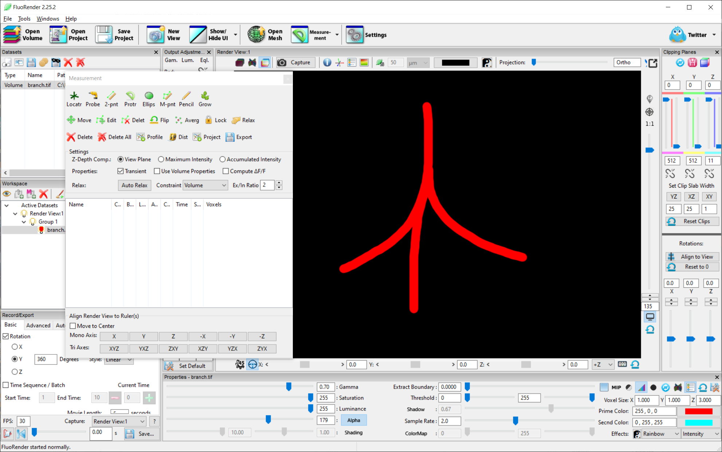

Figure 9‑1. Analyzing branching structure.

3. Choose the Pencil tool. Click on the top of the structure and drag the mouse downward to start a multipoint ruler. Release the mouse button to finish one branch of the ruler.

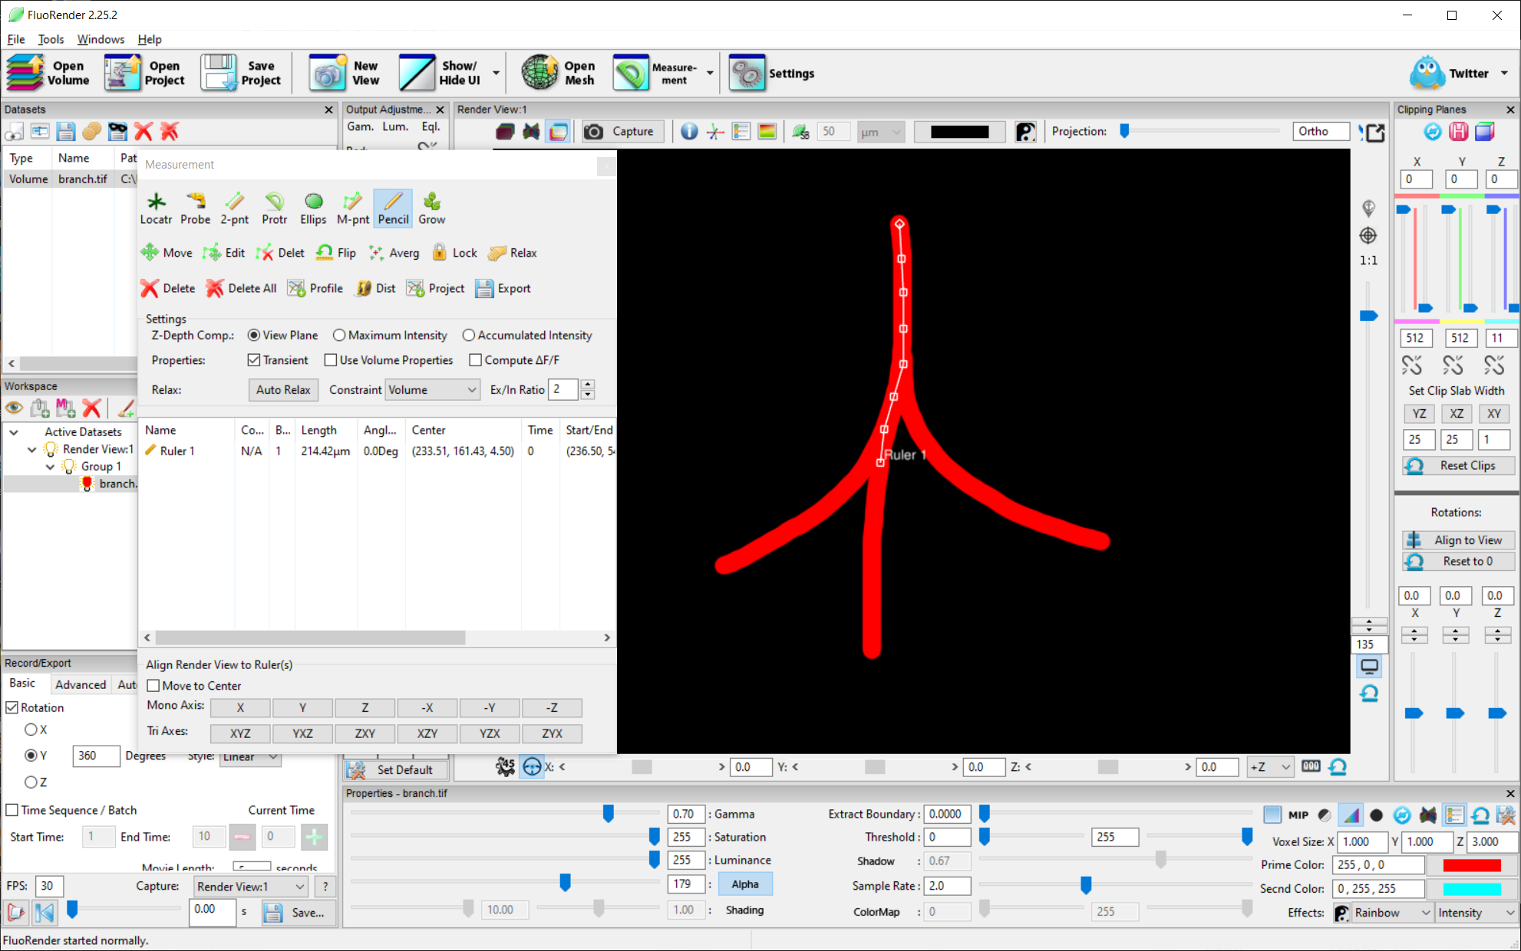

Figure 9‑2. Draw with the pencil ruler.

4. Click on an existing ruler point and drag the mouse to start a new branch. Draw all branches for this structure.

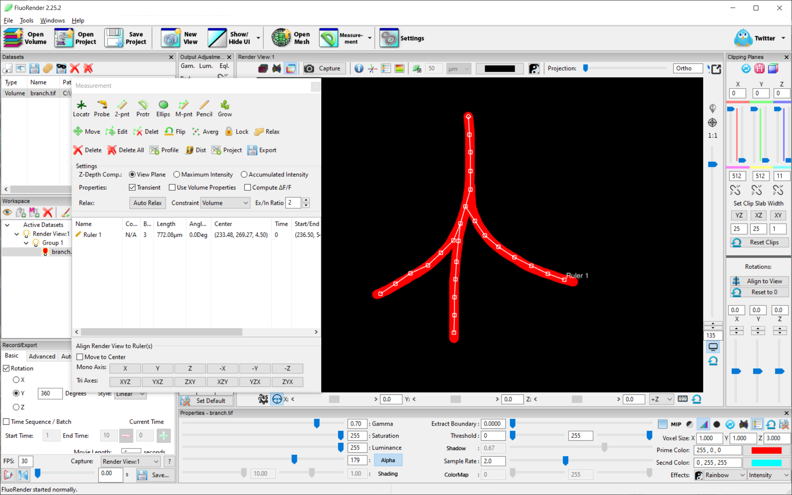

Figure 9‑3. Draw branches.

5. Select the ruler from the list. Click “Relax” to smooth the ruler and reshape it to better follow the structure.

6. The total length and branch count can be read from the list of rulers. You can also enable “Auto Relax” to reshape the ruler when it is drawn.

7. Alternatively, use the Grow tool to automatically analyze the branching structure without drawing. Choose the Grow tool. Click on the top of the structure and hold the mouse button. Wait until the ruler is generated automatically.

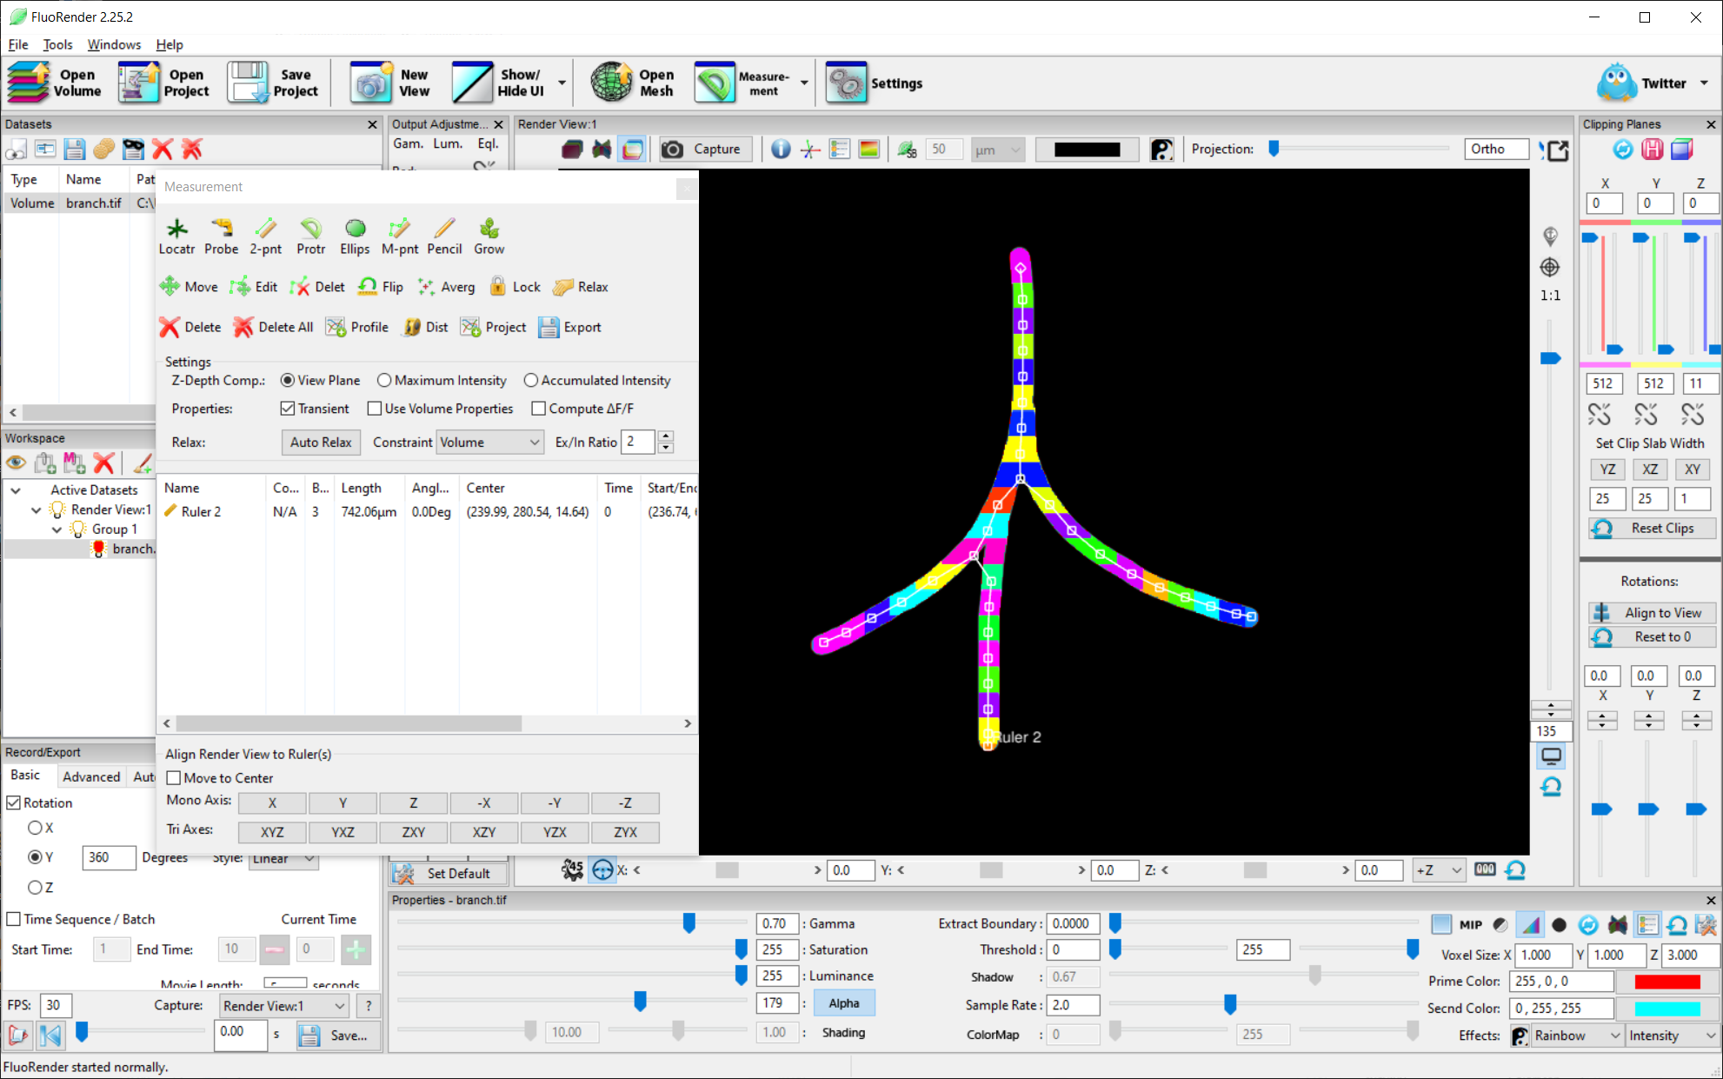

Figure 9‑4. Use the grow tool to automatically generate a branching ruler.

8. The granularity of the grow tool is controlled by the growth strength in the Paint Brush window. Use a weak growth strength for finer details.

# Channel Segmentation with Paint Brush

|  |  |
| --- | --- |
|  | **On YouTube:**  [**https://youtu.be/qngb_IZDHXE**](https://youtu.be/qngb_IZDHXE)  **Or search:**  **FluoRender Tutorials Selecting and Extracting Structures** |

FluoRender allows selecting and extracting 3D structures from volume channels. Users can directly paint on visualizations in render view and select desired structures.

1. Prepare data. Many segmentation functions are based on visualization results. Make sure that you have followed the previous tutorials to generate a satisfactory visualization. Although the paintbrush tools can be used with bricks in data streaming mode, it is recommended that you turn off data streaming if your graphics card has sufficient memory. Changes to data streaming mode have to be made before data loading. To turn off data streaming, go to the “Performance” panel in the “Settings” dialog, and uncheck “Enable streaming for large datasets”.

2. Tools and settings for the paintbrush can be accessed from the “Paint Brush” dialog. To open the “Paint Brush” dialog”, click “Paint Brush”  in the main toolbar. If the button is not currently showing, use the drop-down list on Windows, or the main menu, under Tools, on OS X.



Figure 10‑1. The “Analyze” window.

3. To initiate a selection, click the “select” button  in the toolbar of the “Paint Brush” dialog. When you move the mouse cursor into a render view, the regions that a selection brush stroke can be applied are represented by circles. You can hold down the left mouse button and drag to apply a selection brush stroke. Three dimensional structures under the stroke region can be selected.



Figure 10‑2. Segmentation with paintbrush.

4. There are several settings that further control the selection brush’s behavior, which you can adjust before applying strokes.

**Threshold.** It sets a seeding value to be applied to the center stroke region. Voxels with intensity values greater than the threshold are selected as seeds. Lower this value if you want to select more low-intensity signals.

**Growth.** It determines the number of iterations for a diffusion calculation within the outer stroke region. Strong means more iterations, which allows selection to grow to a larger size.

**Center size.** It controls the size of the inner circle of a brush stroke. Lower the value to make selections on fine structures.

**Grow size.** It controls the size of the outer circle of a brush stroke. The size can be controlled by the mouse wheel. It can be turned off by unchecking the check box to the left of the slider. When it is turned off, no diffusion is calculated. The center size is in turn controlled by the mouse wheel.

5. After an initial selection using the selection brush, you can either append new regions to the existing selections or unselect them. To append regions that are unconnected to the existing selections, use the selection brush again. To append regions that are connected to the existing selections, use the diffuse brush. Click the “Diffuse” button  in the toolbar to choose the diffuse brush. The diffuse brush has only the outer circle for diffusion calculation. To select disregarding the underlying structures, use the solid brush . To unselect the existing selections, use the unselect brush. Click the “Unselect” button  in the toolbar to choose the unselect brush.

6. You can apply brush strokes from different angles to achieve the best segmentation result. Use the following keyboard shortcuts to quickly switch between paint brush tools and normal render view interactions: holding down the “Shift” key for the selection brush; holding down the “Z” key for the diffuse brush; and holding down the “X” key for the unselect brush.

7. You can let FluoRender estimate an initial threshold value by checking “Auto Thresh”. When this option is checked, you do not need to set a threshold value before applying a selection brush stroke. You can paint directly and FluoRender will calculate a threshold value for you. The calculation of the threshold value is based on the intensity distribution in the region covered by the stroke.

8. You can let the diffusion calculation stop at salient structural boundaries by checking “Edge Detect”. For example, check this option when you want to select just one cell from a group of cells that are in close proximity to each other. When the edge detection is enabled, you can adjust how strong the edge detection is performed by setting a value for “Edge STR”. Figure 10‑3 compares the different selected results from a series of edge detection strength settings. When the edge detection strength is set to 0, it is equivalent to disabling edge detection. Adjacent structures have been selected. When the edge detection strength is increased, fewer neighbors can be selected until a satisfactory result at edge strength = 0.6. When the edge detection strength is further increased, we start losing the exterior of the structure.



Figure 10‑3. Edge detection strength

9. You can let FluoRender automatically select only un-occluded structures by checking “Visibly Only”. When this option is checked, all seeding voxels are filtered to see if they are occluded by signal accumulation. Occluded seeds are discarded. You can check this option, for example, when you want to select just one cell from a group of cells that are occluding each other.

10. The selected part of a volume channel can be either extracted or removed from the original data, creating a new channel. To create a new channel by extracting the selected part, click “Extract”  in the toolbar. To create a new channel by removing the selected part, click “Erase”  in the toolbar.

11. Brush tools can be used in conjunction with clipping planes. You can set clipping planes to restrict the rendering of a channel to a sub-region. When you apply a brush stroke, selection can be only made within the visible region. A good example is that you can clip a volume to a single image section, and then select structures section by section, allowing classical 3D segmentation operations found in many other tools. More flexibility can be achieved as you may include any number of image sections between two facing clipping planes.



Figure 10‑4. Select structures section by section.

# Selecting Using the Grow Tool

The Grow tool allows selecting connected structures from a single point. It is useful for tracing branching structures, such as neuron axons, nerves, or blood vessels.

1. An example data set, branches.tif, can be found in the /Data folder of the FluoRender installation. Open the branches.tif file in FluoRender to start this tutorial.

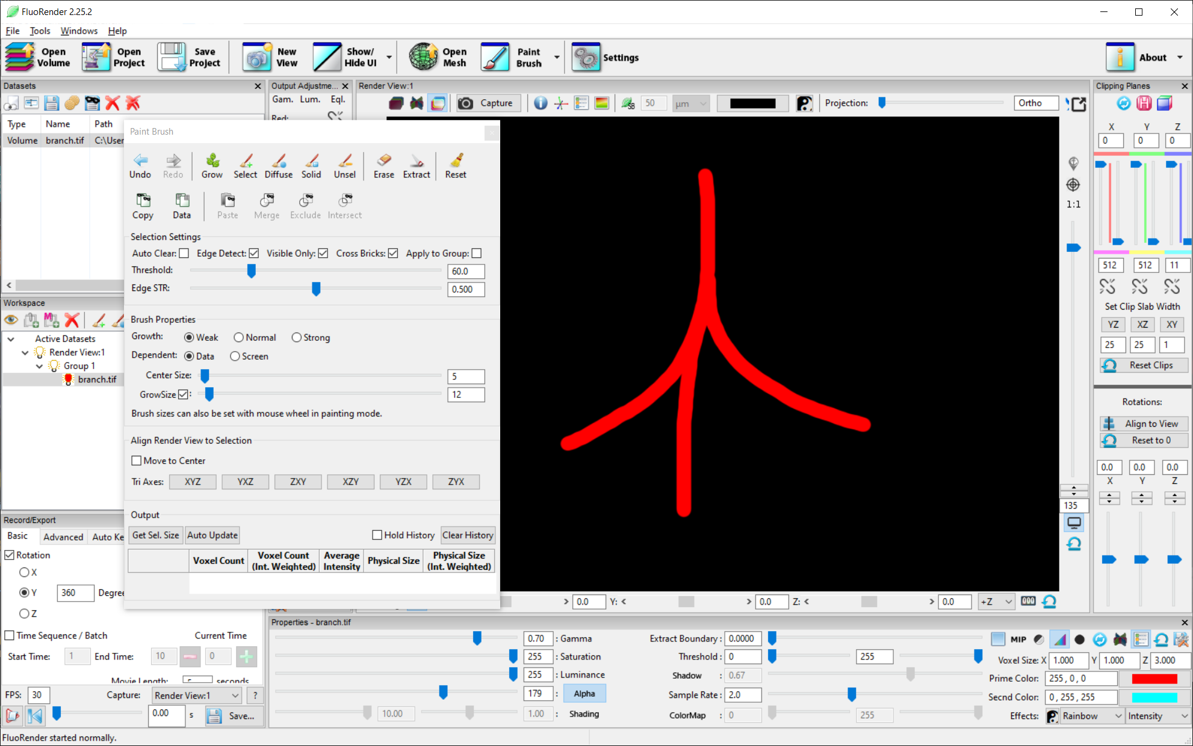

Figure 11‑1. Select a branching structure.

2. Choose the Grow tool. Click on the top of the structure and hold the mouse button. Wait until the entire structure is selected.

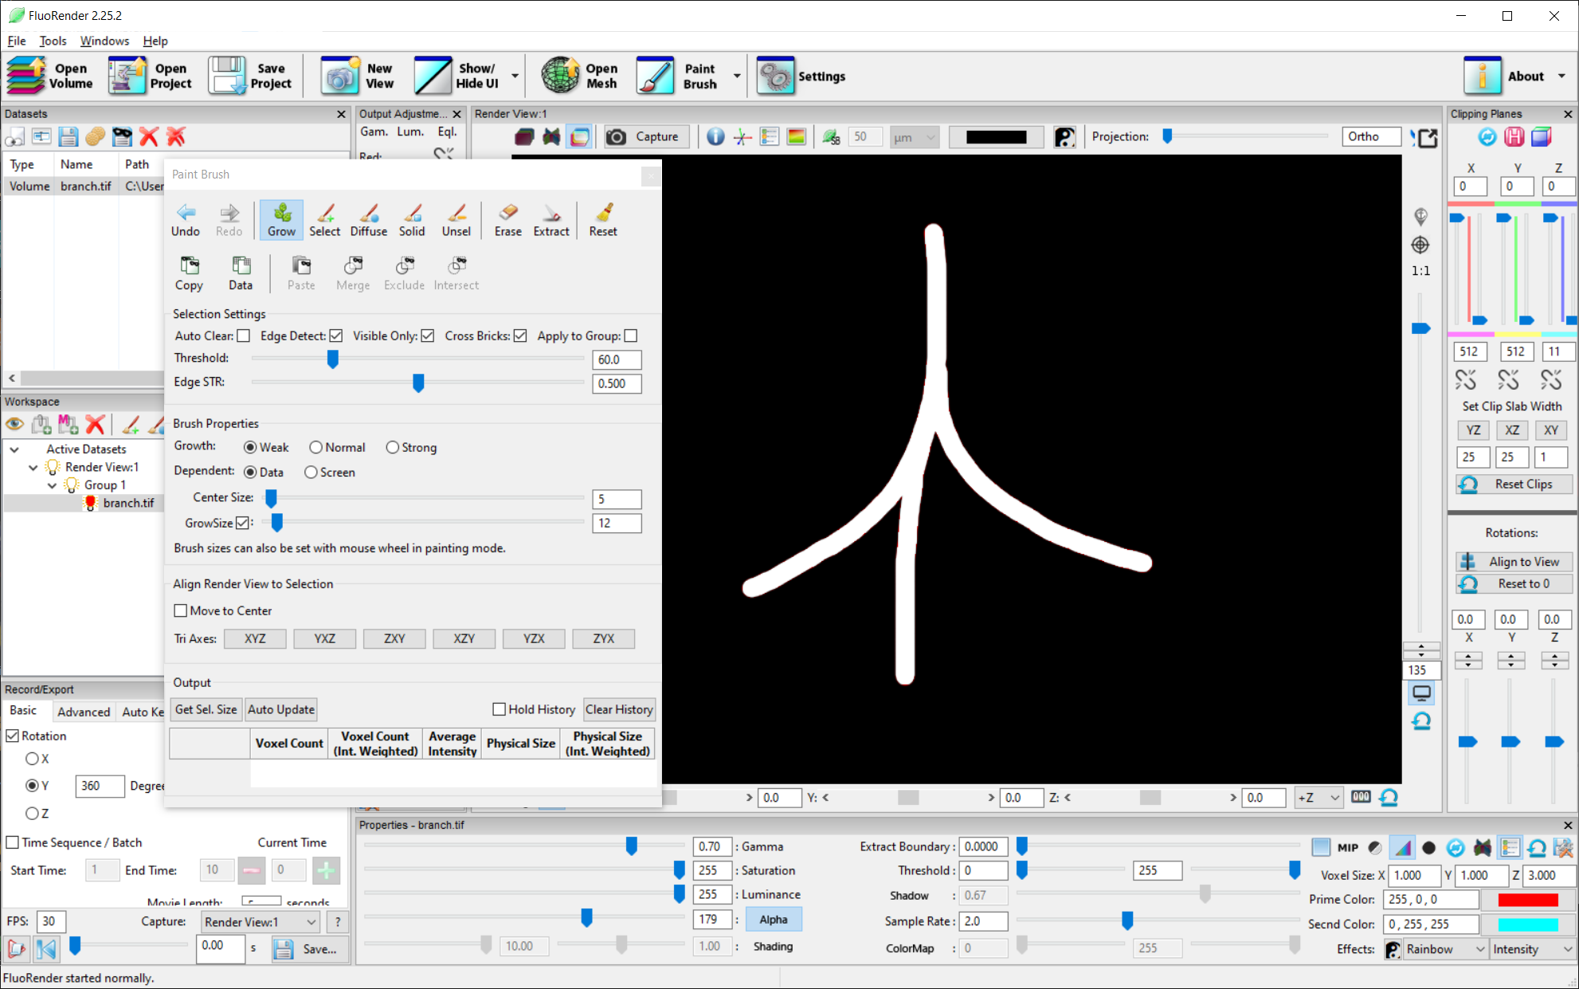

Figure 11‑2. Click and hold with the grow tool.

3. Turn on “Auto Update” in the Output section to enable real-time volume evaluation. Reset the selection and set the growth strength to “weak”. Repeat the grow selection and observe the change in the size of the selection.

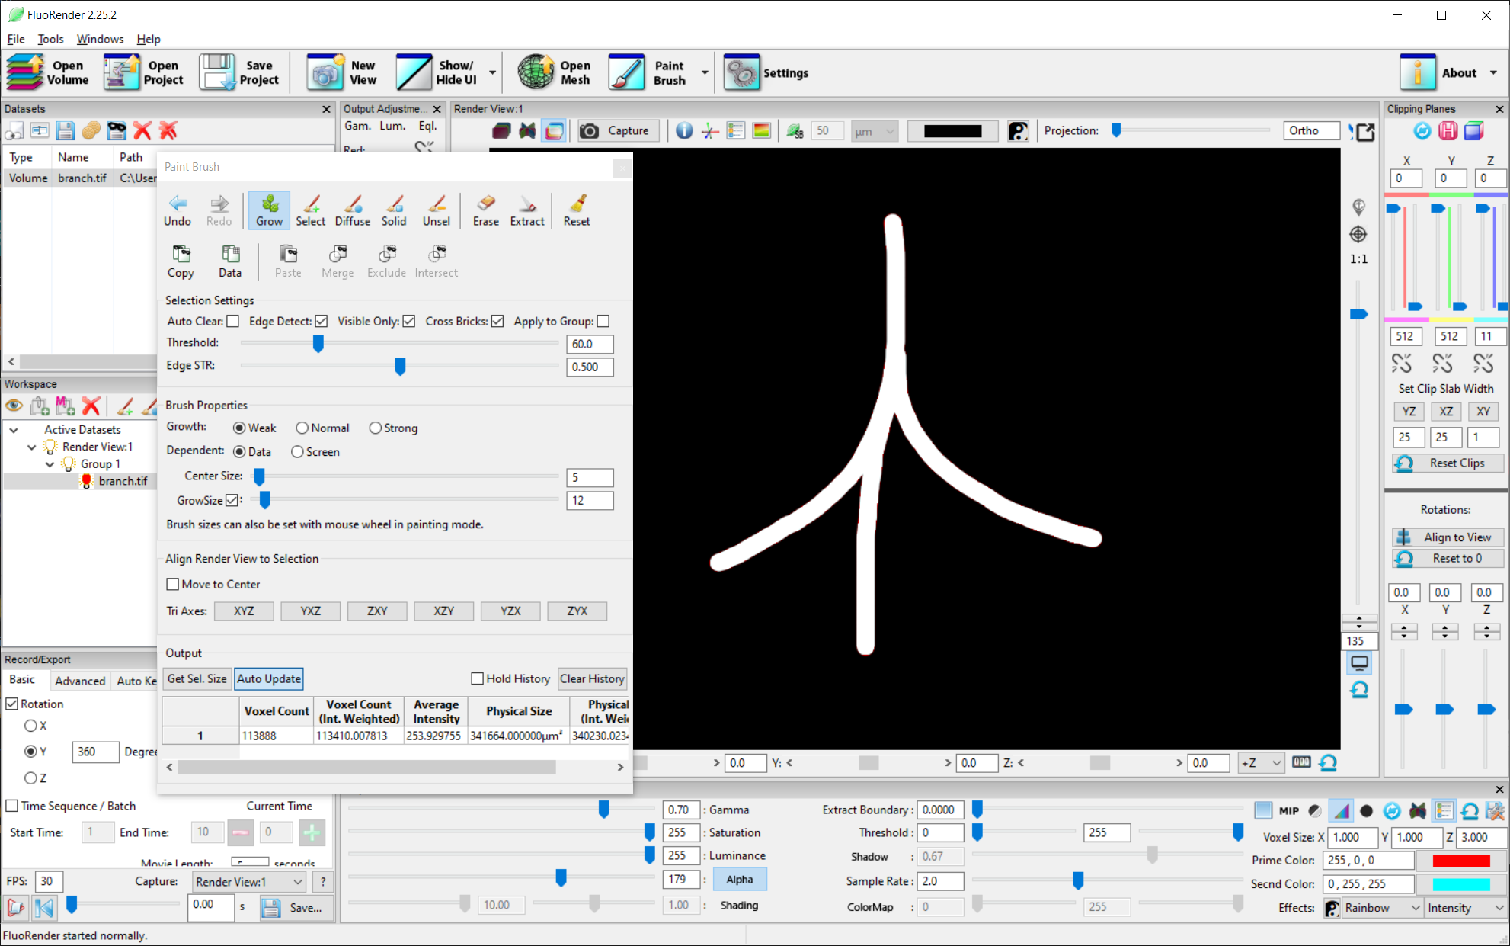

Figure 11‑3. Auto size evaluation.

4. Reset the selection. Use the grow tool to click in the middle of the structure and quickly drag to the right size to use the direction control of the grow tool. Only the right branch of the structure is selected.

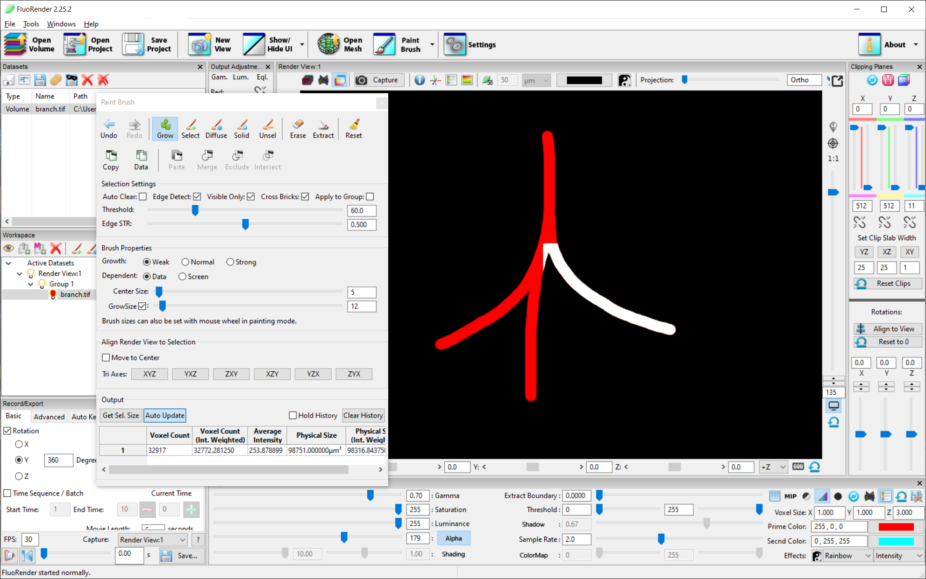

Figure 11‑4. Drag the mouse to one side to control the directional growth.

# Image Processing with OpenCL Kernels

FluoRender allows you to take advantage of modern graphics hardware for image processing with parallel computing. OpenCL is the interface language used in FluoRender to perform computations on a selected volume channel. A piece of OpenCL code for a specific image processing function is called a kernel.

1. Prepare data. An OpenCL kernel can be applied to a volume channel loaded and visualized in FluoRender. Although FluoRender automatically applies a kernel to each data brick when data streaming is enabled, it is recommended that data streaming is disabled for best performance. Changes to data streaming mode have to be made before data loading. To turn off data streaming, go to the “Performance” panel in the “Settings” dialog, and uncheck “Enable streaming for large datasets”.

2. Kernels are managed in the “OpenCl kernel editor” window. To open the “OpenCL kernel editor” window, click the downward arrowhead to the right of the “Analyze” button in the main toolbar. In the drop-down menu, choose “OpenCL kernel editor”.



Figure 12‑1. OpenCL kernel editor.

3. Names of kernel files (*.cl) are listed in the list on the left. These files are in the \CL_code folder of FluoRender’s installation folder. Click the name of a kernel file, and its code is loaded into the code editor on the right.

4. You can browse and load a kernel file saved elsewhere than the default folder. To browse and load a kernel file, click “Browse”. In the file browser dialog, choose a valid OpenCL kernel file. Its code is loaded to the code editor on the right of the window.

5. You can modify a loaded kernel code, or write your own code from scratch. Code can be edited in the code editor on the right of the window. A reference manual of OpenCL 1.2 can be found here: <https://www.khronos.org/registry/cl/sdk/1.2/docs/man/xhtml/>.

6. To execute a kernel, click “Run”. If the kernel fails to execute, error messages are output to the “Output” box at the bottom.

7. A new channel is created as the result of the execution of a kernel. If you repeatedly execute a kernel on a newly generated channel, no more new channel will be created again.

8. Here is an example of using the “skeletonization”, or thinning, kernel to extract the main structures of an example data set. The example data set, branches.tif, can be found in the /Data folder of the FluoRender installation. Load it into FluoRender.

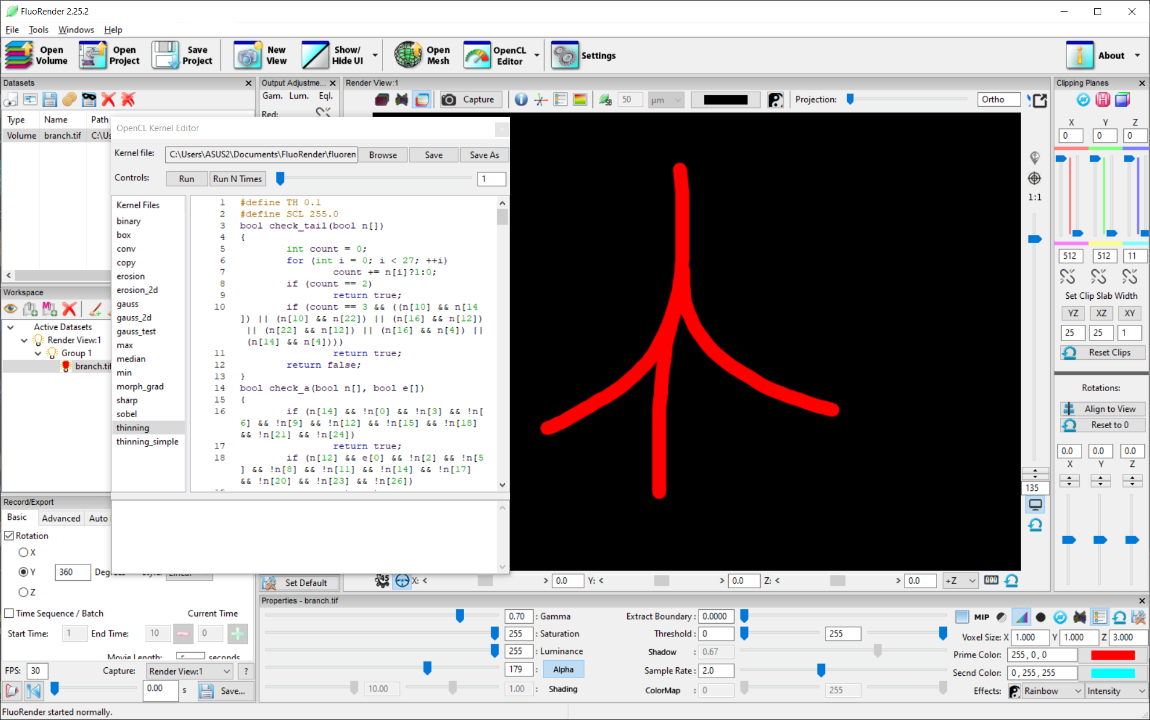

Figure 12‑2. A branching structure for skeletonization.

9. Click “thinning” in the kernel file list to load the kernel program into the OpenCL Kernel Editor. Click Run once to see the result, which shrinks by about one voxel all around.

10. Set an iteration number to about 20 and click “Run N Times”. Successive execution of the thinning filter generates the skeleton of the structure. Lower the Saturation value if the skeleton lines become difficult to see.

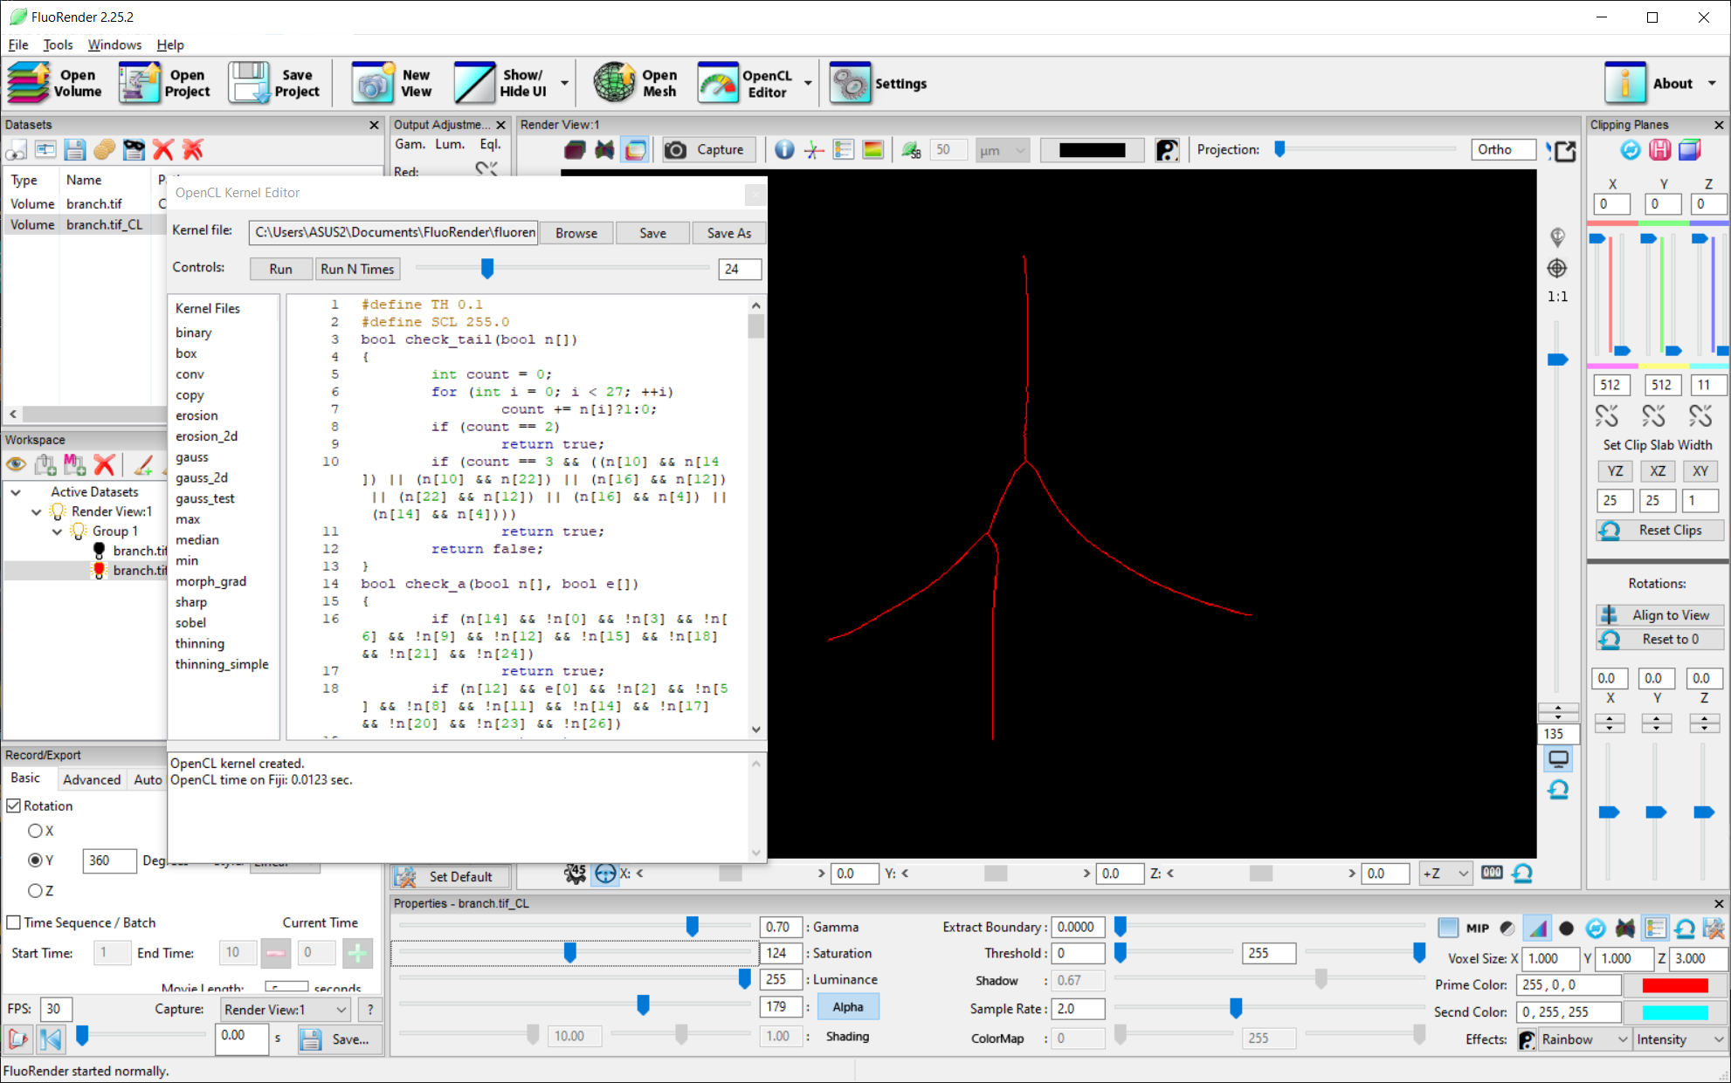

Figure 12‑3. Run the thinning kernels multiple times to generate the skeleton.

# Semi-automatic Tracking of Cells

The semi-automatic tracking function combines paint brush, component analysis, and component linking using a script. A user only needs to select structures from each time point of a scan to track them over time.

1. Load an example data set into FluoRender.

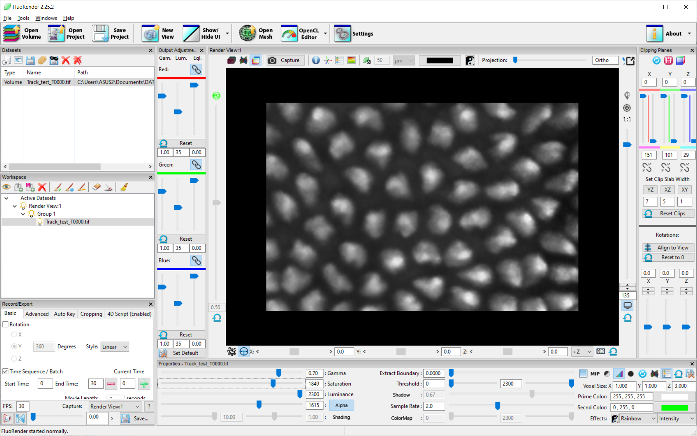

Figure 13‑1. An example 4D data set.

2. In the Record/Export panel, click the Script tab, enable script, and choose the script “track_semiauto”.

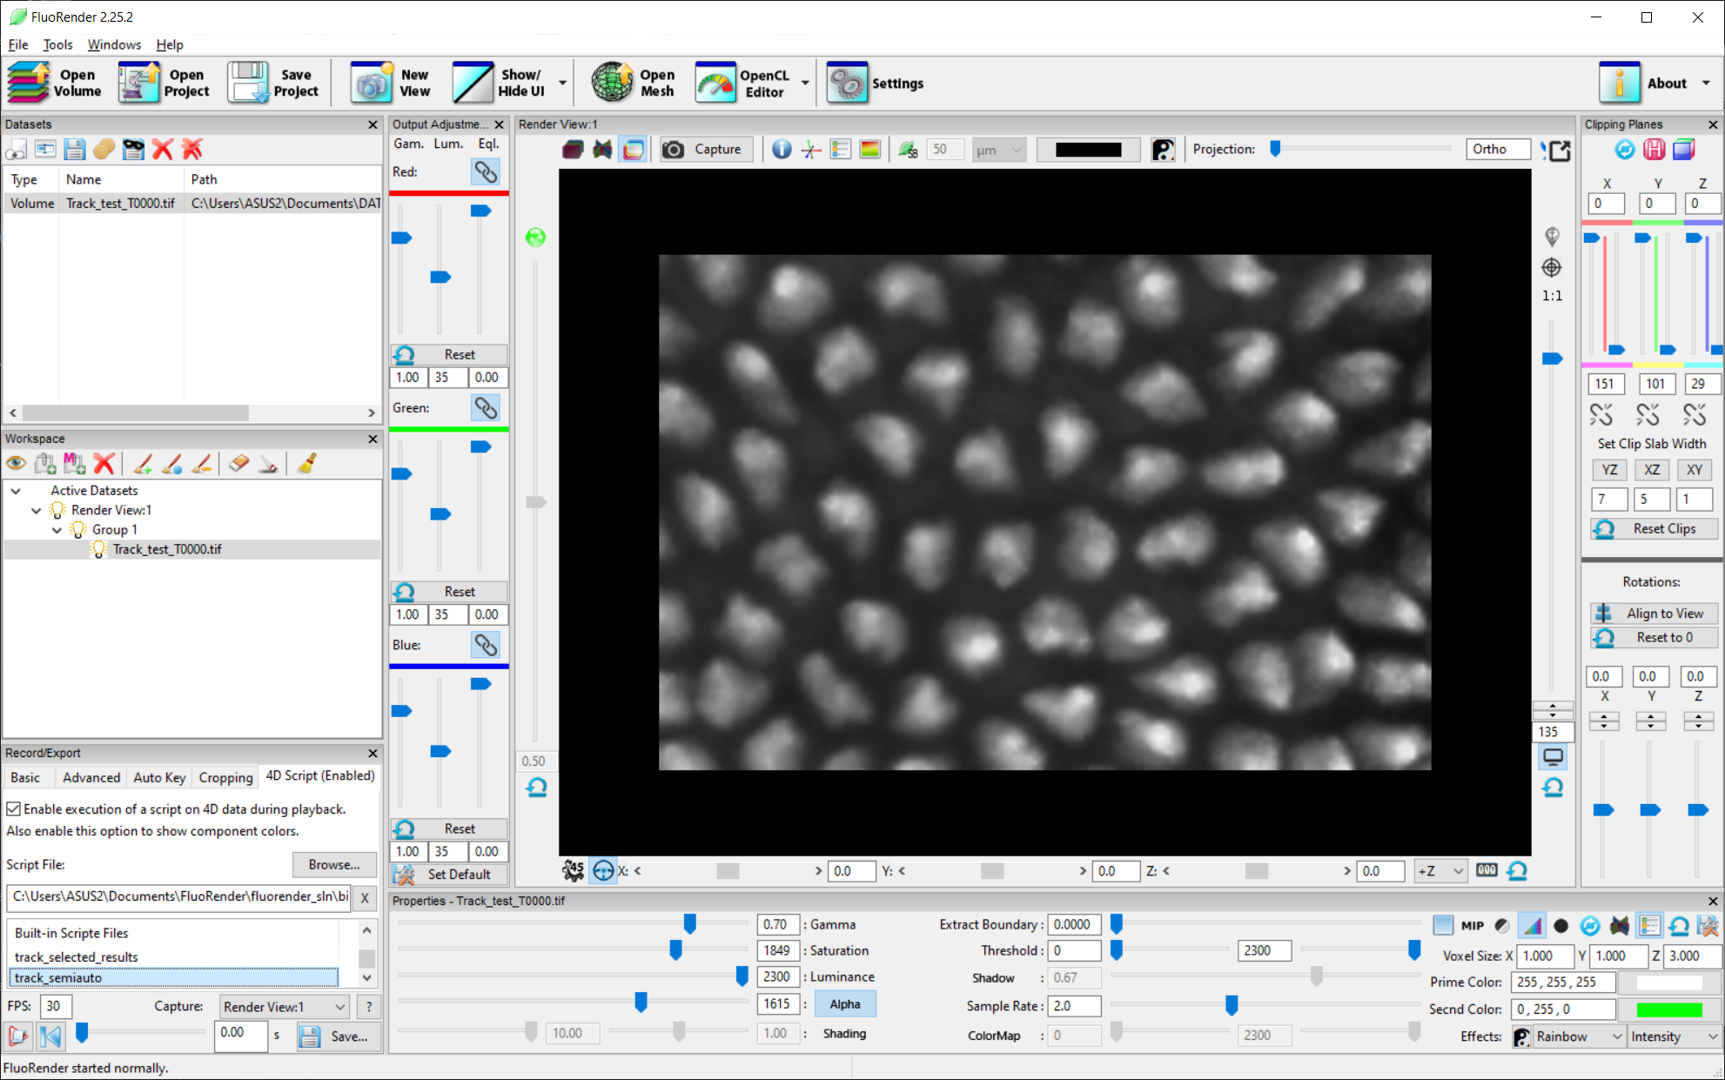

Figure 13‑2. Enable and select the 4D script for semiautomatic tracking.

3. Enable the paintbrush tool by holding down the Shift key. Paint and select cells from the example data set.

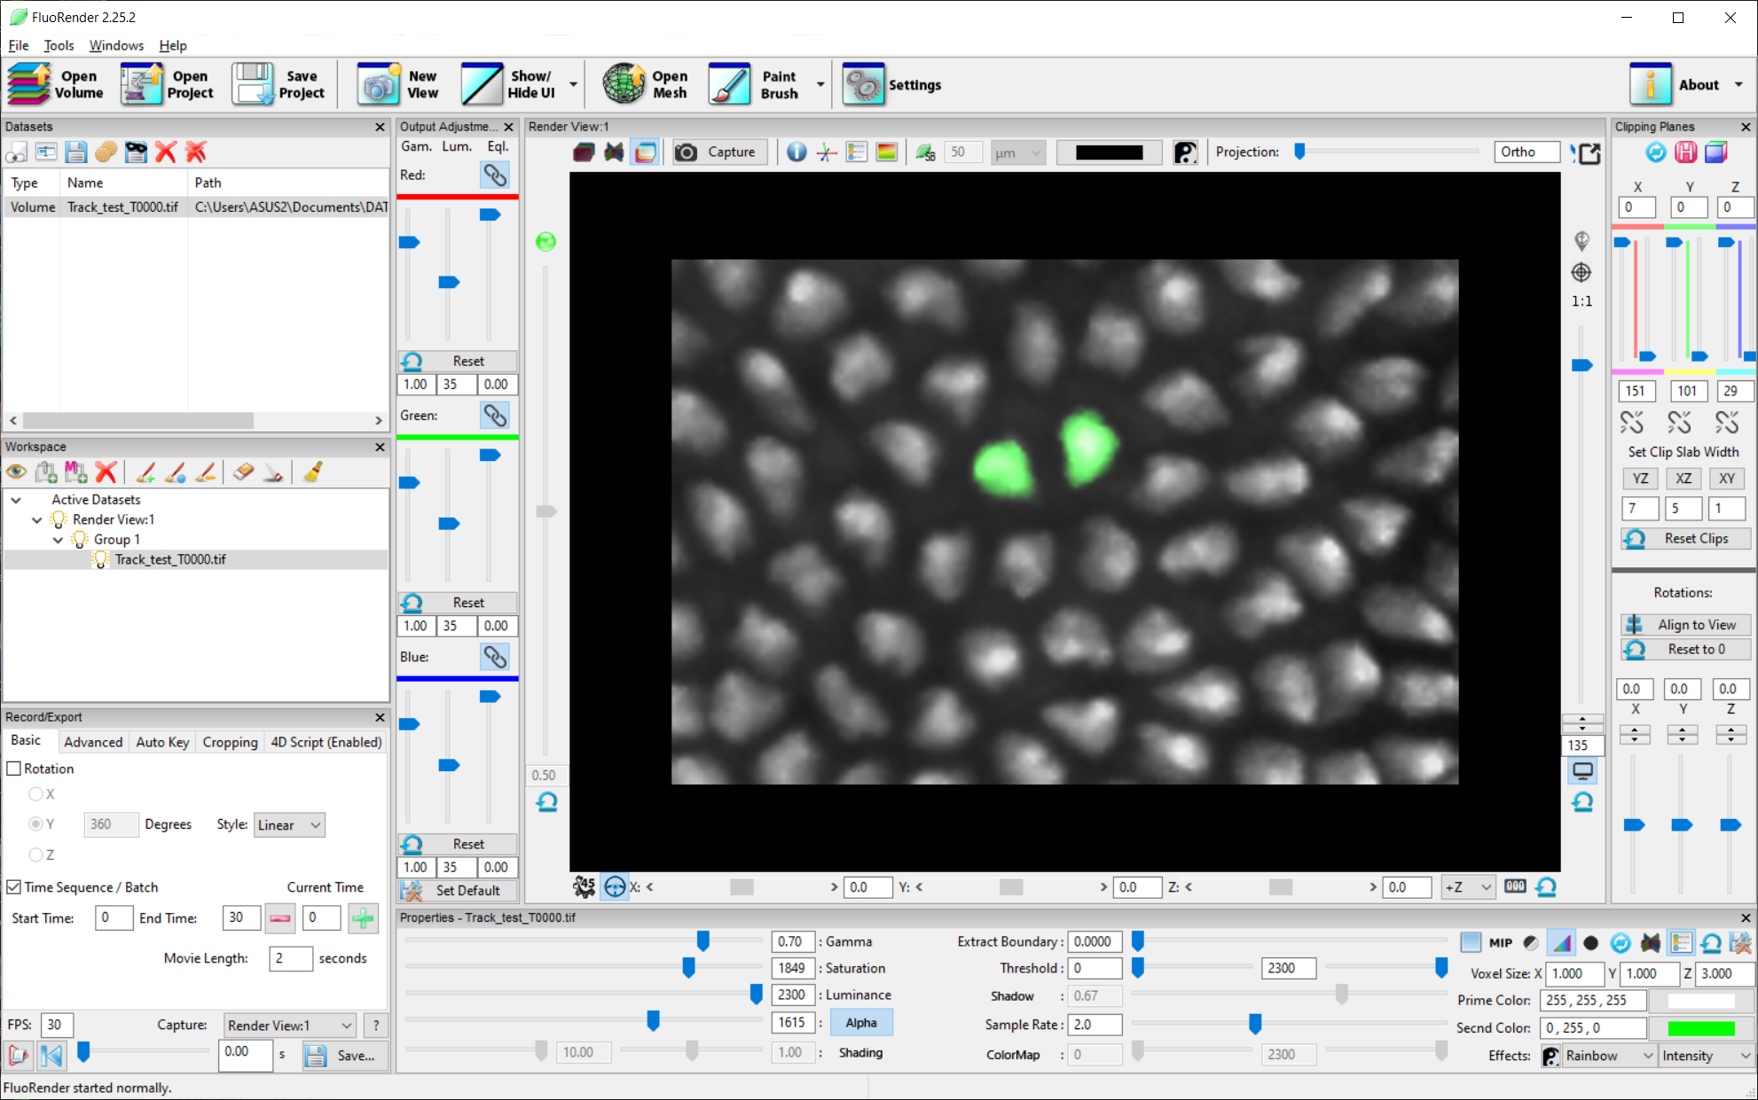

Figure 13‑3. Select two cells that need tracking.

4. Advance one time point by keyboard shortcut “D”, or click the “+” button in the Basic tab of the Record/Export panel. The two selected cells will be automatically segmented. Repeat selecting the same pair of cells in the next time point and advancing one time point again. The cells from the first and the second time points are linked.

5. Once the last time point for tracking is reached. Go to the script tab and switch the script to “track_selected_results”.

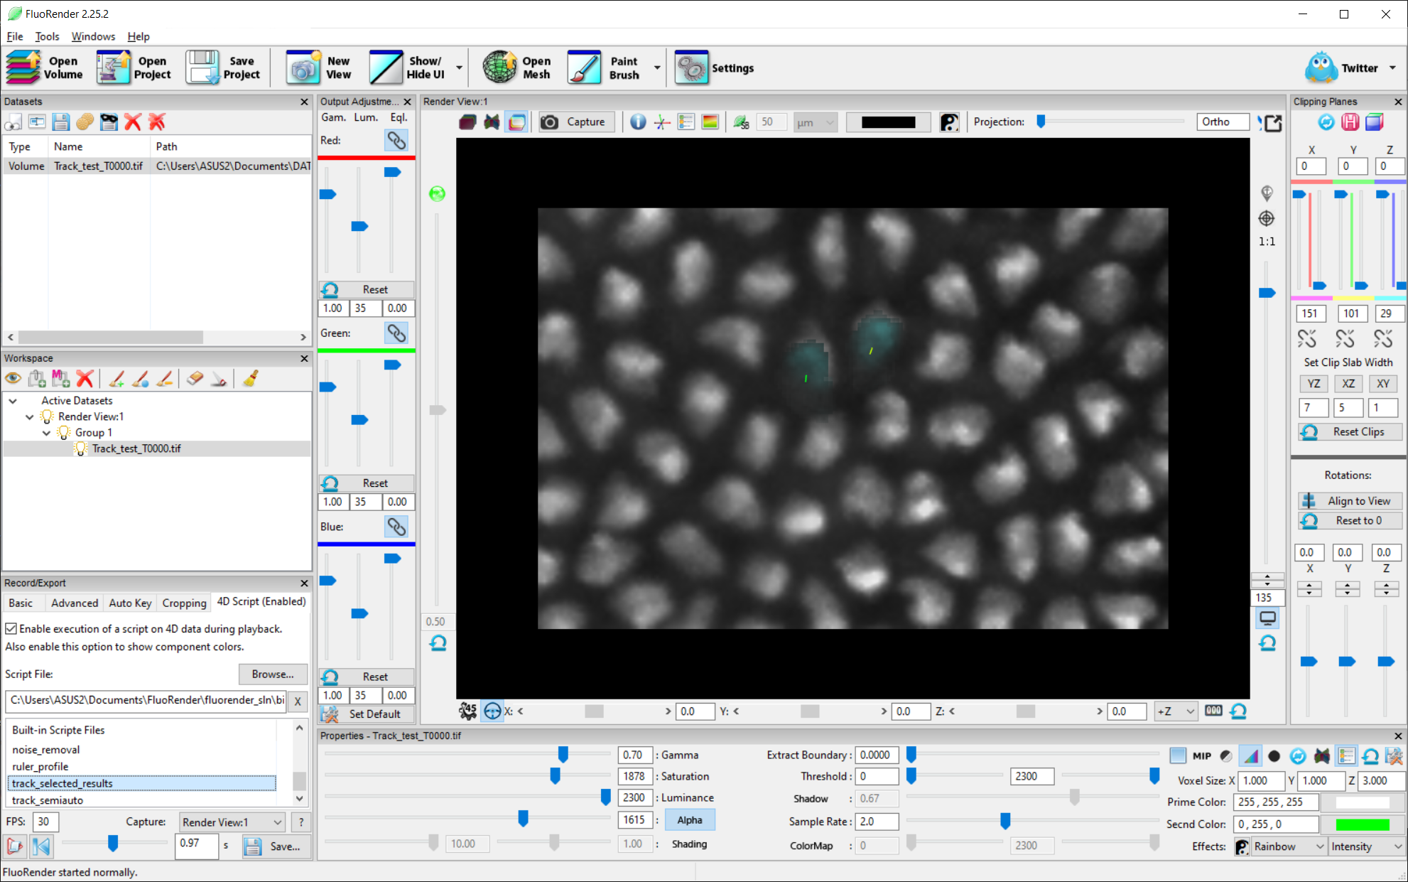

Figure 13‑4. Switch to another script for viewing tracking results.

6. Rewind to the first time point. Select the two cells. Click playback to view the tracking result.

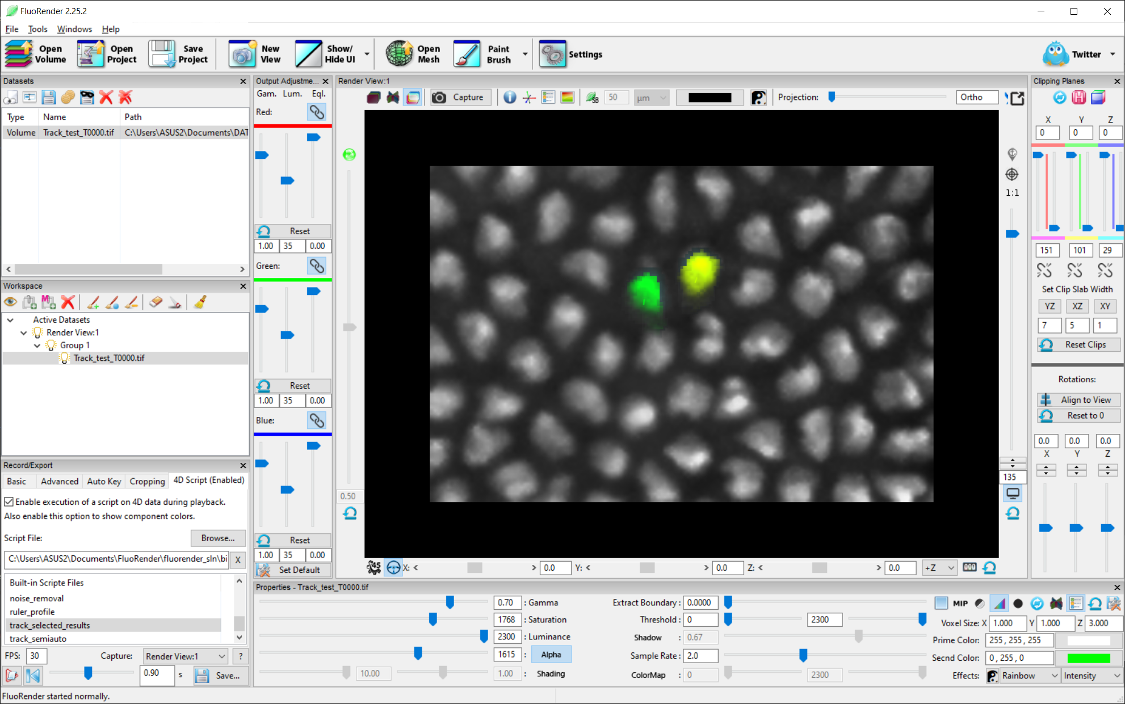

Figure 13‑5. View tracking result.

# Fully Automated Data Analysis

A workflow for fully automated data analysis can be achieved using a script, which contains a sequence of tasks for data processing or result output. An example script for analyzing the intensity change of a time sequence can be found in the Scripts folder of the FluoRender installation. A script file contains commands and associated parameters. Use a text editor program to open the script file. Read through the file to better understand the concept. You may also modify the script file to better suit your analysis workflow.

1. Load an example data set into FluoRender.

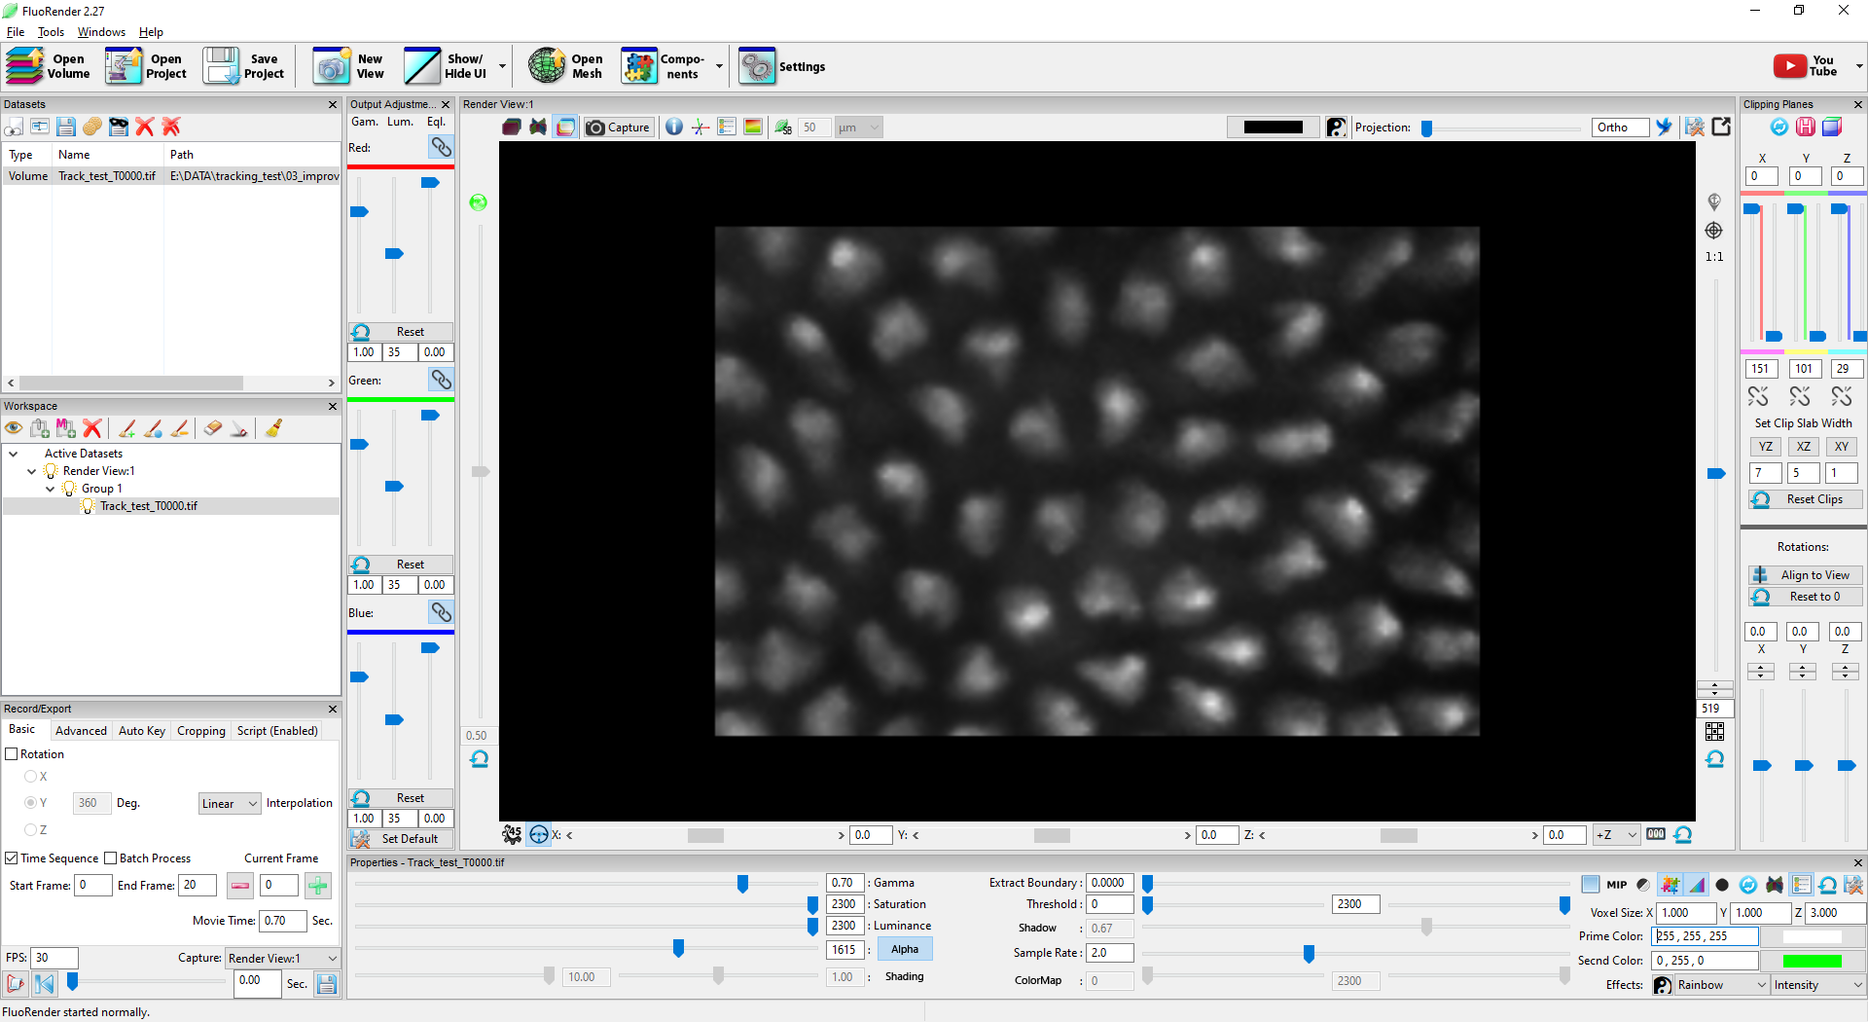

Figure 14‑1. Load data.

2. If there are multiple channels in the data set, select a channel to analyze from the Workspace panel. Most tasks in a script can be configured to apply to multiple channels by setting the channel mode parameter. However, the example here only analyzes a single channel.

3. Click the Script tab in the Record/Export panel. Click the script *comp_gen_track_analyze* to enable script execution. Alternatively, you can load a custom script using the Browse button.

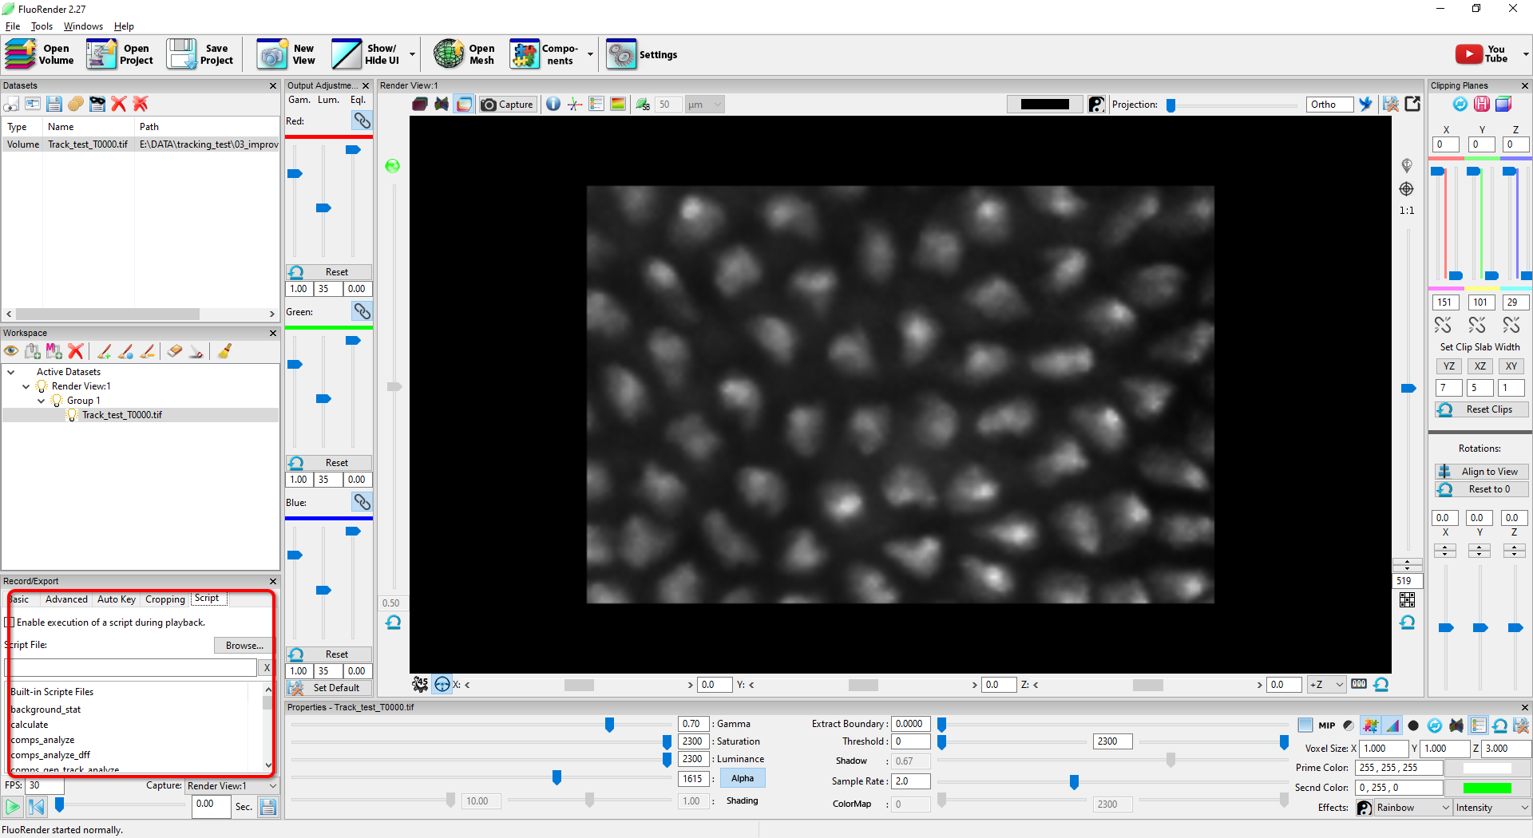

Figure 14‑2. Enable a script.

4. The script *comp_gen_track_analyze* performs a series of tasks. It generates segmented components in the start frame. Then, it filters the components based on size, so that only components of certain sizes are selected. It tracks the selected components over time and analyzes the intensity distribution for each tracked component. It also extracts the background of the scan and analyzes its intensity distribution. The background intensity is used to normalize the component intensities. Finally, the changes in the intensity values are plotted using a ridgeline graph in an HTML file. FluoRender automatically opens the HTML results in the system's default web browser.

5. Select the frame range for the analysis on the Basic tab of the Record/Export panel.

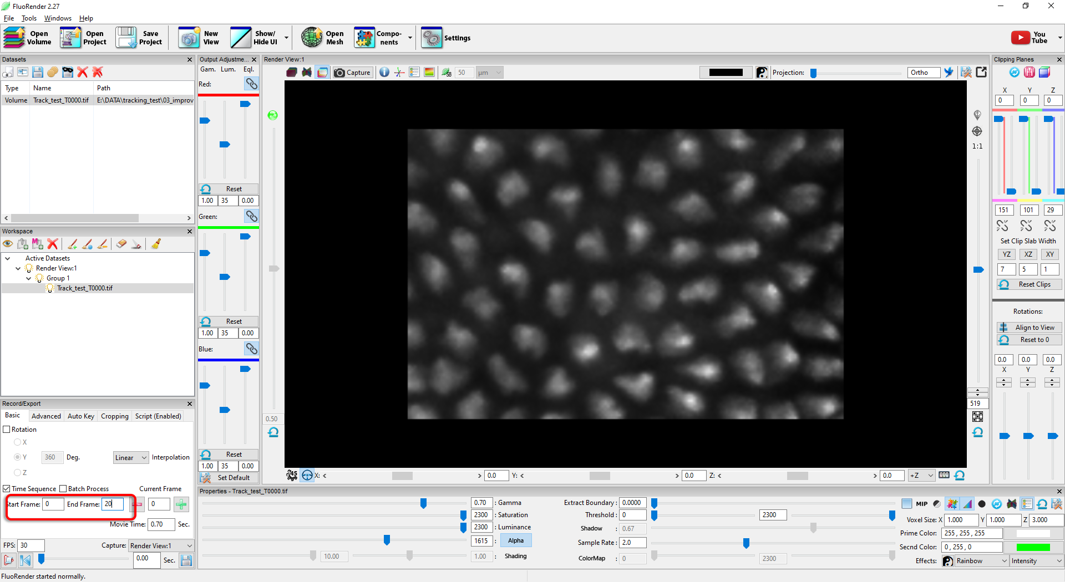

Figure 14‑3. Select frame range.

6. Click Play to play the time sequence and execute the script at the same. The result is shown as a ridgeline graph in the web browser.

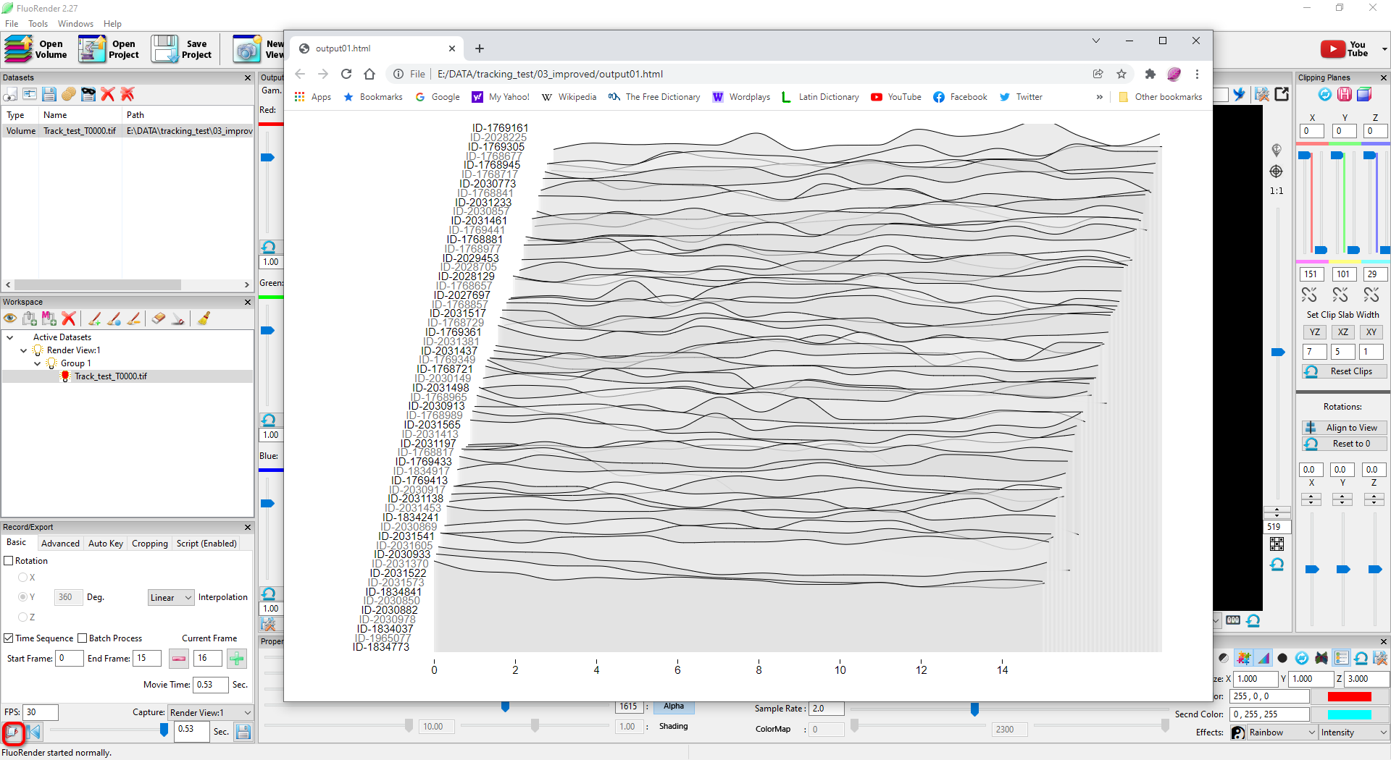

Figure 14‑4. Run the script and see the results.

7. Alternatively, the results can be shown in a spreadsheet. Open the script file and change the parameter template to table.html. Save the file and rerun the script.

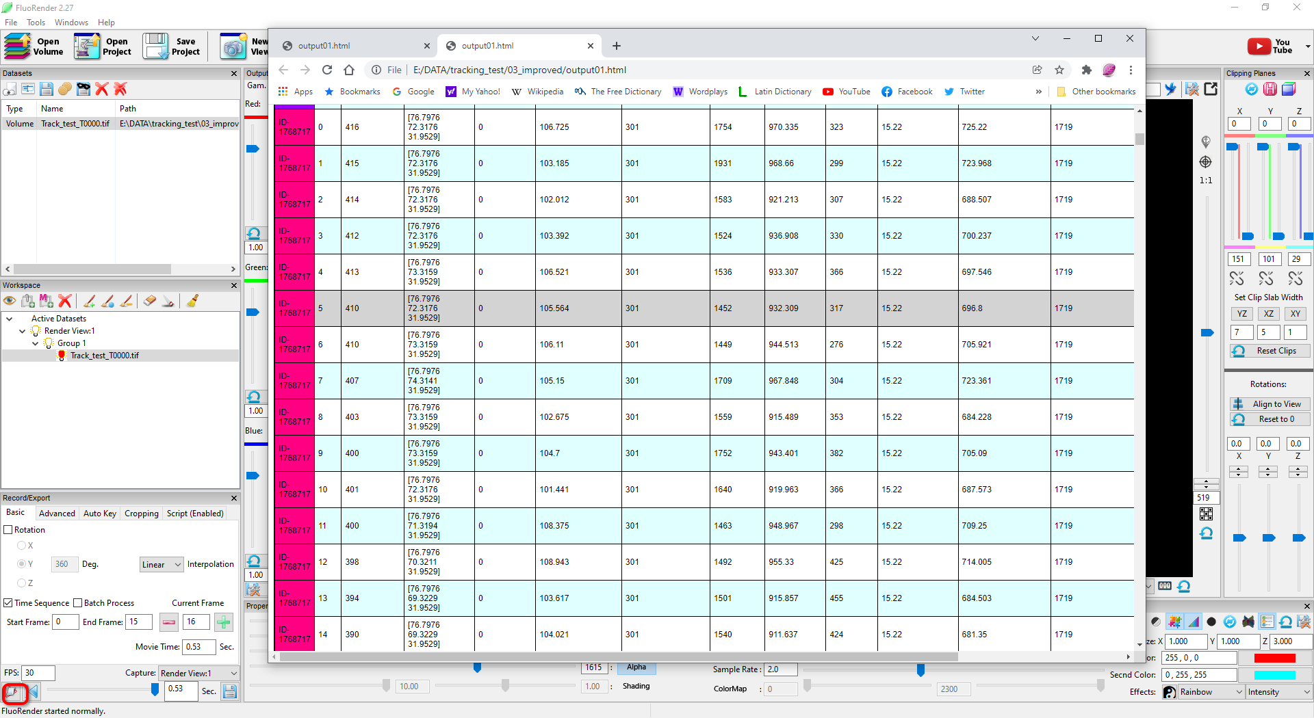

Figure 14‑5. Analysis results in a spreadsheet.

# Image Registration

Run the image registration script to align features in a time sequence. Measurements and analysis can be performed on the aligned data at real-time speed.

1. Load an example data set into FluoRender. This data set contains 5 images of an object at different locations and orientations.

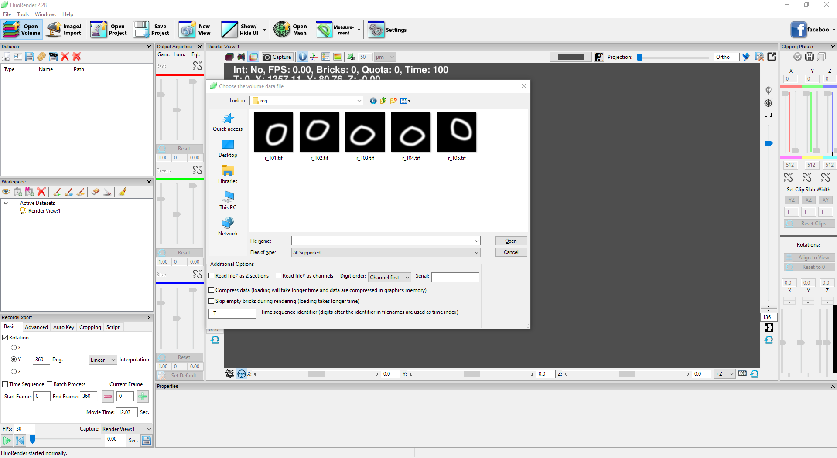

Figure 15‑1. Load time data for image registration.

2. Go to the “Script” tab of the Record/Export panel and select a script called “registrate”.

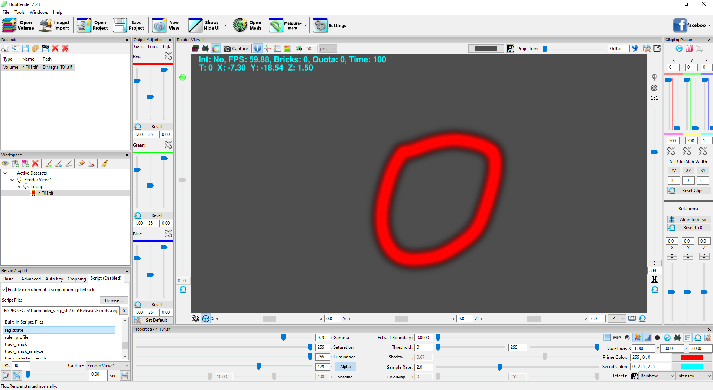

Figure 15‑2. Select the script.

3. Play back the time sequence and perform registration. It saves the transformed images in a folder specified using the save dialog.

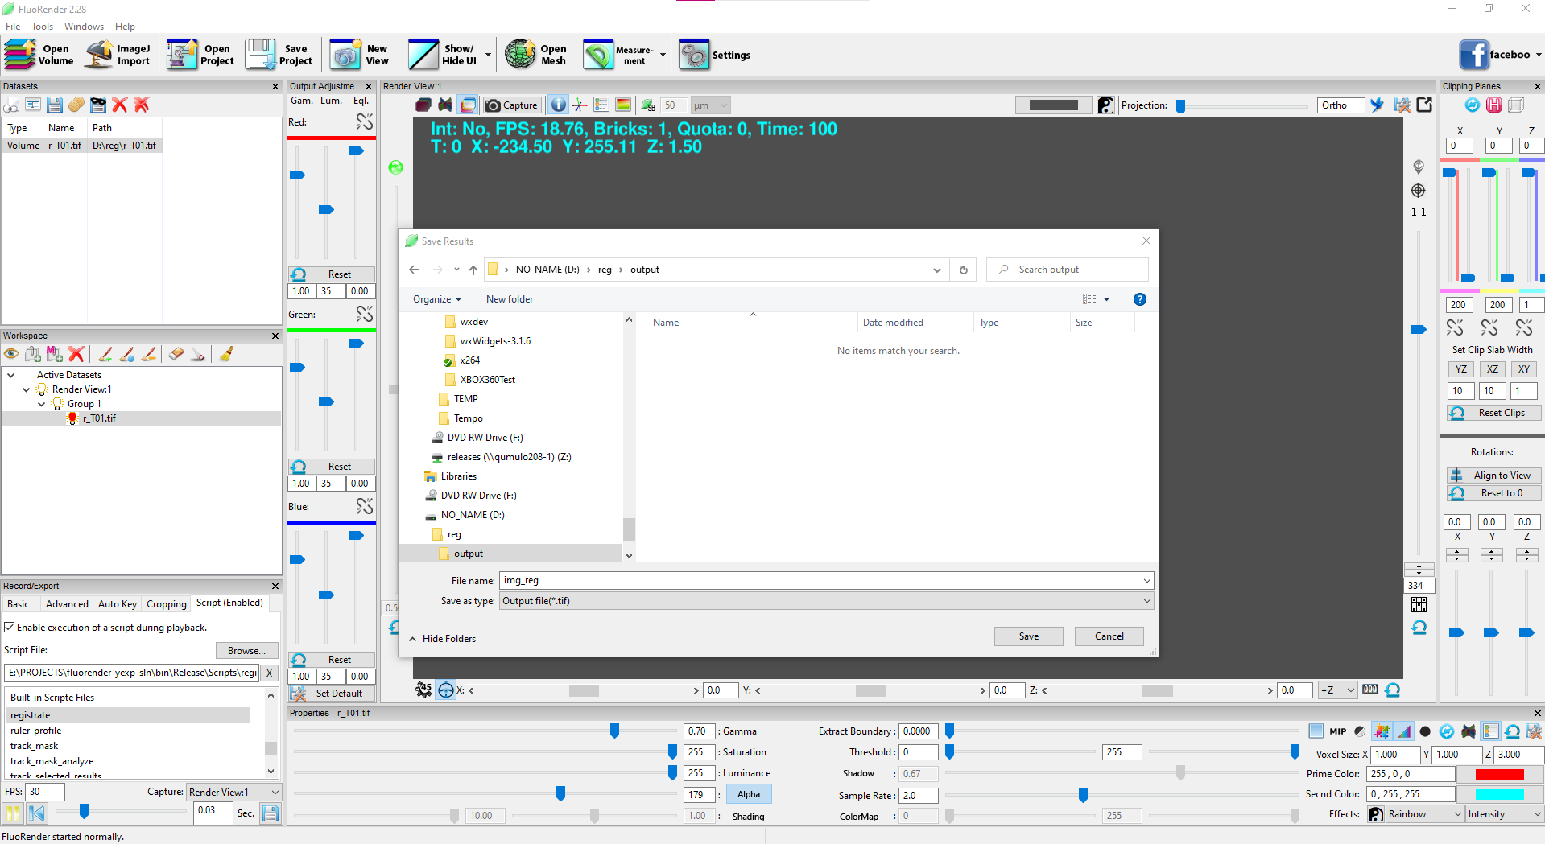

Figure 15‑3. Run the script and resave the time sequence.

4. Load the resaved sequence into FluoRender.

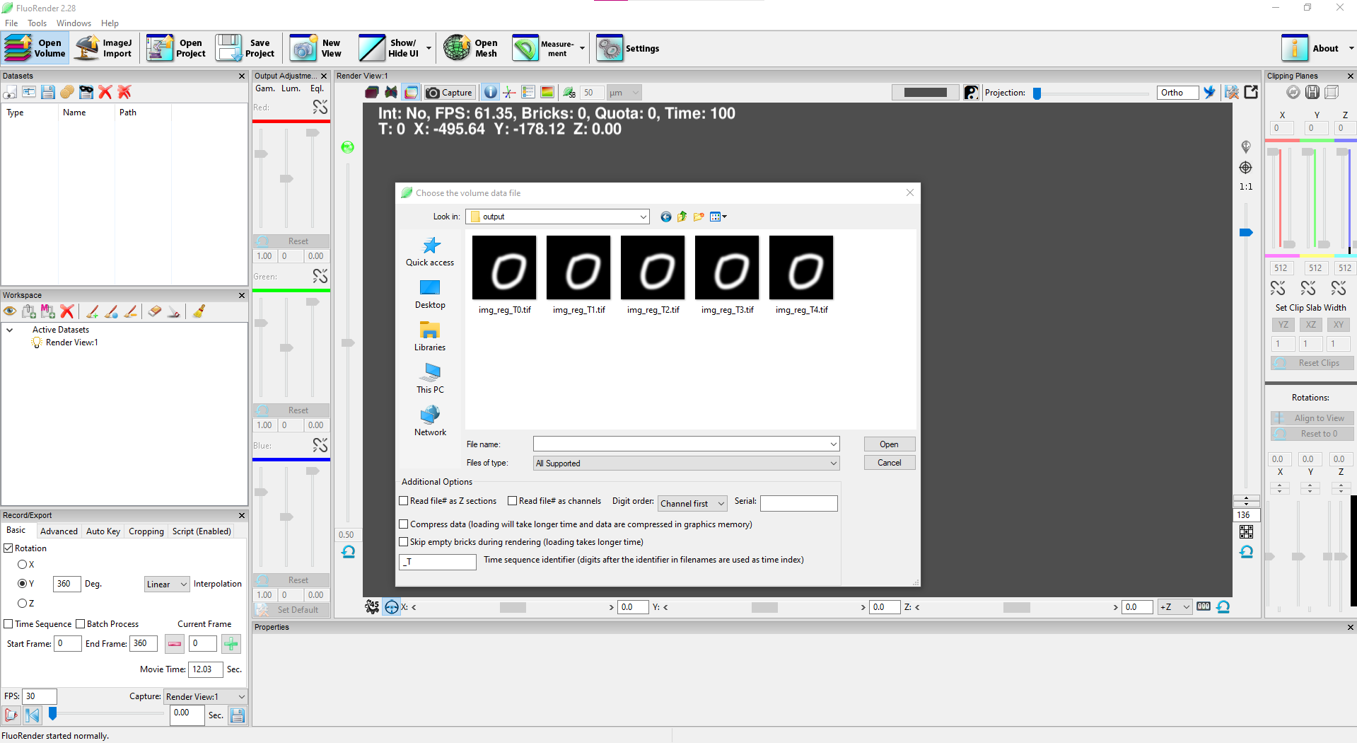

Figure 15‑4. Reload the result.

5. Make sure the script option is turned off for a time sequence that does not register.

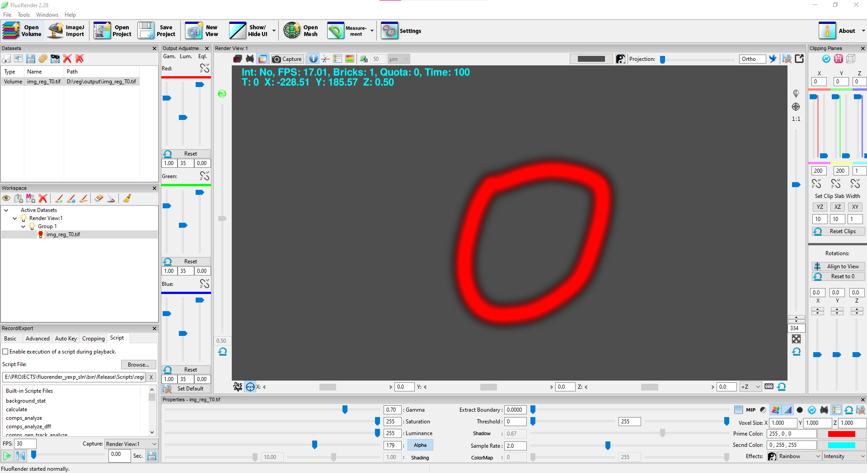

Figure 15‑5. Turn off script running.

# Video Analysis

Use the ruler tools to analyze the movements of objects in video files.

1. Load a video file into FluoRender by opening it as a volume data set. FluoRender supports commonly used video file formats, including mp4, m4v, mov, etc. Each frame of the video is a time point and can be played using FluoRender’s movie playback tools.

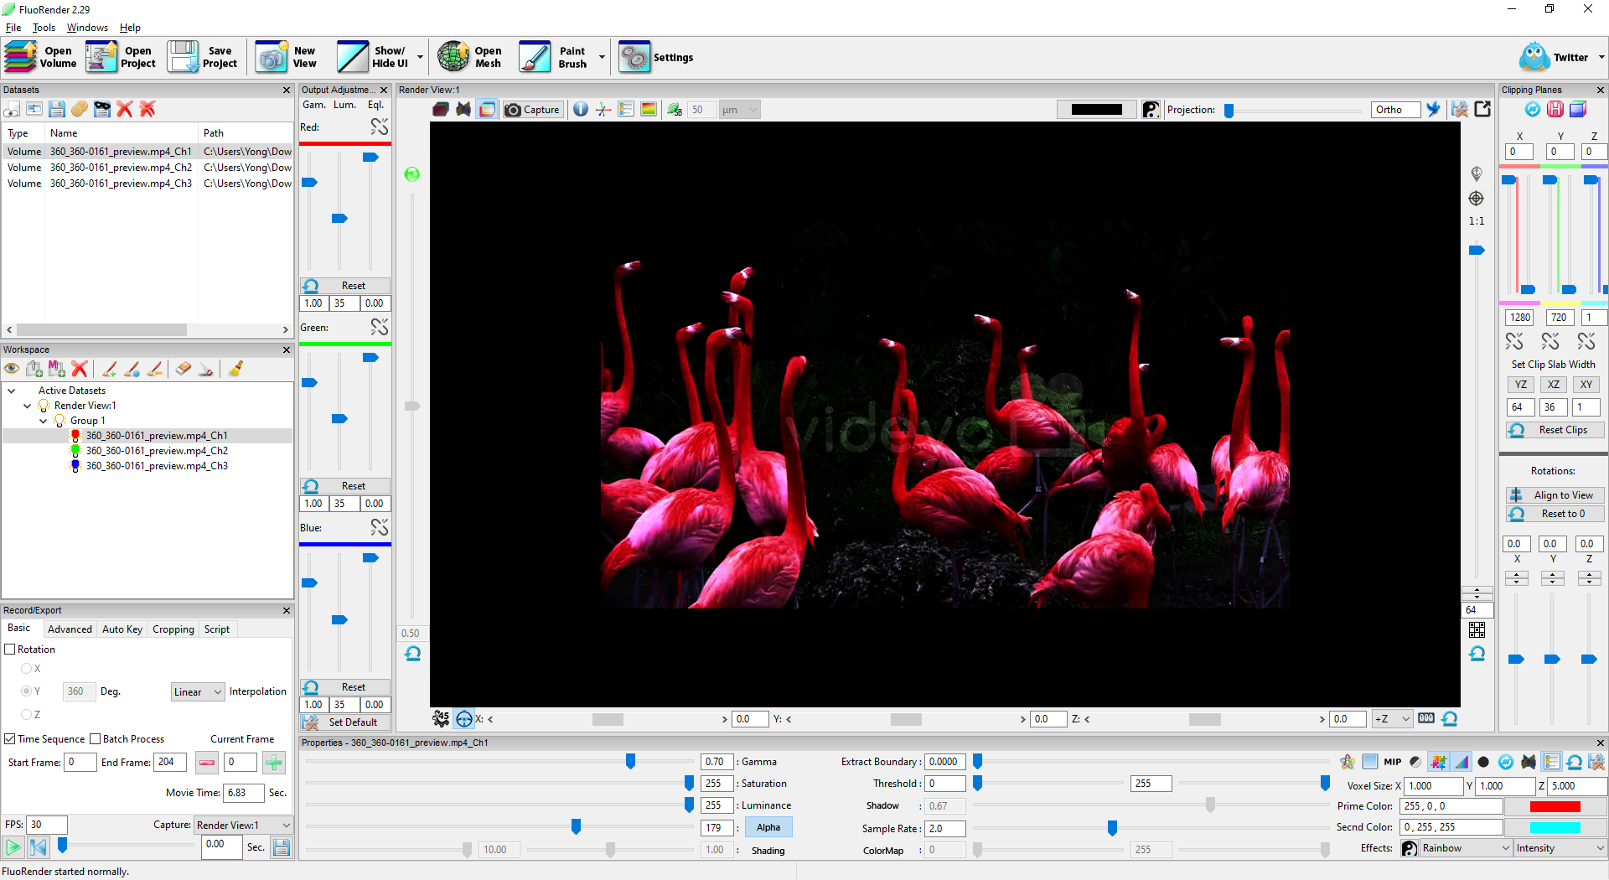

Figure 16‑1. Load a video file in FluoRender.

2. Disable “Alpha” for all channels and enable render view rotation lock. Adjust the brightness and contrast using FluoRender settings if necessary.

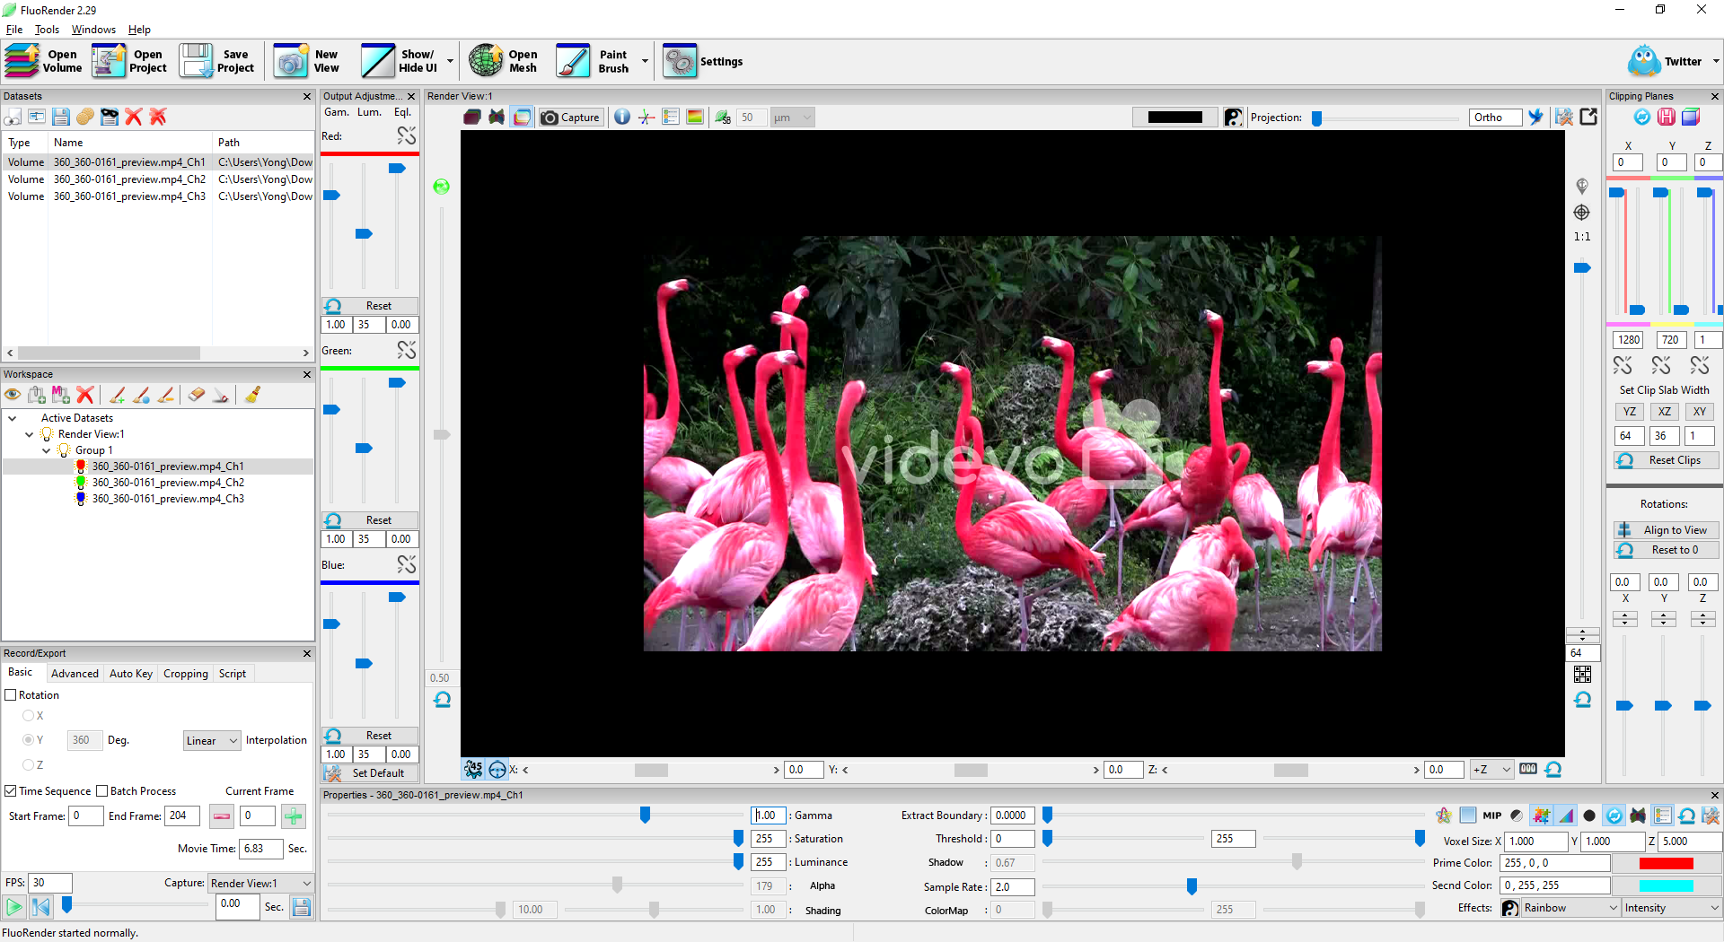

Figure 16‑2. Adjust the settings for the video.

3. Click the Play button in the “Record/Export” panel to view the video. You can also use the slider or set a specific frame to view.

4. Zoom in on one object that needs analysis. Trace the object with the “Pencil” tool from the Measurement window.

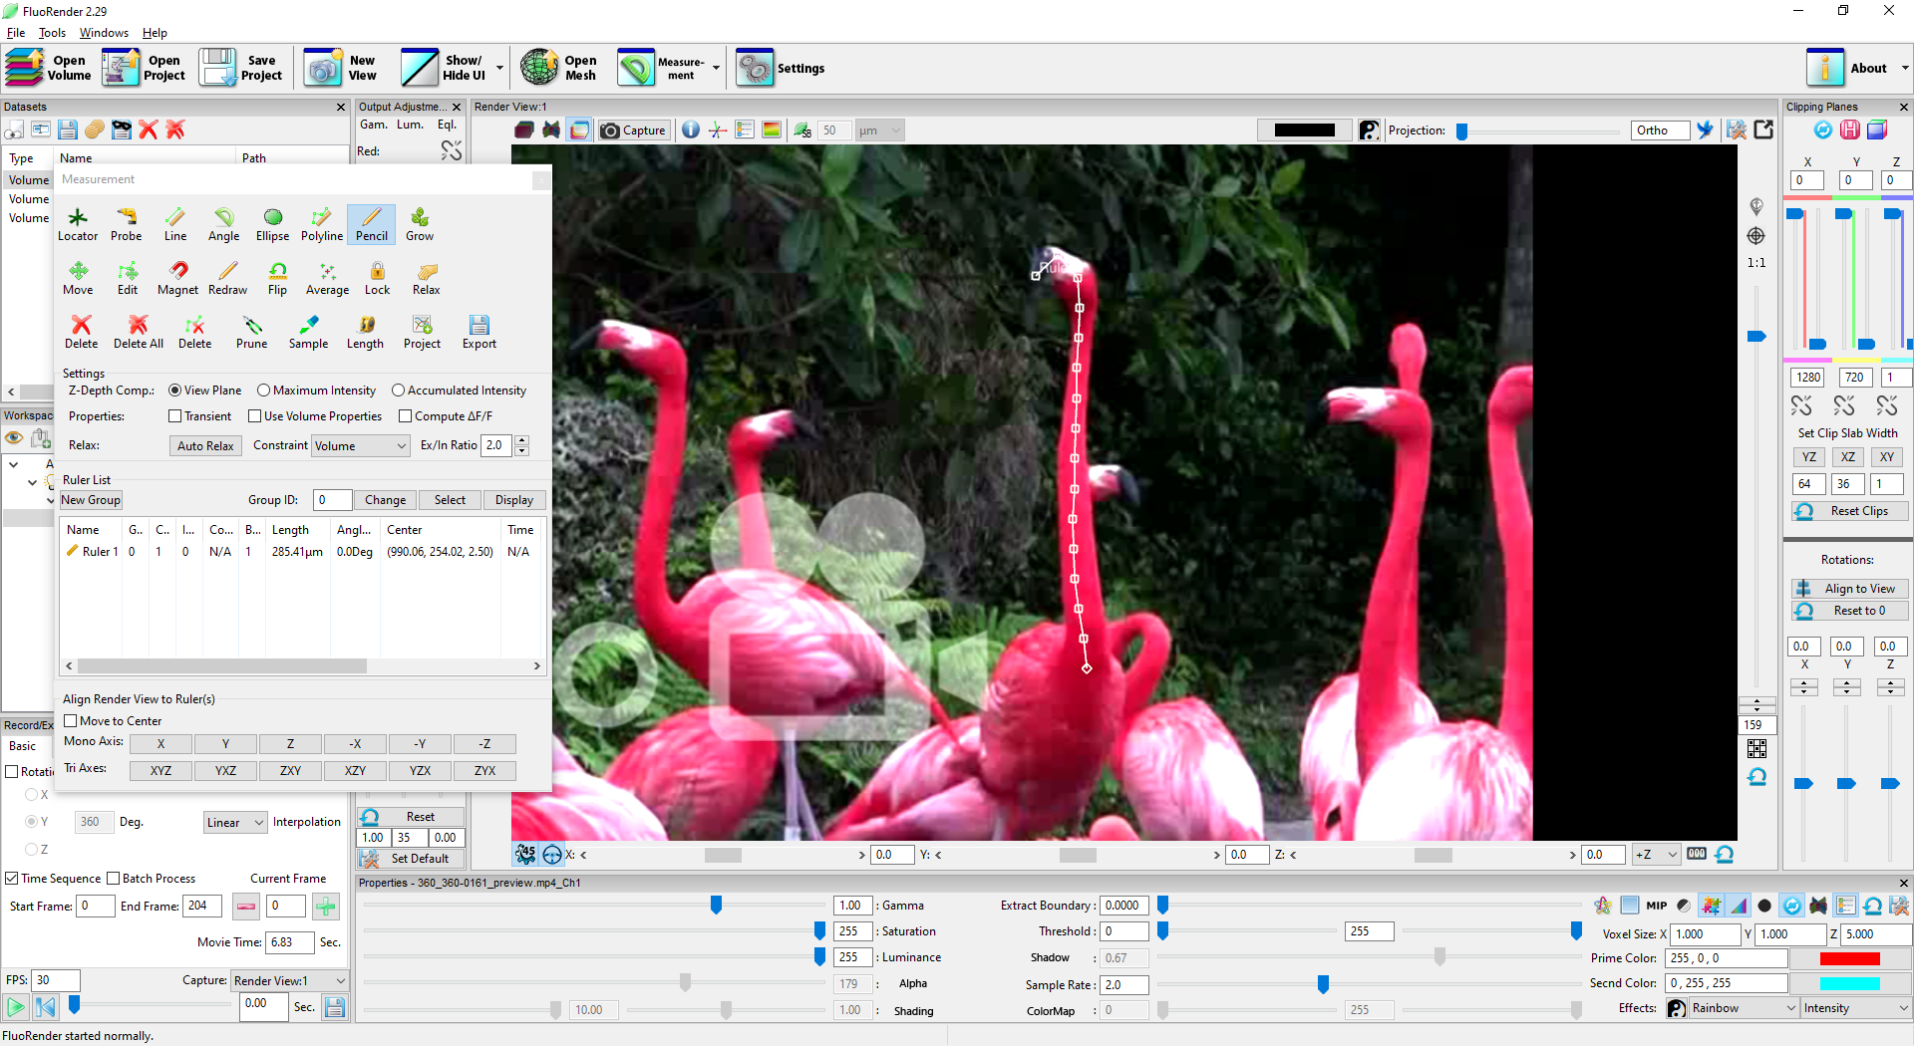

Figure 16‑3. Draw a ruler using the Pencil tool.

5. Advance one frame by the “+” button in the “Record/Export” panel or using the shortcut key “D”. Use the “Magnet” or “Redraw” tool and draw on the object to modify the ruler. Repeat this process to animate the ruler over time.

6. To export the coordinates of the ruler points over time, go to the “Script” tab of the “Record/Export” panel and run the script “ruler_info”. The exported information is saved in a CSV file. If there exists a default spreadsheet editor on the operating system, it will launch and show the result.

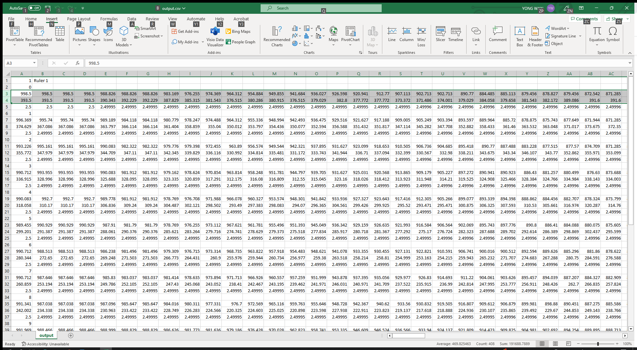

Figure 16‑4. Export ruler point coordinates to a spreadsheet.

7. The manual process above can be automated using the DeepLabCut. FluoRender added Python script support since Version 2.29.2. Several scripts were added to make function calls to the DeepLabCut. First, make sure Python and DeepLabCut are correctly installed on the system. FluoRender doesn’t come with these software packages. You need to go to Python and DeepLabCut websites separately and download and install them. For systems that support Nvidia Cuda, the machine-learning computing from the DeepLabCut can be accelerated. You also need to download Nvidia Cuda SDK to leverage GPU for training and video analysis. You can use the user interface of DeepLabCut to verify all necessary packages are correctly installed. Then, both training and application can be performed from FluoRender’s user interface.

8. Load a video file. Find one video frame where the feature needs tracking is most clear. Use the ruler tools to create points need tracking. You can use a multipoint ruler to trace the skeleton of an animal.

9. Find other video frames. Use move, edit, magnet, and redraw tools to move the points of existing rulers to track the posture of an animal. You don’t need to manually edit all video frames. 20 video frames can be a good starting point and increase from there. To take advantage of the time interpolation of ruler points, first set ruler points at the beginning and end of a video. Ruler point locations of video frames in between are computed by interpolation. So, only move points that don’t match with the video.

10. Rewind to the beginning of the video. Select the script “video_train” and play the video. It will ask for the place to save the DeepLabCut project as its configuration file. After the entire video finishes playing, FluoRender launches DeepLabCut and starts training. Depending on the iteration number setting and computer hardware, it may take hours to days to finish training.

11. A trained model from previous steps can be used to analyze the entire video or other similar video files. Load a new video file. Choose the script “video_analysis” and play the video. It will ask for the DeepLabCut configuration file, which is the same file generated using the training script. The application of the trained model runs with the video playback. Depending on the computer hardware and video length, it may take from several seconds to minutes to finish the video analysis. If the analysis is still running when the video finishes playback, it replays the video. The loop finishes until the analysis results are generated. Then, the results are shown as rulers on top of the video.

12. Saving the FluoRender project also saves the rulers. Use other scripts, such as “ruler_info” and “ruler_profile” to export ruler point coordinates or intensity information.

# Index

A

Alpha 11

C

Channels 7, 24, 30, 38

Clipping plane 13, 40

Colocalized 9

Composite mode 9

D

Depth calculation 31

Depth mode 8

E

Equalization 13

F

FPS 22

G

Gamma 10, 13

I

Install 5

Interpolation 12

L

Layered mode 8

M

Measurement 30

MIP 12

N

Noise 10

O

OpenCL 45

P

Paint brush 32, 38

S

Sample rate 12

Select 10, 32, 38

Sequence 15, 20

Settings 7, 12, 17, 23, 24, 25, 32, 39

Shading 11

Shadow 12, 25

Streaming 7, 38, 45

T

Threshold 11, 39, 40

Tracking 33